Year 5 | Autumn 1
Text type: Newspaper report.
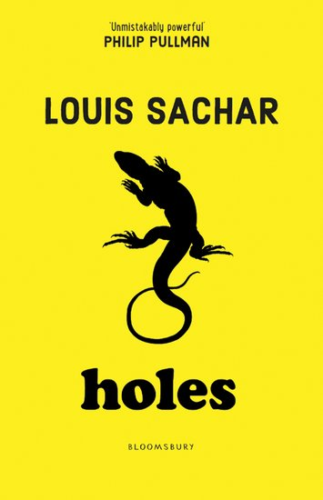
Writing purpose:
Report the closure of Camp Green Lake.
Key Writing opportunities:
WALT 1: Report on the reasons for the closure of Camp Green Lake. (DITLF).
WALT 2: Identify the features of a newspaper report.
WALT 3: Write facts about the closure of Camp Green Lake
WALT 4: Role-Play and plan an orientation paragraph
WALT 5: Role-play examples of direct speech. (DITLF).
WALT 6: Write examples of reported speech.
WALT 7: Write a newspaper report.
WALT 8: Edit our newspaper report
Key features:
- Name of the newspaper
- Headline
- Reporters name and date
- Columns.
- Orientation paragraph including 5 Ws.
- Paragraphs in chronological order.
- Reported speech.
- Formal language.
- 3rd person.
- Past tense
- Images and captions.
- Facts
- Direct Speech with inverted commas
- Reported Speech
- Future Statement (What next?)
My writing targets:
____________________________________________________________________________________________________________________________________________________________________________________________________________________________________________________________________________________________________________________________________________________________________________________________________________

