Year 5 | Autumn 1
Text type: Formal letter.
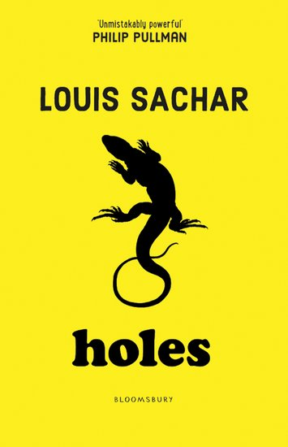

Writing purpose:
Persuade the Warden to release Stanley from Camp Green Lake.
Key Writing opportunities:
WALT 1: Hook lesson- uncover what Mr Sir has discovered (DITLF).
WALT 2: Identify the features of a formal letter.
WALT 3: Explore subject specific and formal vocabulary.
WALT 4: Use emotive language
WALT 5: Write questions to the warden- Hot seating- (DITLF)
WALT 6: Use causal conjunctions and adverbials.
WALT 7: Write a formal letter to the warden
WALT 8: Edit our letter.
Key features:
- Structure of a Letter
- Sender’s address- Right hand side
- Recipient address- Left hand side
- Date- under recipient’s address
- Formal Greeting
- Formal closing- Signature and full name
- Formal language
- Impersonal tone
- Rhetorical questions
- First person
- Paragraphs around one theme.
- Emotive language- thoughts and feelings
- Causal conjunctions
My writing targets:
______________________________________________________________________________________________________________________________________________________________________________________________________
______________________________________________________________________________________________________________________________________________________________________________________________________

