-+/
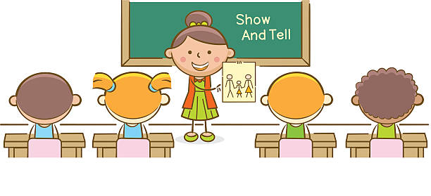
Show and Tell – Autumn 2
We’d like to invite the children to bring something of their choice into school to show and talk about with their friends, in a speaking and listening session we are going to do every Tuesday afternoon. This could be a toy, a book or a special object – however, please ensure it is not a valuable, sentimental or fragile item that could get lost or broken. Please could you bring something in every Tuesday in a clearly labelled carrier bag and hand to a member of staff; we will keep them somewhere safe and return them to you at the end of the day.
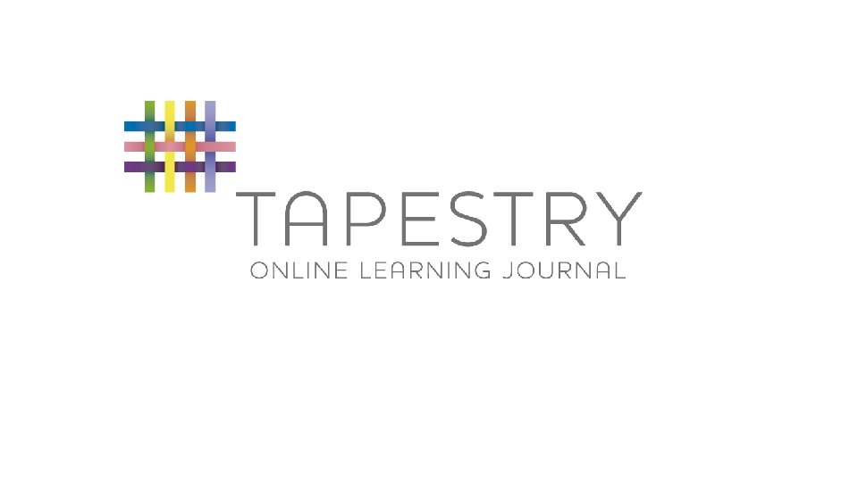
Tapestry
Thank you to all the parents and carers who have been accessing Tapestry. We regularly update Tapestry with photos and videos to share with you all the fantastic learning and activities your children are doing at school. It would really help us if you could click ‘like’ when you have viewed an observation and please do add a comment if you wish. Additionally, thank you to those who have been sharing photos and comments about what your children have been doing at home and all the wonderful experiences they have. We welcome you to share these with us and we have set aside a weekly slot on a Tuesday afternoon to look at these together in class. The children really enjoy this.
If you have any questions about any of the above, please do ask.
Thank you,
Mrs Harrison and the rest of the Acorn Team

