Key Facts to retain:
Light is a form of energy. It is created by light sources. Light sources can be natural or artificial (man-made).
Light travels from a light source in a straight line. The light can travel in any direction from the light source, unless it is being blocked by an object.
A shadow is created when light from a light source is blocked by an object.
In the centre of our eye, is the pupil. This black dot is a hole in the eye which lets light in.
The coloured section around the pupil is called the iris. The iris controls the size of the pupil.
The retina at the back of the eye is what changes the light that enters our eye into signals our brain can read.
The lens can change shape to create a focused image depending on how far away the object is.
Light bounces off objects and enters our eyes allowing us to see them.
It’s harder to see at night as there’s less light to bounce off objects.
Mirrors are highly reflective and smooth. They are made from glass which has a shiny metal coating on one side. They effectively reflect a lot of light and only absorb a small amount.

Children should have a basic understanding from year 3 light topic. They should have already covered:
- How shadows are formed
- That light comes from many different sources - both natural and man-made
- A brief understanding of reflection and how mirrors reflect light.

Newall Green Primary: Knowledge Organiser for Science - Light Year Group 6 Autumn 2
Vocabulary | Definition
Light Ray | Light is an electromagnetic wave and the straight line paths followed by narrow beams of light, along which light energy travels, are called rays.
Light Source | Light source is an object that emits light.
Reflect | Reflection is when an object returns either light or sound waves.
Scatter | Scatter is when an object sends light in separate and various directions.
Absorb | Absorption is when an object takes in another substance
Mirror | A mirror is a smooth surface that reflects light from its surface.
Periscope | A piece of equipment consisting of a tube and a set of mirrors or prisms allowing an observe to see something that would normally be out of sight.
Angle of incidence | The angle which an incident line or ray makes with a perpendicular to the surface at the point of incidence.
Angle of reflections | - The angle made by a reflected ray with a perpendicular to the reflecting surface.
Shadow | A dark area or shape produced by a body coming between rays of light and a surface
Opaque | An object that you are unable to see through.
Translucent | An object that allows light but not detailed objects to pass through.

What I should already know
ggf

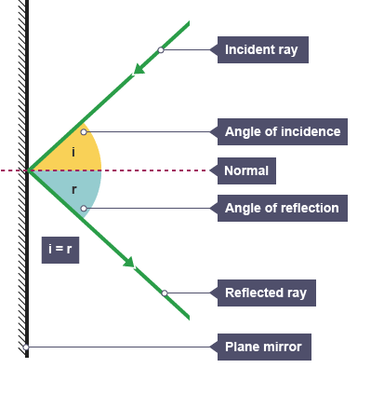

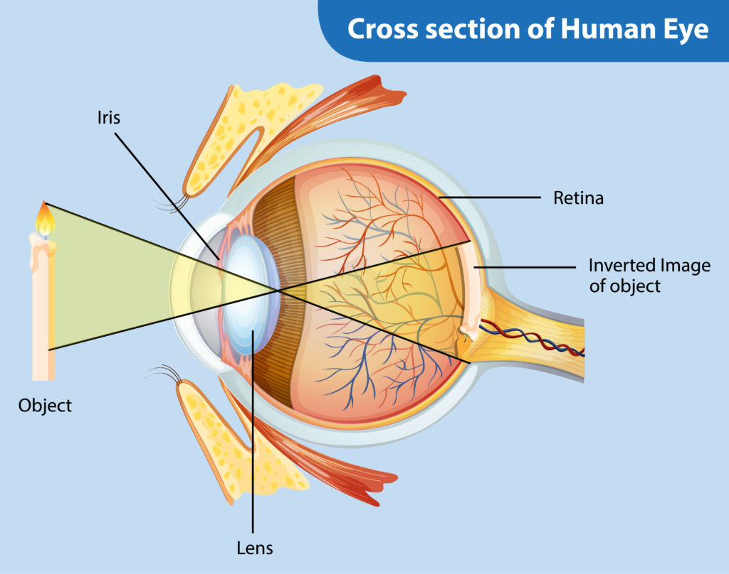
Map (if useful) and/or timeline

