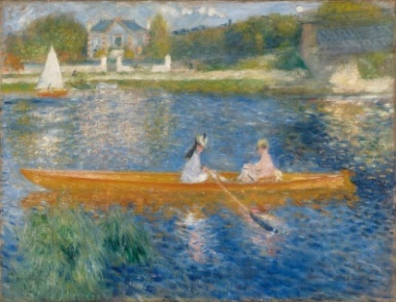
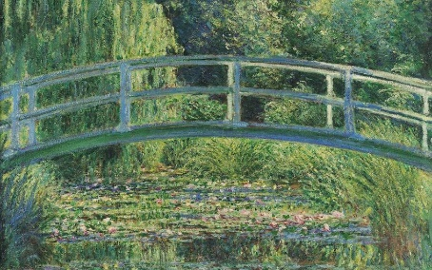
WALT 1: describe and annotate impressionism artwork.
WALT 2: research the work of Claude Monet.
WALT 3: practise impressionist artwork in the style of Monet.
WALT 4: portray moving water.
WALT 5: portray different styles of sky.
WALT 6 and 7: create and evaluate a final piece in the style of Impressionism.

What I should already know:
- How to hold a pencil
- The name of some famous artists
- Some artistic vocabulary
- The names of the primary and secondary colours
- The different tools and equipment to use to create different effects
- The names of different media (paint, charcoal etc)
- How to achieve some different brush strokes

Key facts to retain:
- Who impressionist artists were and how they created their artwork.
- How to use similar brushstrokes to create art in the impressionist style
- How to use watercolour.
- How to create movement in water.

Supporting experiences:
Research different artists such as Monet and Renoir.
Explore outdoor areas to find inspiration for their own art.

Key vocabulary:
Impressionism - a style of painting that focuses on the effects of light and atmosphere on colours and forms. Impressionist artists often used broken brush strokes rather than smooth and unnoticeable ones. They also used many colours to paint scenes of everyday life.
focal point - The area in a pictorial composition to which the eye returns most naturally.
composition - The combination of elements in a painting or other work of art that provides order or structure to the scene.
cool colour - A colour that suggests sensations of coolness, such as blue or its associated hues, blue-green, and blue-violet. In painting, cool colours appear to recede from the picture plane and therefore suggest depth.
vanishing point - In perspective, the point towards which a set of lines, which are in reality parallel to each other, seem to converge.
warm colour - A colour which suggests sensations of warmness, such as red or yellow. Warm colours tend to project from the picture plane.
medium: A medium refers to the materials that are used to create a work of art. The plural of medium is media.

The Skiff (1878) Pierre-Auguste Renoir
The Japanese Bridge (1899) – Claude Monet
Autumn 2 Y6 Art: Impressionism – the movement of water and painting a summer’s day

