**Key Facts**

Many Hindus believe all living beings possess a ‘spark’ of Brahman known as atman, which means that all living beings are sacred and special.

Hindus believe the spark of God is eternal, so when their body dies it will be reborn into another body. Which body it goes into will depend on karma.

Hindus describe life as a journey towards moksha; freedom from the cycle of birth, death and rebirth towards oneness with God.

Hindus see their faith as being a complete way of life – all of life is part of their dharma (duty to act in the right way as God teaches). Hindus show their faith in God through puja (Hindu worship). During worship, the aarti lamp is lit and offered to the deity.

Hindus worship together at a mandir or temple where Puja is performed. There are many shrines inside the temple. Going to worship at a shrine is like visiting the gods and goddesses.

**Newall Green Primary: Knowledge Organiser for RE Year Group 4 Autumn 1**

**What does it mean to be a Hindu in Britain today?**

**What I should already know**

ggf

|  |  |
| --- | --- |
| WALT 1: | Can I explain how Hindus show their faith? |
| WALT 2: | Can I describe two aims in Hindu life? |
| WALT 3: | Can I discuss why Mahatma Gandhi is a Hindu Hero? |
| WALT 4: | Can I explain why being a Hindu is a good thing today and reasons why it might be hard? |
| WALT 5: | End of unit quiz |

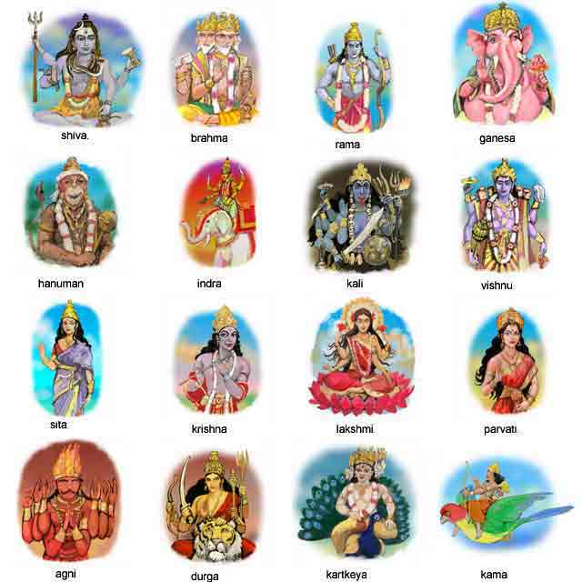

**Vocabulary**

Aum (or om) – Sacred sound and spiritual symbol that represents the ultimate reality.

Bhavagad Gita – the most important Hindu book.

Deities – Hindu Gods and Goddesses

Dharma – the idea of living life in the right way.

Karma – our actions build good and bad karma that is carried on over many lives.

Mandir – Name for Hindu temple or place of worship

Moksha – freeing the soul from death.

Puja – Worship ritual

Reincarnation – all living things have a soul that can’t be destroyed and are reborn.

Shrine – A place where Hindu deities are worshipped.

I know that different religions are celebrated and worshipped across the globe.

Recall facts about Christianity such as the ten commandments and they believe humans should live a good life.

Know how Judaism is worshipped and celebrated.