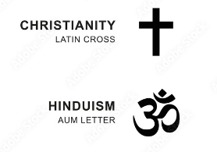 

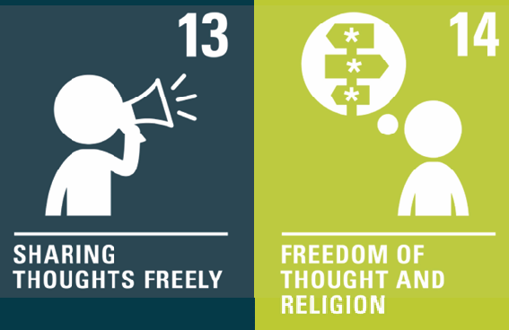

The

What I should already know:

People can be atheist, theist, or agnostic.

Religious people follow specific teachings on how to live their lives.

Non-religious people, such as Humanists, also have certain beliefs around how to live their lives.

That some religions believe in karma and reincarnation and aim to achieve moksha.

|  |  |
| --- | --- |
| **Key Vocabulary** | |
| **secular** | Not connected with religious matters. |
| **religious** | Relating to or believing in a region. |
| **pilgrimage** | A special journey made to a holy place for religious reasons. |
| **un-conditional** | Where a person does or gives something without expecting anything in return. |
| **ahimsa** | An ancient Indian practice of non-violence towards all living things. |
| **reincarnation** | The rebirth of a soul in another body. |
| **karma** | Good or bad luck because of your actions. |
| **moksha** | Reaching freedom from the cycle of death and re-birth. |
| **soul** | The spiritual part of a person that some people believe continues to exist after the body has died. |
| **sewa** | Acting selflessly, helping others in a variety of ways, without any reward or personal gain. |
| **ummah** | The worldwide community of Muslims. There is no living leader of the Ummah. Allah is the only one who Muslims follow. |

**Key facts to retain:**

For Hindus being harmless means, for example, no violence, eating no meat and wearing no leather; ahimsa links to ideas of karma and reincarnation.

For Christians the idea of grace from God means that God loves people unconditionally and is willing to offer forgiveness to anyone for anything.

For Muslims, the worldwide Muslim community is called the Ummah, and being part of the Ummah is expressed, e.g. in pilgrimage to Makkah and in shared welfare through zakat.

**Our lessons:**

**WALT 1:** What does it mean for Hindus, Muslims and Christians to commit to key beliefs? (Day in the life folder)

**WALT 2:** How do Muslim people build their community by following their Prophet? How does it feel to be a part of the Muslim Ummah? (Day in the life folder)

**WALT 3:** What does harmlessness mean in the Hindu religion? Study of Gandhi.

**WALT 4:** How do Hindus show their commitment to ahimsa through acts of service or sewa?

**WALT 5:** What did Jesus teach about God’s grace and forgiveness? Why did Jesus share bread & wine with his disciples, the night of his arrest?

**WALT 6:** What have we learned from Muslims, Christians and Hindus about their commitments to the Ummah, to Ahimsa and to Grace? How are these religions similar, and how are they different?

Knowledge Organiser for **Y6** **RE What difference does it make to believe in Ahimsa (harmlessness), Grace (the generosity of God), and Ummah (community)?**