WALT 1: Understand the key vocabulary – See day in the life folder

WALT 2: Understand the causes and effects of climate change

WALT 3: Understand the impact of plastic pollution

WALT 4: Understand how we can bring about change

WALT 5: Understand what bio-diversity is and why it is important.

WALT 6: Understand how animals can adapt to climate change - See day in the life folder

WALT 7: Research the positives and negatives of palm oil.

WALT 1: Understand the key vocabulary – See day in the life folder

WALT 2: Understand the causes and effects of climate change

WALT 3: Understand the impact of plastic pollution

WALT 4: Understand how we can bring about change

WALT 5: Understand what bio-diversity is and why it is important.

WALT 6: Understand how animals can adapt to climate change - See day in the life folder

WALT 7: Research the positives and negatives of palm oil.

|  |  |
| --- | --- |
| **Key Vocabulary** | |
| **Atmosphere** | The mixture of gases around the earth |
| **Greenhouse gases** | Any of the gases which are responsible for the greenhouse effect. |
| **Biodegradable** | Capable of decaying through the action of living organisms. |
| **Carbon dioxide** | A colourless, odorless gas, CO2, formed during respiration. |
| **Carbon footprint** | The amount of carbon dioxide emitted into the atmosphere by somebody. |
| **Citizen** | A member of a country. |
| **Climate** | Weather conditions of an area over a long period of time. |
| **Fossil fuels** | Fuels that are non-renewable (will run out). |
| **Micro plastic** | Very small pieces of plastic that pollute the environment |
| **Climate Change** | The long-term changes in global temperatures and other characteristics of the atmosphere. |
| **Sustainability** | The quality of not being harmful to the environment. |
| **Weather** | Describes day-to-day weather. |



**Key Facts to retain:**

**Geography**

We will learn what climate change is and what is causing it.

We will learn the effects of climate change on all living things and the environment.

We will learn about plastic pollution and how it effects the planet.

We will investigate different ways to help save the planet, starting in our own community.

We will understand what bio-diversity is and why it is important.

We will investigate palm oil, looking at the pros and cons and decide whether to buy it or not.

**What I**

of things like playdough and snow.

**What I Should Already Know:**

Climate and weather are different things.

People and animals are both threatened by climate change.

Everyone can do their bit to help e.g., recycling and saving electricity.

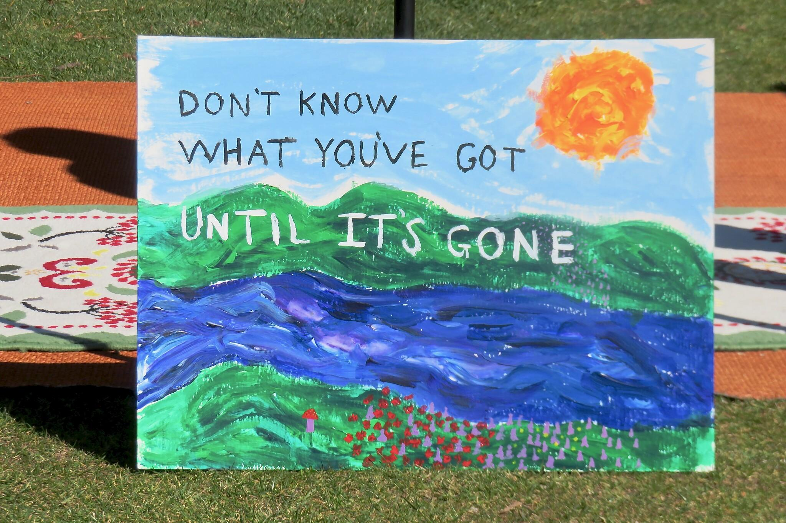

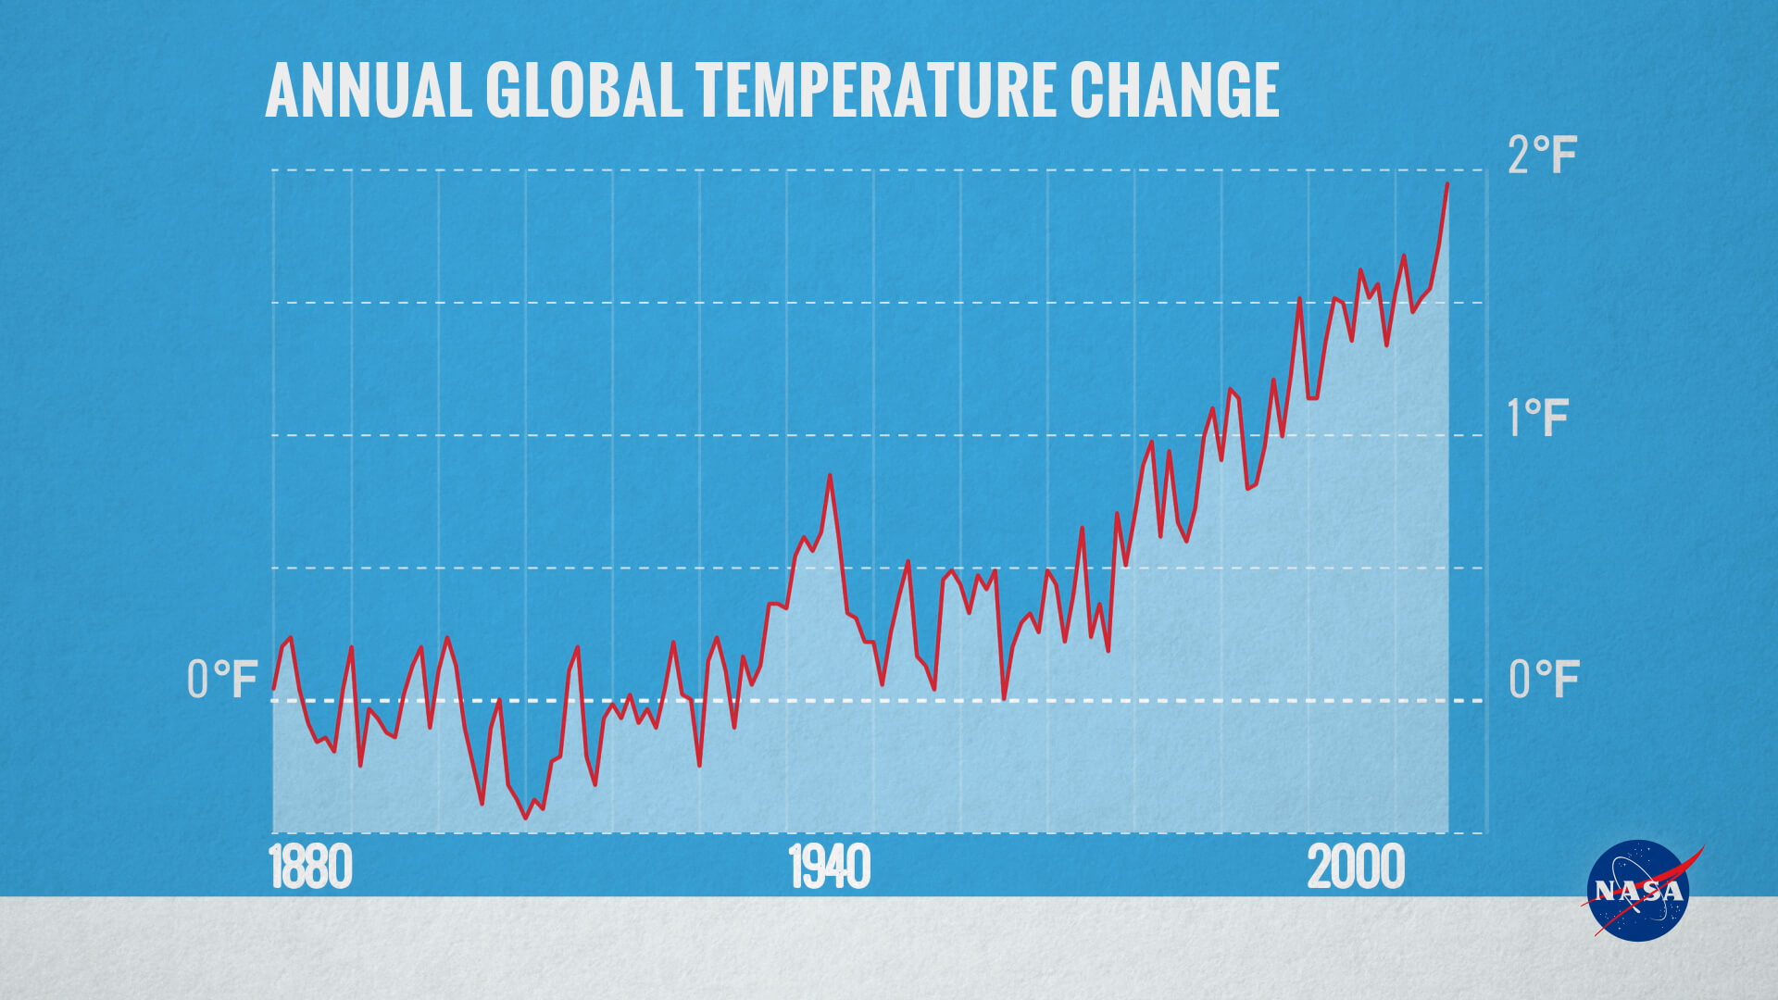

**Newall Green Primary: Knowledge Organiser for Climate Change Year Group 6 Autumn 1**

What I should already know

ggf

**Geography**

Names of the Oceans

Names of the continents

Countries in Europe

What climate is

Global Warming

Ozone