Newall Green Primary: Knowledge Organiser for  **Classifying Organisms** Year Group: 6 **Autumn:1**

**Living things can be organised into 5 kingdoms:**

Animal Kingdom Plant Kingdom

Bacteria Kingdom Fungi Kingdom

Protests Kingdom.

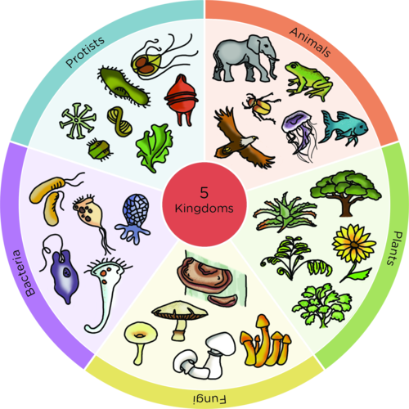

**Key facts to retain:**

Organisms can be organised based on their characteristics using classification systems.

In 1735 Carl Linnaeus published a classification and naming system for organisms that would eventually be used by scientists all over the world.

Yeast is a type of bacteria and bacteria is used in food production e.g. turning milk into yogurt. Bacteria can also cause diseases.

**Classification Key**

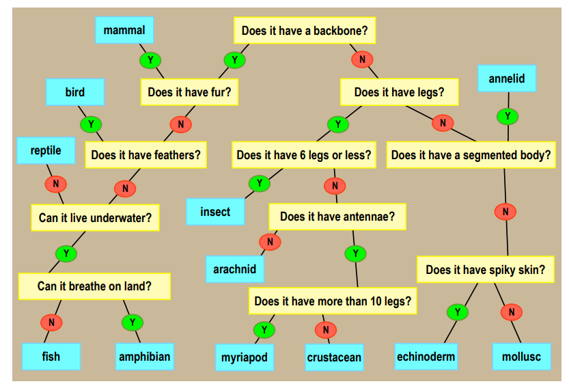

What I should already know:

That we can organise animals into groups based on their appearance, what they eat, where they live etc.

The difference between a vertebrate and an invertebrate.

That organisms can be classified as plants, birds, mammals, fish, reptiles, arachnids, amphibians and insects.

|  |  |
| --- | --- |
| **Key Vocabulary** | |
| **Organism** | A single living thing. |
| **Micro-Organism** | A single living thing that cannot be seen without a microscope. |
| **Classification** | The act or process of dividing things into groups according to their type. |
| **Bacteria** | A very small organism that can be found anywhere. |
| **Fungus** | An organism that’s food source derives from decaying material or other living things. |
| **Protists** | Micro-organisms that are usually made up of just one cell. Protists usually live in water and stay in one place. They can include algae and amoeba. |
| **Vascular** | Plants with roots and a stem to transport water and nutrients around the plant. |
| **Non-vascular** | Plants without roots or a stem that absorb water from their environment. |
| **Echinoderm** | Invertebrate with spiny skin, such as a starfish or sea urchin. |
| **Annelid** | Invertebrate with no legs and a segmented body, such as an earthworm. |
| **Myriapod** | Invertebrate with many legs and body segments, such as a centipede. |

The

**Big Question – How and Why do we classify living organisms?**

WALT 1: To recap ways of grouping organisms according to their characteristics.

WALT 2: To explore ways of distinguishing between organisms that have similar characteristics

WALT 3: To be able to classify plants according to their characteristics

WALT 4: To find out about Carl Linnaeus and his classification system.

WALT 5: To explore what micro-organisms are and how they can be grouped + Yeast Experiment

WALT 6: To be able to identify and classify organisms in the local area

WALT 7: End of Unit Test

**Big Question – How and Why do we classify living organisms?**

WALT 1: To recap ways of grouping organisms according to their characteristics.

WALT 2: To explore ways of distinguishing between organisms that have similar characteristics

WALT 3: To be able to classify plants according to their characteristics

WALT 4: To find out about Carl Linnaeus and his classification system.

WALT 5: To explore what micro-organisms are and how they can be grouped + Yeast Experiment

WALT 6: To be able to identify and classify organisms in the local area

WALT 7: End of Unit Test