[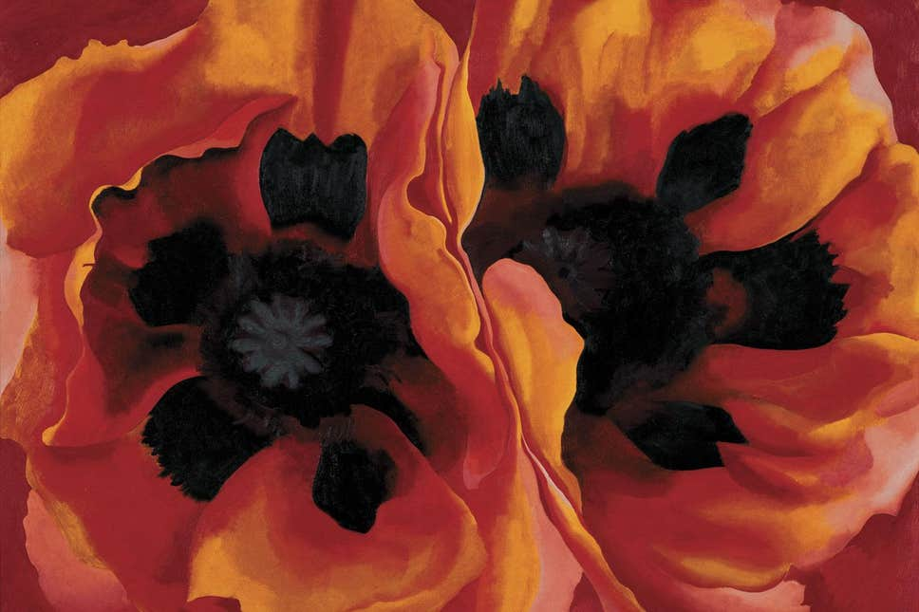](https://www.google.co.uk/url?sa=i&url=https://www.standard.co.uk/go/london/arts/georgia-okeeffe-review-the-artist-who-tried-to-create-a-new-kind-of-painting-for-modern-america-a3288001.html&psig=AOvVaw2RdsDwKRDM9Dmb3MotfYIb&ust=1597843259846000&source=images&cd=vfe&ved=0CAIQjRxqFwoTCIjK6ZrspOsCFQAAAAAdAAAAABAK)[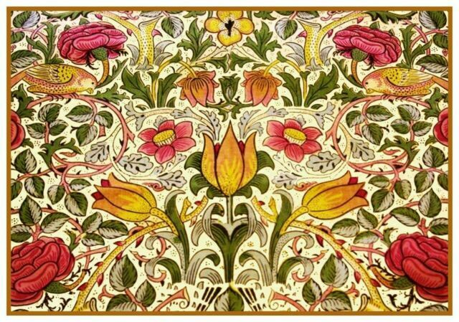](https://www.google.co.uk/url?sa=i&url=https://www.ebay.com/p/1162448787&psig=AOvVaw2Pq-kIyql7yn0_7v4Dcn31&ust=1597843625829000&source=images&cd=vfe&ved=0CAIQjRxqFwoTCNjB7cLtpOsCFQAAAAAdAAAAABAG)

Supporting experiences:

Research different artists such as Georgia O’Keefe, Vincent Van Gagh and William Morris.

Explore the outdoor area to find inspiration for their own art.

Newall Green Primary School: Knowledge Organiser

Art: painting, sculpting and creating flowers.

Term: Autumn 1

Year group: 6

What we will be learning:

Walt 1: Learn about different artists and designers who have used plants and flowers.

Walt 2: Revise parts of the flower and learn how to accurately them.

Walt 3: Collect images of flowers.

Walt 4: Sketch my own flower and learn how to add watercolour.

Walt 5 and 6: Design and make a 3D flower.

Walt 7: Evaluate my 3D flower.

Key vocabulary:

Proportion: how parts of the flower compare to each other in relation to size, shape, colour.

Scale: the size of the parts of an object in relation to other parts.

Perspective:  what gives a three-dimensional feeling to a flat image such as a drawing or a painting

Expressionism:  refers to **art** in which the image of reality **is** distorted in order to make it expressive of the **artist's** inner feelings or ideas.

Medium: A **medium** refers to the materials that are used to create a work of **art**. The plural of **medium** is **media**. Some of the most common **media** are oil paints (paints that use oil to hold pigments together), tempera (pigments held together with egg yolk), marble (soft, white stone), and bronze (a metal used to cast sculptures)

Flowers by William Morris

Flowers by Georgia O’Keefe

What I should already know:

* How to hold a pencil
* The name of some famous artists
* Some artistic vocabulary
* The names of the primary and secondary colours
* The different tools and equipment to use to create different effects when using clay – made pots in Year 4
* The names of different media (paint, charcoal etc)
* The parts of a flower.

Focus: sketching, painting, sculpting and creating flowers.

Key facts to retain:

* How different artists have painted flowers.
* Different parts of a flower.
* Know how to draw a flower using accurate proportions.
* How to use watercolour.
* How to hold a pencil properly.
* How to work with different medium – foil, clay, papier mâché.