Year 5 | Autumn 1
Text type: Persuasive leaflet
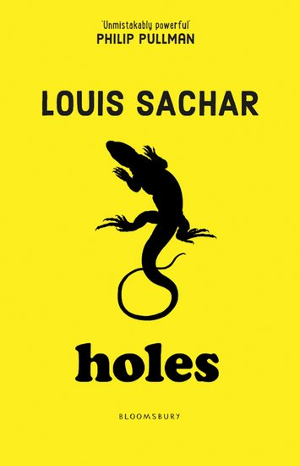
Writing purpose:
Persuade parents to send their children to Camp Green Lake.
Key Writing opportunities:
WALT 1: Create a persuasive presentation (DITLF).
WALT 2: Identify the features of a persuasive leaflet
WALT 3: Use facts, opinions and modal verbs
WALT 4: Use emotive language and causal conjunctions
WALT 5: Effectively use persuasive language
WALT 6: Write a persuasive leaflet
Edit our writing- throughout hot write
WALT 7: Publish our persuasive leaflet to display
Key features:
- Title
- Subheadings
- Slogans
- Introduction/opening paragraph
- Organised into paragraphs/text boxes
- Reasons to support view stated and points explained / expanded
- Emotive language
- Modal verbs
- Rhetorical questions
- Causal conjunctions
- Persuasive words and phrases
- Conclusion
My writing targets:
____________________________________________________________________________________________________________________________________________________________________________________________________________________________________________________________________________________________________________________________________________________________________________________________________________

