#

Key Vocabulary

**Monarchy** – the monarch and royal family of a country

**King** –a male head of a royal family who rules a country 

**Queen** - a female head of a royal family who rules a country (or wife of a king) 

**Heir** – a person who inherits someone’s property or title after their death

**Tudors –**a British royal family that ruled from the 15t h – 16th century 

**Divorce** – the ending of a marriage through law

**Behead** – to remove a person or animal’s head

**Middle Ages** – period of European history between ancient times and the Renaissance

**Civil War** – a war within a country 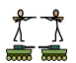

Focus: The rise of the Tudors and life of Henry VIII

**WALT 1:** Explain the origins of The War of The Roses.

Intervention Absent

**WALT 2:** Understand Henry VIII’s childhood and his ascent to the throne. Day In The Life

Intervention Absent

**WALT 3**: Understand the dissolution of the monasteries due Henry’s divorce from Catherine of Aragon

Intervention Absent

**WALT 4:** Understand the significance of Henry’s marriage to Anne Boleyn Day In The Life

Intervention  Absent

**WALT 5:** Explore Henry’s other marriages and the importance of the birth Edward.

Intervention  Absent

**WALT 6:** Understand the key events in Edward’s life.

Intervention Absent

**WALT 7:** Understand Elizabeth’s ascent to the throne

Intervention Absent

**WALT 8:** Explore the role of Sir Frances Drake and his part in the Spanish Armada Day In The Life

Intervention Absent

**END OF UNIT QUIZ**

Intervention Absent

Newall Green Primary School: Knowledge Organiser

History: The Tudors Term: Autumn 1 Date: September 2025

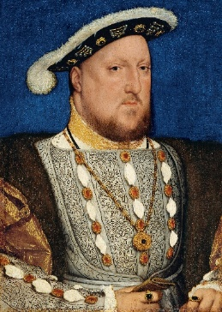

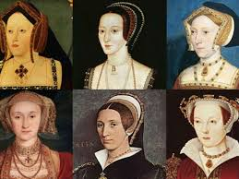

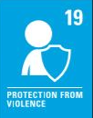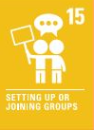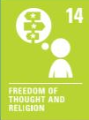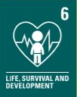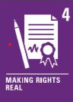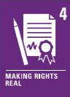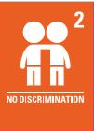 

The rise and life of Henry VIII

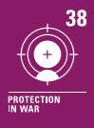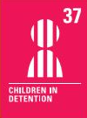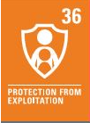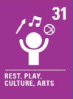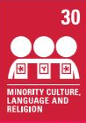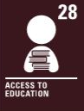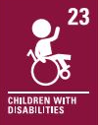

**What I should already know:**

* England had been conquered by Romans, Normans, Vikings and Anglo-Saxons
* William the Conqueror ruled England in 1066 and his heirs since then
* English lords forced the signing of the Magna Carta
* Wales was constantly invaded by England in the Middle Ages
* Scotland was its own country and had its own King
* The United Kingdom didn’t exist
* The Pope led the Catholic church and influenced Kings and Queens across the world
* English Kings and Queens took part in the Crusades in the Middle East