

Attendance Policy 2026
Chair of Governors |  | Ali Basharat
Headteacher |  | Adam Porter
Date | Review Date | Coordinator | Nominated Governor
01/02/26 | 01/02/28

Introduction and School Target

Holden Clough is a successful school and our children and their families play their part in making it so. We aim for an environment which enables and encourages all members of the school community to reach out for excellence. For our children to gain the greatest benefit from their education it is vital that they attend regularly and children should be at school, on time, every day school is open unless the reason for the absence is unavoidable.

The target for attendance at Holden Clough is 97% because we know that good attendance is the key to successful schooling and we believe our pupils can be amongst the best in Tameside.

Ensuring a child’s regular attendance at school is the legal responsibility of Parents/Carers and permitting absence from school without a good reason creates an offence in law which may result in prosecution.

Why Regular Attendance Is So Important

Any absence affects the pattern of a child’s schooling and regular absence will seriously affect their learning. Any pupil’s absence disrupts teaching routines so may affect the learning of others in the same class.
100%  OUTSTANDING  97% and above  EXCELLENT | 95% to 97%  REQUIRES  IMPROVEMENT | 91% to 95%  CLOSELY  MONITORED |  | 90% or below  PERSISTENT  ABSENCE
More likely to achieve highly | Could have an impact on achievement | Could have a more serious impact on achievement |  | Likely to have a serious impact on achievement
Actions:  Student rewards | Actions:  Weekly review / monitoring by attendance officer | Actions:  Letter of concern sent home  Weekly review / monitoring by attendance officer and Headteacher  Attendance panel meeting WITH Parents/Carers, attendance officer, Headteacher and possibly EWO | Actions:  Possible penalty notice or legal action by local authority
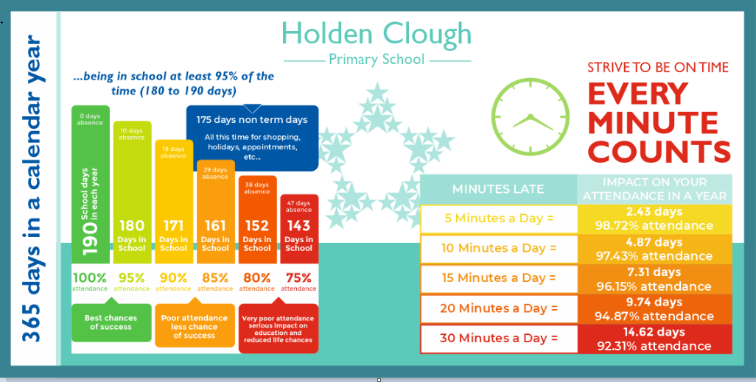

Understanding Types of Absence

The school day consists of 2 sessions AM and PM. Every absence from school has to be classified by the school (not by parents), as either AUTHORISED or UNAUTHORISED. This is why detailed information about the cause of any absence is required.

Authorised absences are mornings or afternoons away from school for a reason such as illness, medical/dental appointments supported by medical evidence which unavoidably fall in school time, emergencies or other unavoidable causes. Wherever possible please provide appointments cards/letters, copies of prescriptions etc. Children are often able to come into school when they are on medication. Please see our Managing Medicines Policy.

Although we appreciate that it is not always possible, please make every effort to book medical/dental appointments outside of school hours. Only 1 session will be authorised for appointments e.g., for a 9 am dental appointment the morning session would be authorised. If the child fails to come to school after the appointment, the afternoon session will be recorded as unauthorised (exceptional circumstances will be taken into consideration)

SICKNESS: Please do not be offended if the amount of time your child is absent from school due to illness is challenged. If absence due to illness exceeds 3 days, it will not be authorised without evidence being provided.

Unauthorised Absences
Unauthorised absences are those which the school does not consider reasonable and for which no leave has been granted. These can lead to the Local Authority issuing penalty notices, which may result in a fine or, in more serious cases, prosecution. Prosecution can lead to harsher sanctions, including a prison sentence.

Examples of Unacceptable Reasons for Absence
- Parents/Carers keeping children off school unnecessarily (e.g., birthdays, holidays, shopping, sibling/parent illness, or caring for other children).
- Any absences during term time not authorised by the Headteacher.
- Any unexplained absences (these will be recorded as unauthorised unless a satisfactory explanation is provided).
- All unexplained or prolonged absences will be investigated and may result in a home visit.

Illness and Reluctance to Attend
While children may occasionally be off school due to illness, sometimes they can be reluctant to attend. Any issues with regular attendance should be resolved between the school, Parents/Carers, and the child. Covering up absences or excusing attendance sends the message that attendance does not matter and often makes the situation worse.

Holidays in Term Time
Holidays during term time affect a child’s education as much as any other absence. Parents/Carers are expected to support the school by not taking children out of school during term time unless there are exceptional circumstances.
- All applications for leave must be made well in advance using the form available from the school office.
- Each application will be considered individually, taking into account any patterns of previous leave.
- Authorised leave will only be granted in exceptional circumstances.
- If a holiday request is refused, this may result in a penalty notice. Current law does not permit parents to take children out of school for holidays or trips.

Important Notes
- If a call is made to school immediately before or after a holiday reporting illness, medical evidence may be requested. If none is provided, the absence will be recorded as unauthorised.
- For extended holidays of three weeks or more, a penalty notice may not be issued. Instead, the matter may be referred to the Magistrates’ Court, where any fines imposed are likely to be higher



Please refer to https://www.tameside.gov.uk/Education/School-Attendance-Fixed -Penalty-Notice

Absence Monitoring

A monitoring file is kept for pupils whose attendance falls to 95% or below and the following procedure is followed:
- The Parents/Carers of pupils whose attendance falls to 95% or below will receive a monitoring letter
- A review of individual attendance will take place on a weekly basis within school
- If there is no improvement Parents/Carers will receive a second letter inviting them to an ‘attendance panel’ meeting to discuss attendance and devise a plan of support if required (an Education Welfare Officer from the Local Authority may be present at this meeting)
- School will continue to monitor, review attendance and work with families. However, if there is no improvement in attendance school may consider legal action

Persistent Absenteeism (PA)

A pupil becomes a ‘persistent absentee’ when they miss 10% or more of schooling across the school year for whatever reason, whether authorised or unauthorised. Absence at this level impacts attainment and prospects. It is a legal requirement that parents/carers ensure their child attends school.

We monitor all absence thoroughly. PA pupils are tracked and monitored carefully through our pastoral/attendance team. We also combine this with academic mentoring where absence affects attainment. All our PA pupils and their Parents/Carers are subject to an Action Plan and the plan may include allocation of additional support.

Lateness

Poor punctuality is not acceptable. If a child misses the start of the day, they can miss work and do not spend time with their class teacher getting vital information and news about the day ahead of them. Late arriving pupils also disrupt lessons and cause embarrassment for the child which can encourage absence.

How we manage lateness
- Children should be in class ready to start learning by 8.40 am
- The external classroom doors will be closed at 8.50 am prompt and pupils will receive a late mark if they are not present by that time.
- If the external door is closed pupils must enter the school through the main entrance and report to the Reception staff. Unless the pupil has travelled to school alone (Yr 5/6) a Parent or Carer is required to sign them in.
- At 9.20am the registers are closed. In accordance with Regulation any pupil arriving after that time will receive a mark that shows them to be on site, but it will NOT count as a present mark and is recorded as an unauthorised absence.
- If a pupil has a persistent late record, Parents/Carers will be asked to meet with one of the attendance team to resolve the problem. However, Parents/Carers can approach the school for support at any time if they are experiencing problems getting their child to school on time
- If the problem persists there may be a possibility of a penalty notice being issued.
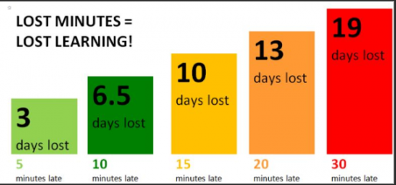

Promoting Regular Attendance

At Holden Clough Primary School, we recognise that when children miss school, they miss more than lessons. They miss friendships, routines, support, opportunities to build resilience and experiences that help them feel part of the school community. We therefore take a supportive, graduated approach to attendance through a multi-tiered model of support.


When children miss school, they miss more than lessons.

Multi-Tiered Model of Attendance Support

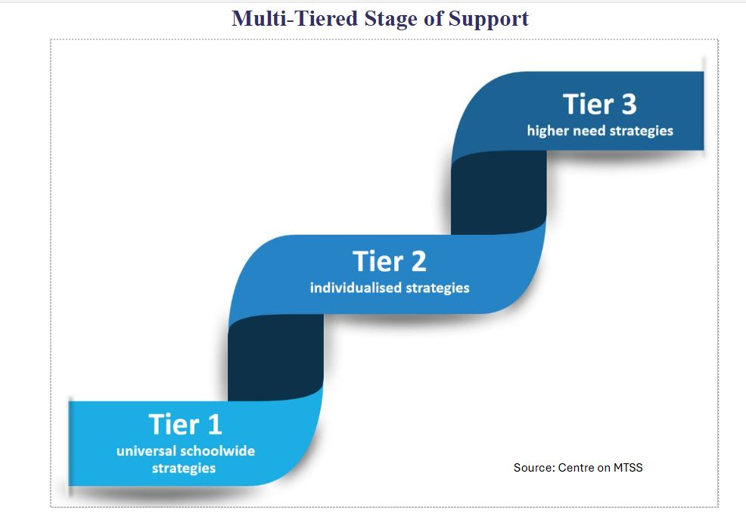

Tier 1 – Universal Attendance Strategies
These strategies apply to all pupils and are embedded in everyday school practice. Staff create welcoming environments, build positive relationships, monitor attendance proactively and celebrate success. Children are expected to attend regularly, engage in learning and celebrate achievements. Parents promote positive attitudes to attendance and communicate early with school.

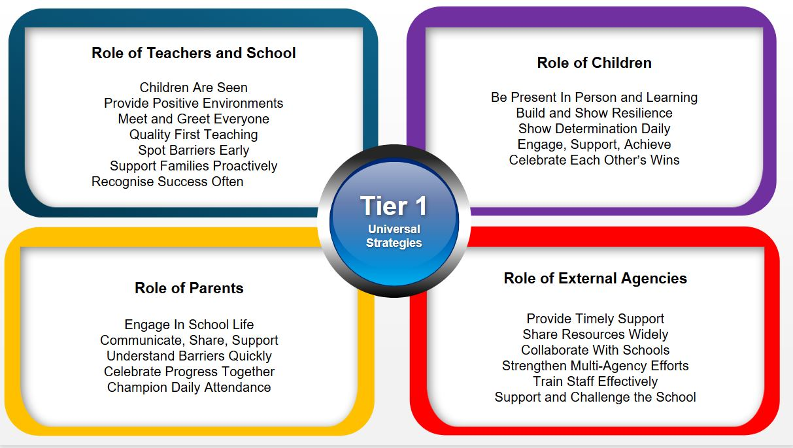

Tier 2 – Targeted Attendance Strategies
Where attendance causes concern, targeted support is introduced. School staff work closely with families to understand barriers, implement tailored strategies and monitor progress. Children engage in interventions and parents work in partnership to prevent escalation.

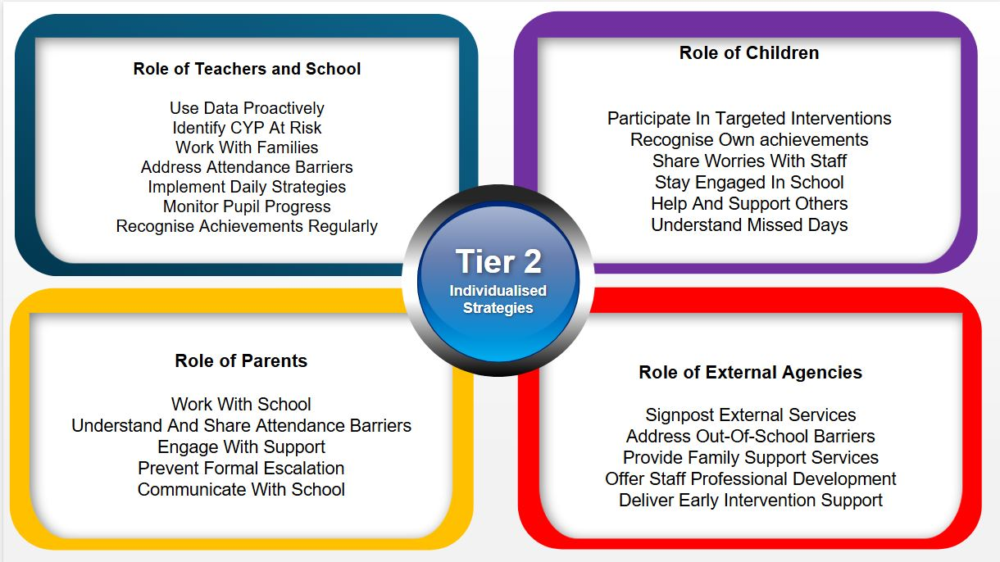

Tier 3 – Intensive Attendance Strategies
For persistent or complex attendance difficulties, the school works in collaboration with parents and external agencies. Individual plans are reviewed regularly, multi-agency support is coordinated and every improvement is recognised.

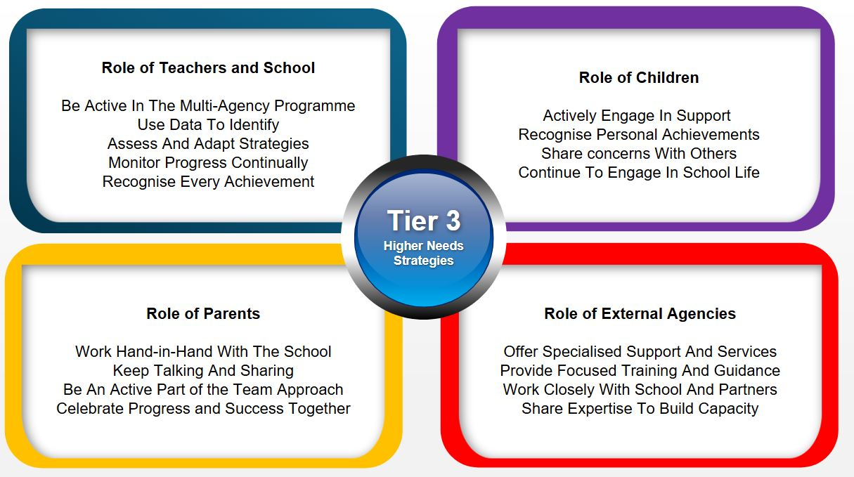

School will use a staged approach. Helping to create a regular pattern of attendance is everybody’s responsibility – Parents/Carers, pupils and all members of school staff.

To help us all focus on this we will:
- Give attendance information on weekly newsletters
- Report in the Spring and Summer Terms to Parents/Carers on how their child is performing in school, and what their attendance rate is
- Celebrate good attendance for children who get 100% attendance each term. Their family will be in with a chance of winning a £50 Asda voucher

Absence Procedures

Reporting pupil absence

If a child is absent from school for any reason Parents/Carers must:

- Contact the school as soon as possible on the first day of absence using one of the following methods
  - Telephone - 0161 330 5248. You can either speak to a member office staff or select option 1 which will direct you to a 24hr answering service which is dedicated to pupil absence. Please give your child’s name, class and the reason for their absence; please give as much detail as possible. Not well/under the weather are not satisfactory reasons for absence.
  - Email – attendance@holdenclough.victoriousmat.org please give name of child, class and details of absence. Again, you can request a ‘callback’ if you wish to speak to someone
- You must update the school daily unless agreed otherwise with the attendance team
- Provide medical evidence for all appointments within school time.

Please do not use Class DOJO to report absence.

Any unreported absence is a cause for concern. In the event that we are unable to contact you for 2 consecutive days we may visit your home address in accordance with our safeguarding procedures.

The Local Authority and Education Welfare Officer (EWO)

The local authority monitors all school absences during term time. All schools in Tameside are required to have firm policies or stringent checks to ensure that there is a significant reduction in the number of absences during term time.

The Education Welfare Officer (EWO) visits school ½ termly to review attendance and offer advice and support.

Parents/Carers are expected to contact school at an early stage and to work with the staff in resolving any problems together. This is nearly always successful; however, if difficulties cannot be resolved in this way, the school may refer the family to the Education Welfare Officer. He/she will try to resolve the situation by agreement but if other ways of trying to improve the pupil’s attendance have failed and unauthorised absences persist; legal action may be taken. Details of the options open to enforce attendance at school are available from school or the Local Authority.

Parent/Carers Contact details

There are times when we need to contact Parents/Carers about lots of things, including absence. Parents/Carers are asked to ensure that we always have up-to-date contact details, address and contact numbers – if we don’t then something important may be missed.

People Responsible for Attendance Monitoring at Holden Clough

Mr Adam Porter – Headteacher
Mrs Katie Whiteman – Attendance Officer

Summary

The school has a legal duty to publish its absence figures and to promote attendance. Equally Parents/Carers have a duty to make sure their children attend school. All school staff are committed to working with Parents, carers and pupils as the best way to ensure as high a level of attendance as possible

HOLDEN CLOUGH ATTENDANCE POLICY

I have read and understood the terms and conditions of the attendance policy at Holden Clough Primary School.

Signed: ………………………………………………………. Name: ………………………………………………………..

Date: ……………………………………………………….

Pupils name: ………………………………………………………………………. Class: …………………………………………

