

Swimming Data Holden Clough Community Primary School
As of April 2018, schools have the responsibility of publishing swimming data. This data should express how the children have met the National Curriculum expectations in KS2. By the end of Year 6 children should be able to:
- swim competently, confidently and proficiently over a distance of at least 25 metres
- use a range of strokes effectively
- perform safe self-rescue in different water-based situations.
As part of our recovery curriculum and PE action plan, Year 6 children received extra swimming lessons in the summer term to improve the number of children leaving school meeting the national curriculum requirements.
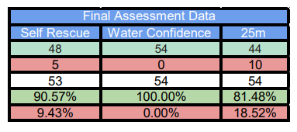
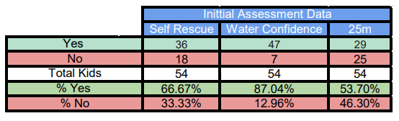
Children took part in an intensive three-week course of swimming in which children received lessons in small groups within school. Details of data can be seen below.

Action Plan
Next Steps: we are striving to continue to improve our swimming data to ensure as many children as possible are achieving curriculum expectations by the conclusion of KS2. In order to secure this, we have developed an action plan as set out below.
Improving Swimming Data – Action Plan
Objective | Tasks | Success Criteria | Time Frame | Resources/Cost
To maintain the number of children leaving Year 6 having achieved National Curriculum objectives. | Use Sports Premium Grant to part fund swimming provision and allow more time for more targeted intervention. To continue with Autumn term swimming provision for a 3-week period. Year 6 children to be grouped accordingly and receive additional extra swimming classes. | Maintain over 80% of children leaving in Year 6 reach curriculum expectations when it comes to swimming. | Current Year 6 cohort met this target this academic year with 81% meeting curriculum expectation. This needs to be maintained so we are providing extra sessions to close the gap. We will continue with a 3-week course. | Rental of Elite Swimming Pop Up Pool complete with swimming teacher and life guard.  £3800 for swimming.  This requires no transport.

