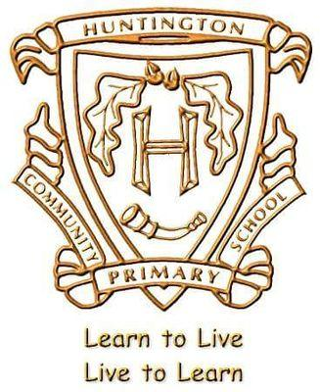


Year 3 Summer Term Curriculum Letter
Dear Parents,

Welcome back to your final term in Year 3! We hope you all had a lovely Easter break J

Over the next term we will be covering the following topics:

English: We are looking forward to focusing on two fantastic texts with the children this term. For the first half term we will be exploring ‘Journey’ by Aaron Becker. This is a wordless picture book full of magic and adventure that we will use as inspiration for some wonderful descriptive writing. For the second half term, we will be reading ‘Zeraffa Giraffa’ which is an astonishing true story about a Giraffe who was sent, as a gift, to France in 1826. We will be using this text to help develop our narrative writing and to create informative leaflets for tourists visiting Paris. Alongside this, we have weekly 'Pathways to Read' lessons where we will be looking at features of non-fiction in Usborne's ‘Illustrated Atlas of Britain & Ireland’ and spotting similarities from the classic tale in ‘Egyptian Cinderella’ by Shirley Climo. These whole class reading sessions are designed to really expand the children's reading skills and develop their comprehension and understanding of the texts they encounter.

Maths: For the beginning of this term, the children will continue developing their understanding of ‘mass and capacity’. The children will measure, compare, add and subtract mass (kg and g) and capacity (l and ml). We will then move on to think about ‘time’. The children will be learning how to: tell and write the time from an analogue clock, including Roman numerals (I to XII); how to tell the time using a 12-hour clock and also begin to use the 24- hour clock; estimate and read time to the nearest minute. Later in the term, we will be looking at ‘property of shapes’ during which the children will identify right angles, whether angles are greater than or less than a right angle and identify horizontal, vertical, perpendicular and parallel lines. Throughout the term the children will continually work on their times table - please continue to practice the 3-, 4- and 8-times tables at home with your child.

Science: Our topic for the Summer term will be Plants. Children will explore what plants need and will compare and describe plant materials. They will then investigate the parts of a plant, including the life-cycle of a plant and the reproductive parts of a flower.

History and Geography: For our History topic this term the children will be learning about ‘Ancient Egypt.’ The children will spend time learning about life in Ancient Egypt, Mummies, Egyptian Gods, Hieroglyphics, Tutankhamen and the River Nile. In Geography, we will be learning about rivers and how they change from source to mouth.

Computing: This term in Computing the children will be creating media, focusing on desktop publishing and will be applying their programming knowledge.

Art and DT: This term Art and DT link with our History to[pic. The children will be creating Egyptian inspired clay pots.

P.E
Day | Year 3 Birch | Year 3 Hazel
Monday | Athletics/Dodgeball | Dance/Outdoor Adventurous Activities
Tuesday | Dance/Outdoor Adventurous Activities
Friday |  | Athletics/Dodgeball

R.E: In RE this half term, we will focus on ‘What is humanism?’ and ‘How do Hindus worship?’

French: In French this term, the children will be learning about Seasons, days of the week and months of the year.

PSHE: We will be using the Jigsaw scheme to explore three units this term: ‘Healthy Me’, ‘Relationships’ and ‘Changing Me’.

Music: Sing Up - In Music this term we will use games to explore elements of music (pulse, rhythm, pitch etc.), sing, compose, improvise and play instruments. The children will also listen and appraise other genres of music

Homework: Children will receive Maths, English and/or Topic homework on a Friday via Google Classrooms. This is due in the following Wednesday. Spellings will be sent home every Friday and children will be tested the following Friday.

If you have any questions or queries, please email the class email address.

Many thanks for your continued support,
Mrs Caldecott, Miss Hickman and Mrs Tranter

