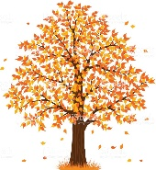

**Year Four Autumn Term 2025**

Welcome back to a new school year. We hope that you have had a wonderful summer break! We are really looking forward to the year ahead. If you haven’t already, please have a look at our class page on the school website. Year Four Hawthorn – your teacher will be Mrs Bunning-Williams. Year Four Lime - your teachers will be Mrs Nicholson (Tuesday and Wednesday) and Mrs Osholaja (Monday, Thursday and Friday).

**English**

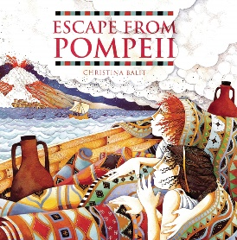In Year 4, children will develop their ability to write in a range of styles, from letters and arguments to recounts and stories. We will continue to build grammar, spelling, and punctuation skills, while encouraging reading and writing across the curriculum.

This term, our main texts will be *Leon and the Place Between* by Angela McAllister and *Escape from Pompeii* by Christina Balit, which will inspire creative and cross-curricular writing.

**Reading**

Reading skills will be taught through a whole class approach, where we will focus on a text linked to our writing. During the second half term, the reading focus will be a non-fiction text based on volcanoes.

**Maths**

In our daily Maths lessons, we follow the White Rose Maths scheme, covering key areas such as place value, addition and subtraction, multiplication and division and measurement. A strong focus is placed on developing mental arithmetic skills and secure recall of times tables, which are essential for all areas of Maths and for the Year 4 Multiplication Check. To support this, we use Times Table Rock Stars both in school and at home.

We also encourage children to explain their reasoning and apply Maths to real-life situations. Simple questions such as “How much change will I get?” or “How long until dinner?” are excellent ways to practise these skills at home.

**Science**

During the first half term, we will be covering electricity and have fun creating electrical circuits. We will then be exploring sound and how it is made.

**French**

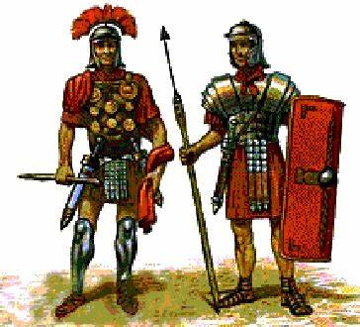This year, we will be using the Practical Learning Network’s scheme for French. In the Autumn term, we will be covering the topics ‘Welcome to School’, and ‘My Town, Your Town’.

**History**

During the Autumn term, we will be immersing ourselves in historical enquiry, specifically based around the Romans and their time in Chester. This topic allows plenty of scope for historical research of Roman life by focussing on when and why the Romans invaded, the reception they faced from native Britons and their cultural influence.

**PSHE (Personal, Social, Health and Economic Education)**

For PSHE, we use the Jigsaw scheme, which takes a mindful approach to personal, social and health education. This term, our focus will be on the units *Being Me in My World* and *Celebrating Difference*. Alongside this, we also use *My Happy Mind* to help children develop positive mental wellbeing, resilience, and confidence.

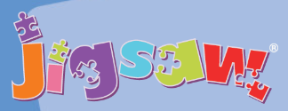

**Computing**

In computing sessions this term, children will be learning all about computing systems and networks, creating media (specifically audio editing) alongside E-safety.

**Music**

In Year Four, children receive music sessions delivered by the organisation ‘Music for Life’. This term’s instrument will be samba. Towards the end of the term, the children will share their skills by performing in a concert for parents.

**Art and DT**

During the Autumn term, our main focus in art will be texture work through mosaic and drawing. We will be using our scheme ‘The Art Tree’.

**Homework**

Children will be expected to read at home; this must then be recorded in their reading records. Children will also receive Maths and English homework once per week- this will be set via our online learning platform and will be returned in the same way. Times Table Rock Stars should also be completed at home. The log in details for this will be recorded in the children’s reading records.

**Homework will be set on a Friday and is due in by Wednesday.**

Spellings are linked to our comprehensive and progressive spelling programme and the Year 3/4 common exception words. These will be put onto Google Classroom at the beginning of each term.

**Reading**

Children in Year Four will be benchmarked to assess their current level of reading and will bring a book home to read. Every child also has a reading record in which responses are to be recorded (these can accompany the books to and from school). Please do discuss books and reading choices with your child and continue to listen to them reading aloud when possible; this enables them to read at a pace to allow spellings and grammatical structures to be absorbed more readily.

**P.E.**

P.E. is timetabled twice per week (Tuesday and Friday for Lime and Tuesday and Thursday for Hawthorn). Pupils should come to school wearing their kit (dark shorts/tracksuit bottoms and white t-shirt) with their school jumper/cardigan.

**Uniform**

Please make sure that all clothing is marked with your child’s name. We would ask parents to support us by ensuring that your son/daughter comes to school wearing the correct uniform. Black footwear should be worn, with Velcro fastening unless pupils are able to tie their own laces or buckle their shoes. 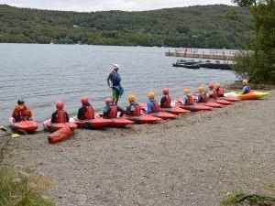Please ensure that if your child has their ears pierced that these are taken out on P.E. days. In addition, we do ask that if your child has long hair that they tie it back for school.

**Water Bottles**

It is very important that children keep hydrated. It would be much appreciated if you send your child in with a clearly labelled container/ bottle which we can use in school. Their water bottle should only contain water.

If you have any questions or queries, please don’t hesitate to contact us.

Best Wishes,

Mrs Nicholson, Mrs Osholaja and Mrs Bunning-Williams (known as Mrs Bunning in school).