Todwick Primary School – Calculations Policy (Multiplication) Nov 21
Year Group | Foundation | Rapid Recall | Mental Calculation | Objective | Method | Practical Methods | Pictoral / Written methods | Vocabulary
EYFS |  | Chanting and counting in 2’s 5s and 10’s for children exceeding the early learning goals. |  | Repeated grouping  Counting in pairs  Doubling | Practical/ recorded using ICT (e.g. digital photos/pictures on IWB) | Toys, beads, Rhymes, counters, objects, number lines, Numicon, stories, role play, number lines – hopping on, counting pairs.  | Drawing problems  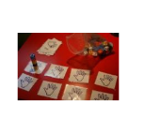  Begin to record using marks they can explain   | Chanting  Counting in 2s.
Y1 | Count in 2’s  Countin in 10’s  Double up to 10  Count in 5’s  Double multiples of 10  Count in 2’s 5’s and 10’s | Consolidation of EYFS for children who were exceeding.  Chanting of counting in 2’s 5’s and 10’s  Double pairs to 10 then 20 |  | Consolidation of EYFS  Begin to understand multiplication through grouping small quantities.  Solve one-step problems involving multiplication  Make connections between arrays and number patterns.  Double numbers and quantities.  Count in multiples of twos , fives and tens | Practical / recorded using ICT  Informal written methods  Horizontal recording | 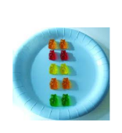    Long number lines, 100 square, counting sticks, Dienes, tape measure, coins, cubes, bead strings, peg boards, numicon. | Pictures to represent working out.  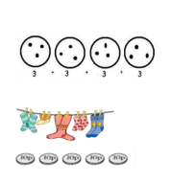  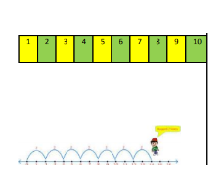  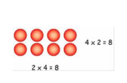  Using arrays with teacher support. | Chanting/ counting in 2’s.
Y2 | 2x table  10 x table  Doubles up to 20 and multiples of 5  5 x table  Count in 3’s  2x, 5x and 10 x tables | Count in 2’s 5’s and 10s  Derive multiples of 2, 5 and 10  Relate to x facts (and derive related facts)  Understand that halving is the inverse of doubling and derive and recall doubles of all numbers to 20, and the corresponding halves. | Doubles of two numbers | Consolidation of Y1  Count in steps of 2 and 5 from 0, and in 10s from any number, forwards and backwards.  Recall and use multiplication facts for the 2,5 and 10 multiplication tables, including recognising odd and even numbers.  Calculate mathematical statements for multiplications within the multiplication tables and write them using the multiplication (x) and equals (=) signs  Show that multiplication of two numbers can be done in any order (commutativity)  Solve problems invling multiplication using materials, arrays, repeated addition, mental methods, and multiplication facts, including problems in contexts.  Connect the 10 x multiplication table to place value.  Relate multiplication to grouping discrete and continuous quantities, to arrays and to repeated attion.  Use commutativity and inverse relations to develop mulplicative reasoning ( for example, 4 x 5 = 20 and 20 divided by 5 = 4) | Practical  Informal written methods  Horizontal recording | Counting sticks, bead strings, number lines, 100 squares, deines, objects in groups and arrays.  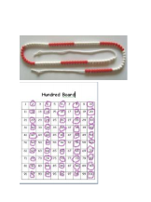  Counting on  Arranging objects in array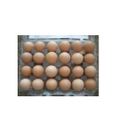 | Arrays  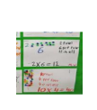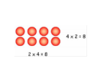  Repeated addition  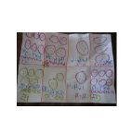  Horizontal recording as repeat addition and using x and =  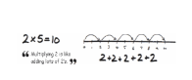  Multiplying by 10 using place value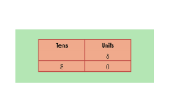 | Chanting/ counting in2s  Count on in… lots of , groups of.  Pattern,  Odd, even, every other, how many times, multiple,of, sequence, times, multiply, multiplied by, multiple of once, twice, three times, four times, five times… ten times… as (big, long, wide etc) , repeated addition, array, row, column, double.
Y3 | Review 2x, 5x, and 10x tables  4x tables  Double 2 digit numbers.  8x tables.  3x table.  6x table or review others. | Derive and recall 2,3,4,5,8 and 10 times tables  (derive related division facts. Also count in multiples of above.  Recognise multiples of 2,5 and 10 up to 1000  Use knowledge of number operations and corresponding inverses, including doubling and halving, to estimate and check calculations. | O/TO - x 10/100  (describe the effect)  Doubles of TO/HTO numbers | Consolidation of Y2  Count from 0 in multiples of 3, 4, 50 and 100  Connect the 2,4 and 8 multiplication tables through doubling.  Recall and use multiplication and division facts for the 3,4 and 8 multiplication tables.  Mlultiply TO x O using mental methods and progressing to formal written methods.  Solve problems, including missing number problems, involving multiplication including positive integer scaling problems and correspondence problems in which n objects are connected to m objects.  Pupils develop efficient mental methods, for example, using commutativity ( for example , 4 x 12 x 5 = 4 x 5 x 12 =20 x 12 = 240 and multiplication facts to derive related facts ( for example, 3 x 2 = 6, 30 x 2 = 60). | Practical  Informal written methods  Horizontal recording  Formal written methods | Counting sticks, deines, number lines, hundred squares, tape measures  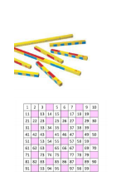  Grid method using concrete materials:  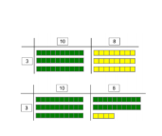 | Partitioning  32 x 6 =  Introduce formal written method expanded form:  3 6  X 5  3 0  1 5 0  1 8 0 | Chanting/ counting in2s  Count on in… lots of , groups of.  Pattern,  Odd, even, every other, how many times, multiple,of, sequence, times, multiply, multiplied by, multiple of once, twice, three times, four times, five times… ten times… as (big, long, wide etc) , repeated addition, array, row, column, double.  Count on in hundreds, multiplication, product
Y4 | 4x , 8x tables  10 times bigger  3x , 6x and 12 x tables.  Double larger numbers and decimals.  3x and 9x tables.  11x and 7x tables. | Derive and recall facts to 12 x 12  Count in multiples of 6,7,9,25 and 1000  Recognise and use factor pairs and commutativity in mental calculations | Multiply numbers up to 1000 by 10/100 (whole number answers and understand the effect)  Doubles of TO and HTO numbers and multiples of 10 and 100 | Consolidation of Y3  Count in multiples of 6,7,9,11, 12, 25 and 1000  Recall facts for multiplication tables up to 12 x 12  Use place value, known and derived facts to multiply mentally, including: multiplying by 0 and 1  multiplying together 3 numbers  Recognise and use factor pairs and commutativity in mental calculations.  Multiply TO x O using formal written layout  Solve problems involving multiplying and adding, including using the distributive law to multiply two digit numbers by one digit, integer scaling problems and harder correspondence problems such as n objects are connected to m objects. | Practical  Informal written methods  Formal written method | Deines, place value counters, coins. 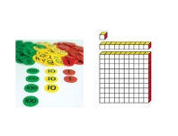 | Formal written method (compact form)  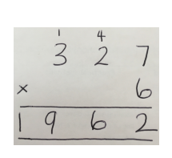 | Chanting/ counting in2s  Count on in… lots of , groups of.  Pattern,  Odd, even, every other, how many times, multiple,of, sequence, times, multiply, multiplied by, multiple of once, twice, three times, four times, five times… ten times… as (big, long, wide etc) , repeated addition, array, row, column, double.  Count on in hundreds, multiplication, product  Factor, Exchange
Y5 | 4x , 8x tables  10, 100, 1000 times bigger  3x,6x and 12 x tables.  10,100,1000 times smaller  Double larger numbers and decimals.  3x and 9x tables.  11x and 7x tables.  Partition to multiply mentally. | Recall quickly facts to 12 x 12  Use facts to multiply pairs of multiples of 10/100  Use known facts to derive other facts e.g. 300 x 6 = 1800  Also, find common multiples of two numbers | TO xO (eg 12 x 9)  TO x TO (eg 12 x 25)  Doubles of 0.t / 0.th  Multiply whole numbers and decimals by 10/100/1000 | Consolidation of Y4  Identify multiples and factors, including finding all factor pairs of a number and common factors of two numbers.  Know and use the vocabulary of prime numbers, prime factors and composite (non-prime) numbers.  Establish whether a number up to 100 is prime and recall prime numbers up to 19  ThHTO x O using a formal written method  ThHTO x TO  Using a formal written method including long multiplication for two digit numbers.  Multiply numbers mentally drawing on known number facts  Multiply whole numbers and those involving decimals by 10,100 and 1000  Recognise and use square numbers and cube numbers, and the notation for squared (2) and cubed (3)  Solve problems involving multiplication including using their knowledge of factors and multiples, squares and cubes.  Solve problem involving multiplication. | Practical  Informal written methods  Formal written methods | Deines, place value counters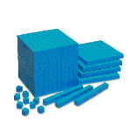 | Written method:  Moving to a more formal method:  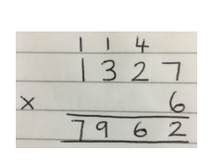  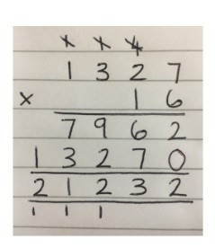 | Chanting/ counting in2s  Count on in… lots of , groups of.  Pattern,  Odd, even, every other, how many times, multiple of, sequence, times, multiply, multiplied by, multiple of once, twice, three times, four times, five times… ten times… as (big, long, wide etc) , repeated addition, array, row, column, double.  Count on in hundreds, multiplication, product  Factor, Exchange  Factor, prime , prime factor
Y6 | Multiplication facts up to 12 x 12  Partition to multiply mentally  Double larger numbers and decimals | Use facts up to 10 x 10 to derive facts involving multiples of 10/100 (e.g. 80 x30) and decimals (e.g. 0.7 x 8)  Derive squares of numbers to 12 x 12  Derive corresponding squares of multiples of 10. | TO x O  O.t x O  Integer x 1000/100/10  /O.1/0.01 | Consolidation of y5  ThHTO x TO using the formal written method of long multiplication  Multiply one digit numbers with up to two decimal places by whole numbers.  Identify common factors, common multiples and prime numbers.  Explore the order fo operations using brackets: for example 2+ 1 x3 = 5 and (2 + 1) x 3 = 9  Use common factors to find equivalent fractions  Multiply simple pairs of proper fractions, writing the answer to its simplest form.  (1/2 x 2/4 = 2/8 = 1/4) | Practical  Informal written methods  Formal written methods | Deines and place value counters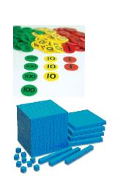 | As above (including multiplying decimals by whole numbers e.g. 4.92 x 3)  Equivalent fractions:  Multiplying fractions | Chanting/ counting in2s  Count on in… lots of , groups of.  Pattern,  Odd, even, every other, how many times, multiple,of, sequence, times, multiply, multiplied by, multiple of once, twice, three times, four times, five times… ten times… as (big, long, wide etc) , repeated addition, array, row, column, double.  Count on in hundreds, multiplication, product  Factor, Exchange  Common denominator

