Progression in Calculations
Our calculation policy recognises the importance of children learning through interacting with concrete apparatus. These are also sometimes referred to as manipulatives. Once a child has used an object to help them in their understanding, they are introduced to the same concept with a pictorial representation. The final stage in their understanding is when they complete a calculation at an abstract point. Although a child may be able to show that they can complete calculations at an abstract level, it is their UNDERSTANDING of what is happening that is MOST IMPORTANT so they can go on to reason their way through a problem and complete puzzles.

Please feel free to use this policy to help support your child’s learning at home. The methods used in this policy match the methods we use to teach our children at Todwick Primary.

Addition
Objective and Strategies | Concrete | Pictorial | Abstract
Combining two parts to make a whole: part- whole model | Use cubes to add two numbers together as a group or in a bar.  8  1 | 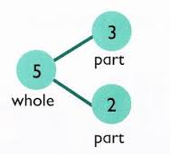    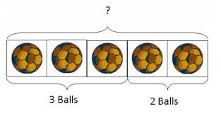  Use pictures to add two numbers together as a group or in a bar. | 4 + 3 = 7  10= 6 + 4  5  3  Use the part-part whole diagram as shown above to move into the abstract.
Starting at the bigger number and counting on | 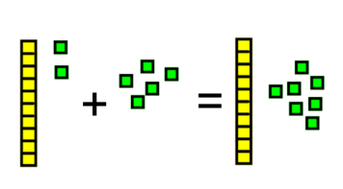  Start with the larger number- create with base 10 and then count on to the smaller number 1 by 1 to find the answer. | 12 + 5 = 17  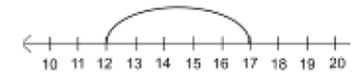  Start at the larger number on the number line and count on in ones or in one jump to find the answer. | 5 + 12 = 17  Place the larger number in your head and count on the smaller number to find your answer even if the smaller number appears first in the calculation.
Re grouping numbers. | Represent the two values with base 10. The 11 ones (green) have been exchanged in the answer for a rod of 10 and one single.  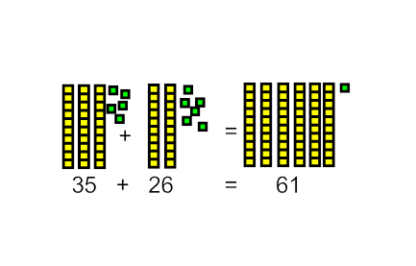  This progresses to the value of the deines being represented as place value counters. | Show the same set up of apparatus as a diagram similar to in the previous column. Make your pictures clear so that both ones and rods of ten can be clearly identified | 35 + 26 =61
Regrouping to make 10. | 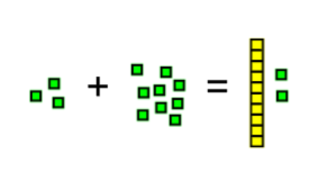  3 + 9 =  Base 10. 3 + 9 = children see that they can group 10 and so replace 10 ones with a rod of ten, leaving two ones.  6 + 5 = 11  Start with the bigger number and use the smaller number to make 10. | Use pictures or a number line. Regroup or partition the smaller number to make 10.  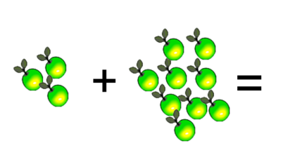  3 + 9 = | 7 + 4= 11  If I am at seven, how many more do I need to make 10. How many more do I add on now?  If I have nine apples and buy three more
Adding three single digits | 4 + 7 + 6= 17  Put 4 and 6 together to make 10. Add on 7.  Following on from making 10, make 10 with 2 of the digits (if possible) then add on the third digit.  Add together three groups of objects. Draw a picture to recombine the groups to make 10. |         +  +  + | Combine the two numbers that make 10 and then add on the remainder.
Column method- no regrouping | 24 + 15=  Add together the ones first then add the tens. Use the Base 10 blocks first before moving onto place value counters.  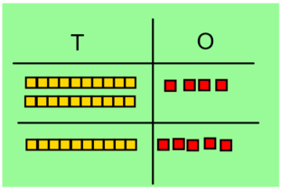  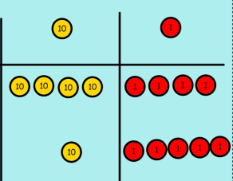 | After practically using the base 10 blocks and place value counters, children can draw the counters to help them to solve additions.  T O | 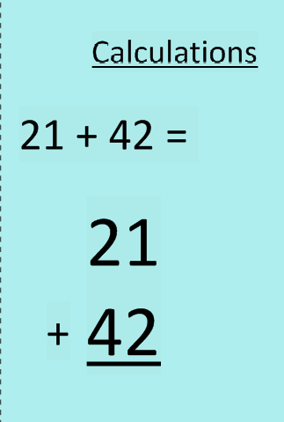
Column method- regrouping | Make both numbers on a place value grid.  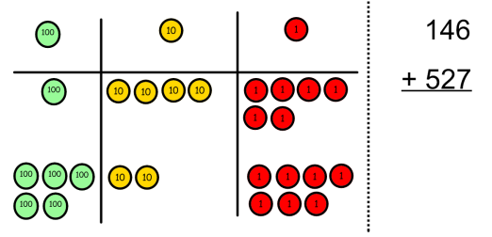  Add up the units and exchange 10 ones for one 10.  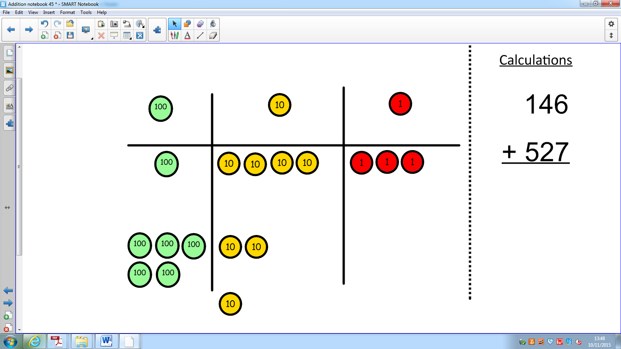  Add up the rest of the columns, exchanging the 10 counters from one column for the next place value column until every column has been added.  This can also be done with Base 10 to help children clearly see that 10 ones equal 1 ten and 10 tens equal 100.  As children move on to decimals, money and decimal place value counters can be used to support learning. | 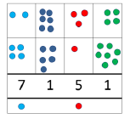  Children can draw a pictoral representation of the columns and place value counters to further support their learning and understanding. | Start by partitioning the numbers before moving on to clearly show the exchange below the addition.  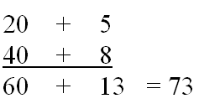  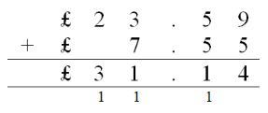  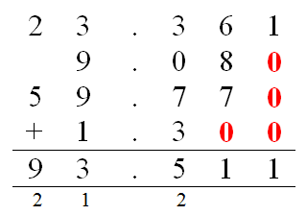  As the children move on, introduce decimals with the same number of decimal places and different. Money can be used here.

Subtraction
Objective and Strategies | Concrete | Pictorial | Abstract
Taking away ones | Use physical objects, counters, cubes etc to show how objects can be taken away.      6 – 2 = 4 | Cross out drawn objects to show what has been taken away. | 18 -3= 15  8 – 2 = 6
Counting back | 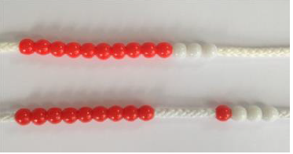  Make the larger number in your subtraction. Move the beads along your bead string as you count backwards in ones.  13 – 4  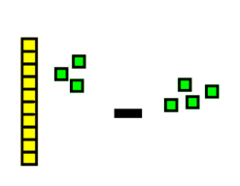  13 – 4 = Here children recognise the need to exchange a rod of 10 for 10 ones (green) to complete the subtraction.  Use counters and move them away from the group as you take them away counting backwards as you go.  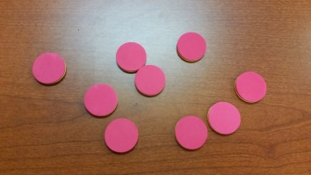 | Count back on a number line or number track  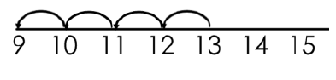  Start at the bigger number and count back the smaller number showing the jumps on the number line.  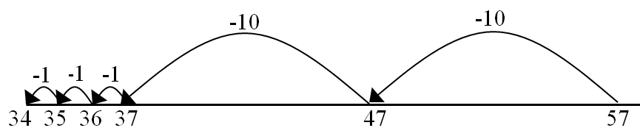  This can progress all the way to counting back using two 2 digit numbers. | Put 13 in your head, count back 4. What number are you at? Use your fingers to help.
Find the difference | Compare amounts and objects to find the difference.  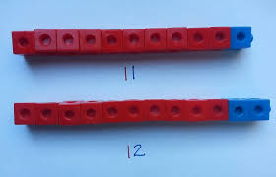  Use cubes to build towers or make bars to find the difference  Use basic bar models with items to find the difference | Count on to find the difference.  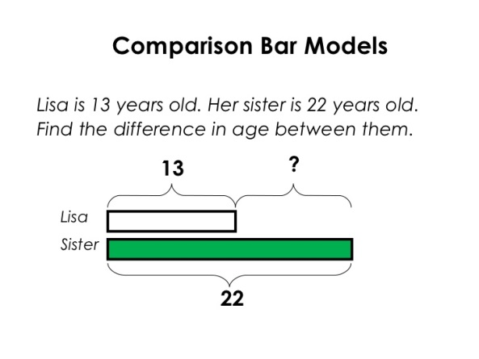  Draw bars to find  the difference between 2 numbers. | Hannah has 23 sandwiches, Helen has 15 sandwiches. Find the difference between the number of sandwiches.
Part Part Whole Model | Link to addition- use the part whole model to help explain the inverse between addition and subtraction.  If 10 is the whole and 6 is one of the parts. What is the other part?  10 - 6 = |     Use a pictorial representation of objects to show the part part whole model. | 10  5  Move to using numbers within the part whole model.
Make 10 | 14 – 9 =  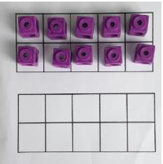  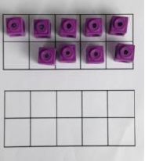  Make 14 on the ten frame. Take away the four first to make 10 and then takeaway one more so you have taken away 5. You are left with the answer of 9. | 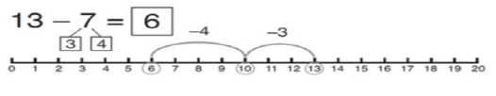  Start at 13. Take away 3 to reach 10. Then take away the remaining 4 so you have taken away 7 altogether. You have reached your answer. | 16 – 8=  How many do we take off to reach the next 10?  How many do we have left to take off?
Column method without regrouping | Use Base 10 to make the bigger number then take the smaller number away.  Show how you partition numbers to subtract. Again make the larger number first. | 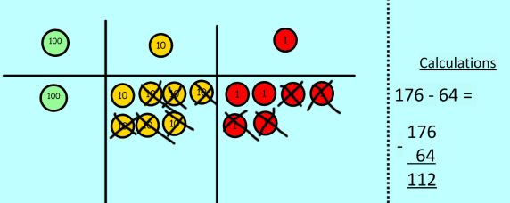  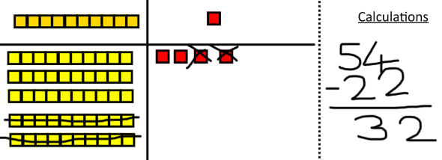  Draw the Base 10 or place value counters alongside the written calculation to help to show working. | 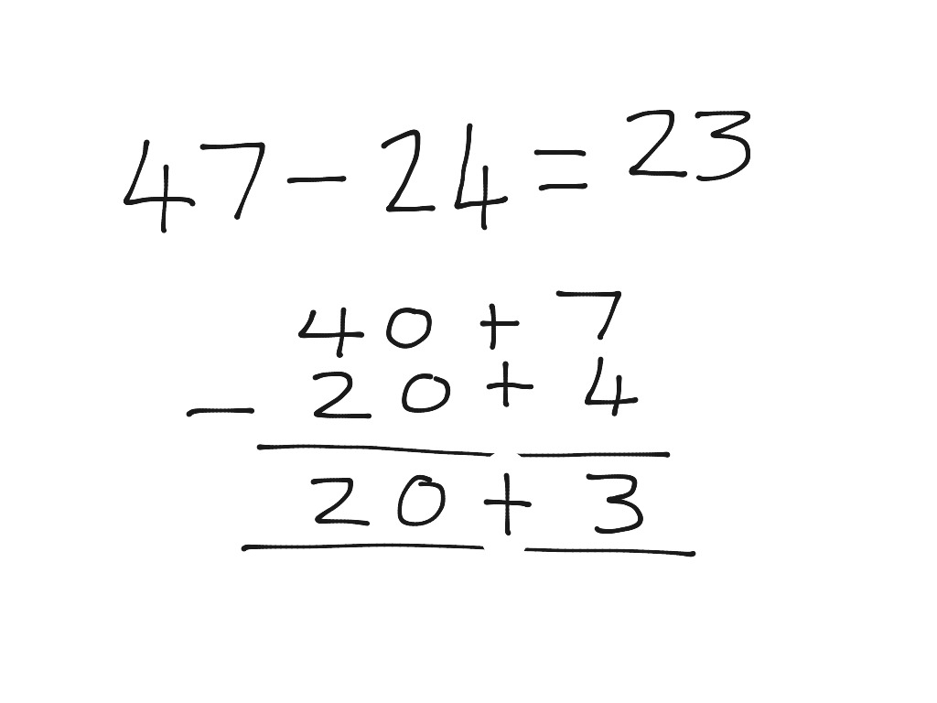  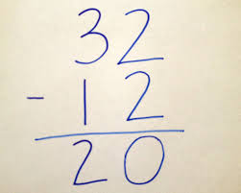  This will lead to a clear written column subtraction.
Column method with regrouping | Use Base 10 to start with before moving on to place value counters. Start with one exchange before moving onto subtractions with 2 exchanges.  Make the larger number with the place value counters  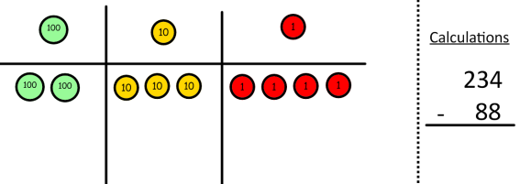  Start with the ones, can I take away 8 from 4 easily? I need to exchange one of my tens for ten ones.  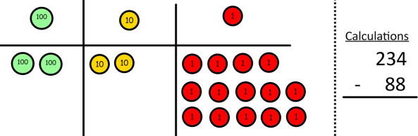  Now I can subtract my ones.  Now look at the tens, can I take away 8 tens easily? I need to exchange one hundred for ten tens.  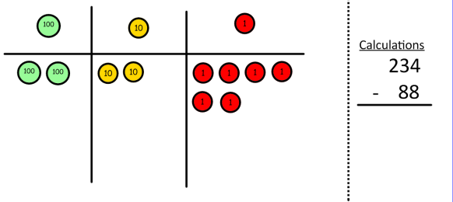  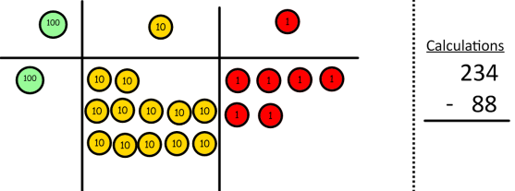  Now I can take away eight tens and complete my subtraction  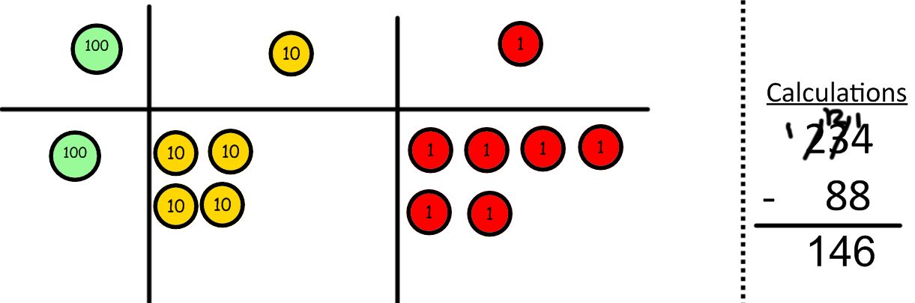  Show children how the concrete method links to the written method alongside your working. Cross out the numbers when exchanging and show where we write our new amount. | 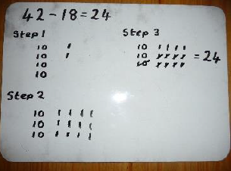  Draw the counters onto a place value grid and show what you have taken away by crossing the counters out as well as clearly showing the exchanges you make.  When confident, children can find their own way to record the exchange/regrouping.  Just writing the numbers as shown here shows that the child understands the method and knows when to exchange/regroup. | Children can start their formal written method by partitioning the number into clear place value columns.  Moving forward the children use a more compact method.  This will lead to an understanding of subtracting any number including decimals.

Multiplication
Objective and Strategies | Concrete | Pictorial | Abstract
Doubling | 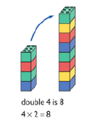  Use practical activities to show how to double a number. | Draw pictures to show how to double a number. | 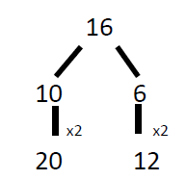  Partition a number and then double each part before recombining it back together.
Counting in multiples | 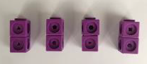  Count in multiples supported by concrete objects in equal groups. | Use a number line or pictures to continue support in counting in multiples. | Count in multiples of a number aloud.  Write sequences with multiples of numbers.  2, 4, 6, 8, 10  5, 10, 15, 20, 25 , 30
Repeated addition |   Use different objects to add equal groups. |  | Write addition sentences to describe objects and pictures.
Arrays- showing commutative multiplication | 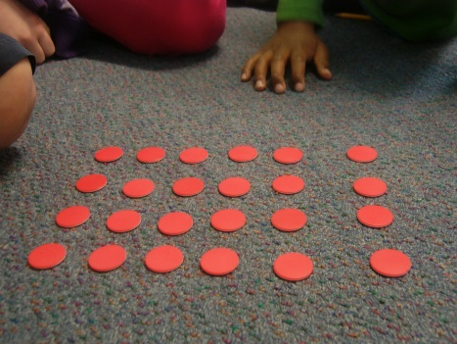  Create arrays using counters/ cubes to show multiplication sentences. | Draw arrays in different rotations to find commutative multiplication sentences.  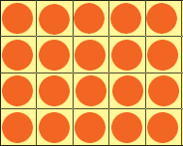  Link arrays to area of rectangles. | Use an array to write multiplication sentences and reinforce repeated addition.  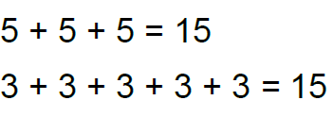  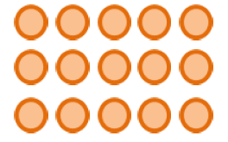
Grid Method | Show the link with arrays to first introduce the grid method.  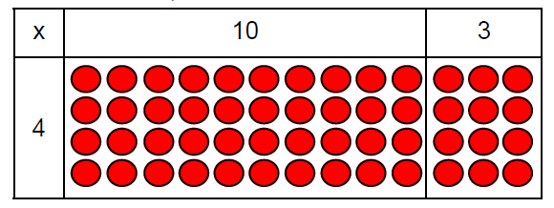  4 rows of 10  4 rows of 3  Move on to using Base 10 to move towards a more compact method.  4 rows of 13  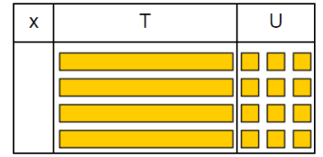  Move on to place value counters to show how we are finding groups of a number.We are multiplying by 4 so we need 4 rows.  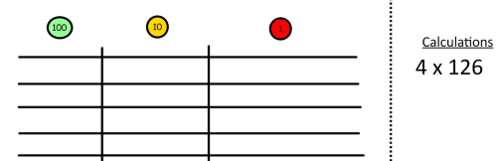  Fill each row with 126.  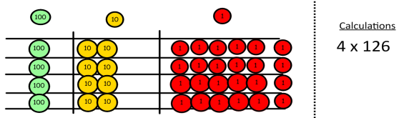  Add up each column, starting with the ones making any exchanges needed.  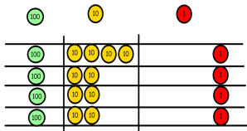  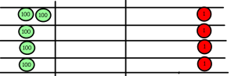  Then you have your answer. | Children can represent the work they have done with place value counters in a way that they understand.  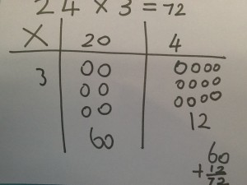  They can draw the counters, using colours to show different amounts or just use circles in the different columns to show their thinking as shown below. | Start with multiplying by one digit numbers and showing the clear addition alongside the grid.  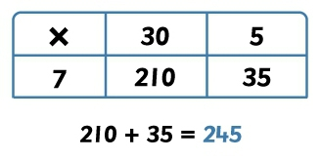  Moving forward, multiply by a 2 digit number showing the different rows within the grid method.  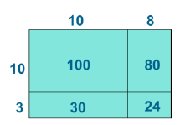  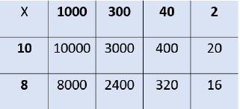
Column multiplication | 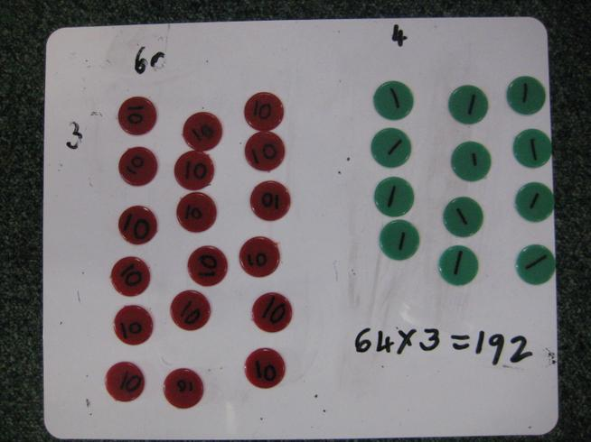  Children can continue to be supported by place value counters at the stage of multiplication.  It is important at this stage that they always multiply the ones first and note down their answer followed by the tens which they note below. | Bar modelling and number lines can support learners when solving problems with multiplication alongside the formal written methods.  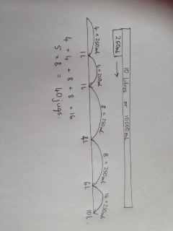  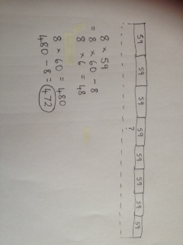 | Start with long multiplication, reminding the children about lining up their numbers clearly in columns.  If it helps, children can write out what they are solving next to their answer.  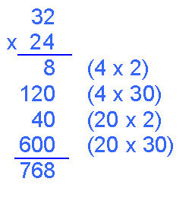  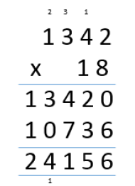  This moves to the more compact method.  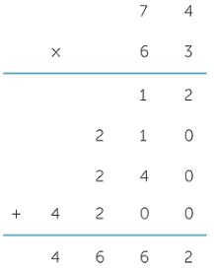
Division
Objective and Strategies | Concrete | Pictorial | Abstract
Sharing objects into groups | 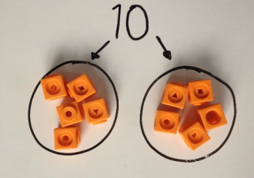  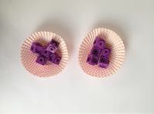  I have 10 cubes, can you share them equally in 2 groups? | Children use pictures or shapes to share quantities.    8 ÷ 2 = 4 | Share 9 buns between three people.  9 ÷ 3 = 3
Division as grouping | Divide quantities into equal groups.  Use cubes, counters, objects or place value counters to aid understanding.  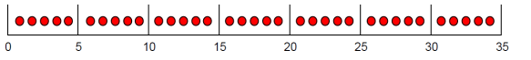 | Use a number line to show jumps in groups. The number of jumps equals the number of groups.  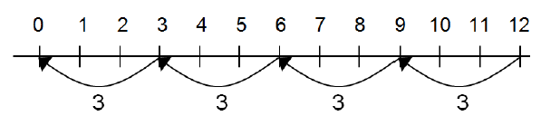  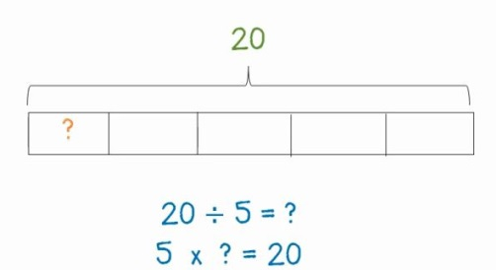  Think of the bar as a whole. Split it into the number of groups you are dividing by and work out how many would be within each group. | 28 ÷ 7 = 4  Divide 28 into 7 groups. How many are in each group?
Division within arrays | 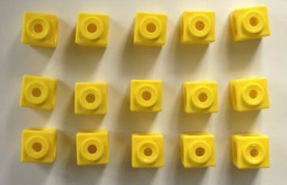  Link division to multiplication by creating an array and thinking about the number sentences that can be created.  Eg 15 ÷ 3 = 5 5 x 3 = 15  15 ÷ 5 = 3 3 x 5 = 15 | 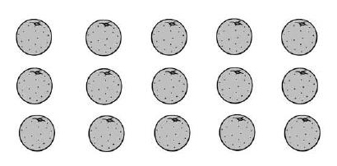  Draw an array and use lines to split the array into groups to make multiplication and division sentences. | Find the inverse of multiplication and division sentences by creating four linking number sentences.  7 x 4 = 28  4 x 7 = 28  28 ÷ 7 = 4  28 ÷ 4 = 7
Division with a remainder | 14 ÷ 3 =  Divide objects between groups and see how much is left over  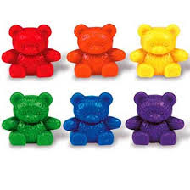 | Jump forward in equal jumps on a number line then see how many more you need to jump to find a remainder.  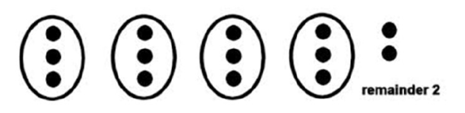  Draw dots and group them to divide an amount and clearly show a remainder. | Complete written divisions and show the remainder using r.  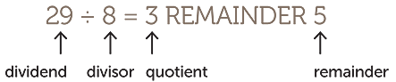
Short division | 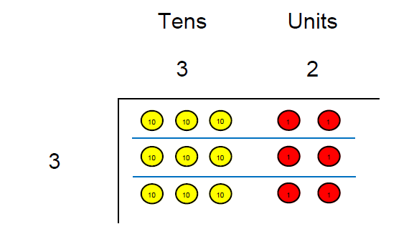  Use place value counters to divide using the bus stop method alongside  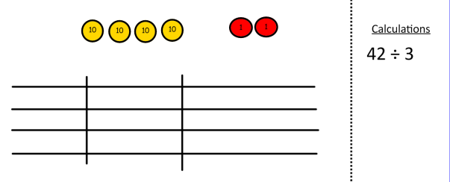  42 ÷ 3=  Start with the biggest place value, we are sharing 40 into three groups. We can put 1 ten in each group and we have 1 ten left over.  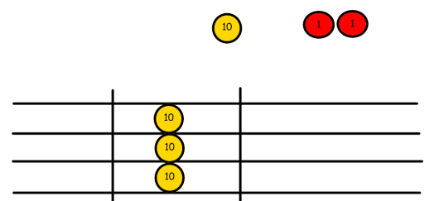  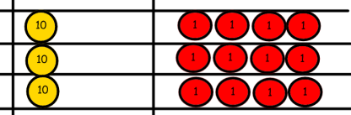  We exchange this ten for ten ones and then share the ones equally among the groups.  We look how much in 1 group so the answer is 14. | 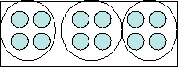  Students can continue to use drawn diagrams with dots or circles to help them divide numbers into equal groups.  Encourage them to move towards counting in multiples to divide more efficiently. | Begin with divisions that divide equally with no remainder.  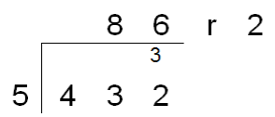  Move onto divisions with a remainder.  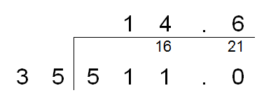  Finally move into decimal places to divide the total accurately.

