
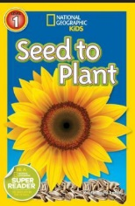
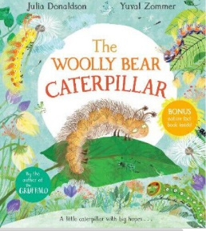
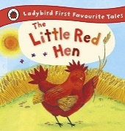
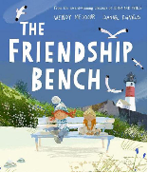
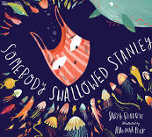

Reception Curriculum
2024-2025
Sandbach Primary Academy
Planning a sequenced curriculum to ensure all children make progress and are ready for the next stage of their education.
© EY2P Early Years 2 Primary LLP www.ey2p.org Draft: September 2023

Planning a sequenced curriculum to ensure all children make progress and are ready for the next stage of their education.
EYFS: Reception Sequenced Curriculum
New EYFS Framework
Age Related Expectations * Teaching and learning to be differentiated through short term planning, driven by assessment
Consolidation and revisit of key skills, knowledge and understanding through continuous and enhanced provision
Area of Learning | Autumn 1 |  | Autumn 2 | Spring 1 | Spring 2 | Summer 1 | Summer 2
EYFS Theme | All About Me |  | Changes | Animals Who Live in Cold & Warm Places | Growing | Lifecycles  / Mini-Beasts | Journeys
Planning around a quality text: | 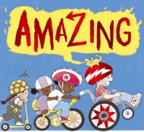 |  | 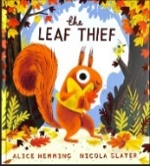 | 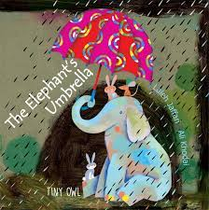 | 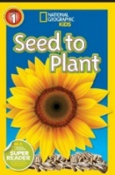  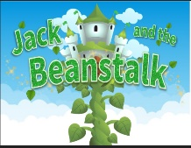 | 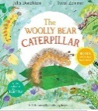  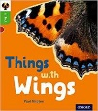 | 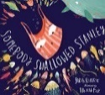  
Linked texts  Fiction  Non-fiction  Traditional tales  Diversity | □ Different Families □ All About Me – Look and Learn □ Smelly Louie – Catherine Rayner □ The Colour Monster □ The Elves and the Shoemaker □ You Must Bring a Hat □ Christianity – Info Buzz |  | □ Chick to Hen – Elspeth Graham □ What Can You See in Autumn – Sian Smith □ Owls in the Night – Catherine Baker □ Percy the Park Keeper _ After the Storm □ Judaism – Buzz info □ The Nativity | □ The Storm Whale in Winter – Benji Davies □ The Little Raindrop – Joanna Gray □ Hey, Water by Antoinette Portis □ What Can You See in Winter – Sian Smith □ Melting and Freezing □ Chinese New Year – Saviour PIrotta □ Myra Plays Holi by Sheena Garg and Shruti Bhave | □ Jasper’s Beanstalk  □ The Enormous Turnip □ Supertato □ The Extraordinary Gardner □ Plants – National Geographic □ The journey of a sunflower □ Hinduism by Buzz Info | □ Caterpillar to Butterfly – National Geographic □ Nests by Elspeth Graham □ Christopher’s Caterpillars by Charlotte Middleton □ Islam by Buzz Info | □ Somebody Crunched Colin □ Ten Things I Can Do to Help My World □ New from Old, Recycling Plastic □ The Queen’s Handbag □ Paddington Postcards from Around the Globe
Linked rhymes / songs | - This is the way we brush our teeth / hair …  - Happy Birthday (possibly in different language to represent cohort_  - I Look in the Mirror  - Finger Family Song  - Families are all Different |  | - Who Shall Help the Little Red Hen  - It is Autumn  - Five Little Leaves  - The Little Pumpkins  - Christmas songs | - The Little Penguins  - Winter Animals  - Snowball  - Waiting for Snow  - The Jungle Song  - The Animal Fair  - Chinese New Year | - Farmer Plants the Seeds  - Grow a Plant Song | - Butterfly Cycle  - There is a Tiny Caterpillar  - Ten / Twenty Little Butterflies  - Out of the Ark Minibeast song | - The Transportation Song  - Many Ways to Travel  - The Wheels on the Bus  - The Train Ride
Occupations | - School staff  - Photographer  - News Reporter |  | - Farmer  - School cook  - Shop keeper  - Baker  - School caretaker  - Park Keeper | - Fishermen  - Safari Keeper  - Vet | - Gardner  - Farmer | - Conservationist  - Bee Keeper  - Bird Keeper - Life as a Bird Keeper | A Day In The Life | Our Zoo Keepers | Chester Zoo | - Park Ranger  - Bus conductor  - Pilot  - Policeman / woman
Trips/Visitors  Enrichments | Visitor:  - Nurse / doctor / dentist  Trip:  - Visit to see the school’s friendship / Buddy Benches  - Walk around school grounds  - Weekly welly walk/forest school |  | Experience:  - Bread Making  Trip:  - Autumn walk – school grounds | Videos:  - Penguins / sea creatures  - Monterey Live Webcam  Trip:  - Winter walk – school grounds | Experience:  - Growing seeds  Trip:  - Walk to the local shop to buy some fruit and vegetables  - Visit to the library | Experience:  - Caterpillars  Trip:  - Visit to the farm | Video:  - Monterey Live webcam  Trip:  - Transition to Year One
Special Events | - Starting school  - Birthdays  - National Poetry Week  - Black History Month  - European Day of Languages  - International Day of Peace  - Recycle Week |  | - National Nursery Rhyme Week  - Guy Fawkes / Bonfire Night  - Advent/ Christmas Time/ Nativity  - Diwali  - Hannukah  - Remembrance day  - Road Safety  - World Space Week  - Children in Need  - Inter- Faith week | - World Religion Day  - Chinese New Year  - Shrove Tuesday  - LENT  - Children’s Mental Health Week  - Story Telling Week  - Random Acts of Kindness Week  - Internet Safety Day | - Easter  - Mother’s Day  - Science Week  - International Women’s Day  - World Book Day  - Ramadan and Eid  - Pentecost | Pride Month  - World Refugee Day / week  - RSE Day  - International Day of Friendship | - World Ocean’s Day  - World Music Day
Characteristics of Effective Learning …… to be embedded through all areas of learning … creating powerful learners and thinkers
Playing & Exploring |  | - Realise that their actions have an effect on the world, so they want to keep repeating them.  - Plan and think ahead about how they will explore or play with objects  - Guide their own thinking and actions by talking to themselves while playing  - Make independent choices  - Do things independently that they have been previously taught  - Bring their own interests and fascinations into early years settings. This helps them to develop their learning  - Respond to new experiences that you bring to their attention
Active Learning |  | - Participate in routines, such as going to their cot or mat when they want to sleep.  - Begin to predict sequences because they know routines  - Show goal-directed behaviour  - Begin to correct their mistakes themselves  - Keep on trying when things are difficult.
Thinking and Creating Critically |  | - Take part in simple pretend play  - Sort materials  - Review their progress as they try to achieve a goal. Check how well they are doing.  - Solve real problems  - Use pretend play to think beyond the ‘here and now’ and to understand another perspective  - Know more, so feel confident about coming up with their own ideas. Make more links between those ideas.  - Concentrate on achieving something that’s important to them. They are increasingly able to control their attention and ignore distractions.

COMMUNICATION & LANGUAGE: □ Listening, Attention & Understanding □ Speaking
Educational Programme: The development of children’s spoken language underpins all seven areas of learning and development. Children’s back-and-forth interactions from an early age form the foundations for language and cognitive development. The number and quality of the conversations they have with adults and peers throughout the day in a language-rich environment is crucial. By commenting on what children are interested in or doing, and echoing back what they say with new vocabulary added, practitioners will build children's language effectively. Reading frequently to children, and engaging them actively in stories, non-fiction, rhymes and poems, and then providing them with extensive opportunities to use and embed new words in a range of contexts, will give children the opportunity to thrive. Through conversation, story-telling and role play, where children share their ideas with support and modelling from their teacher, and sensitive questioning that invites them to elaborate, children become comfortable using a rich range of vocabulary and language structures.
Autumn | Spring | Summer
Learning Priorities: Linked to Development Matters 2021
Listening, Attention and Understanding  - Understand how to listen carefully and why listening is important:  □ one-to-one □ small groups □ whole class  - Listen carefully to rhymes and songs, familiar and new  □ pay attention to how they sound □ anticipate words / phrases  - Listen to stories and begin to be an active participant in Talk for Writing activities, join in with  □ short repeated refrains □ oral text retelling with beginning, middle and end  - Learn new vocabulary  Linked to: □ daily routine □ learning environment □ themes / focus text □ new experiences  - Understand a question or instruction that has two parts  Linked to: □ daily routines □ activities: adult-led / child-initiated  Speaking  - Use familiar and new vocabulary throughout the day within a range of contexts:  □ daily routine □ adult-led □ child-initiated learning  - Develop use of social phrases with correct pronouns  - Speak using full tenses with some correct use of tenses  - Begin to ask questions to find out more and develop understanding  □ Who? □ What? □ Why? □ When?  - Begin to articulate ideas and thoughts in well-formed sentences  □ one-to-one □ ‘talk’ partners □ small group  - Begin to connect one idea or action to another using a range of connectives… because, although, but...  - Begin to describe events in some detail, showing awareness of the listener  - Begin to retell a simple story using some story language | Listening, Attention and Understanding  - Listen carefully in a range of contexts, including  □ whole class inputs □ visitors into class □ events beyond the classroom – assembly / walk into the local community  - Listen carefully to rhymes, songs and poems  □ identify word patterns □ respond with relevant comments  - Begin to understand humour e.g., nonsense rhymes / jokes  - Listen to stories and be an active participate in Talk for Writing activities, join in with  □ longer repeated refrains □ oral text retelling with 4+ parts  - Listen to read-aloud of non-fiction books  - Learn new vocabulary  Linked to: □ whole school experiences □ themes / focus text □ new experiences □ visits beyond the local community  - Understand and follow a set of instructions independently  - Understand a range of questions and respond staying on topic  Speaking  - Use new vocabulary, linked to key themes and texts, in different contexts with increasing confidence  - Use a range of social phrases with developing confidence  - Speak using full sentence with increasing accuracy of tenses  - Answer and ask questions to develop understanding  □ Who? □ What? □ Why? □ When?  - Articulate ideas and thoughts in well-formed sentences  □ one-to-one □ ‘talk’ partners □ small group □ and begin to in whole class discussions  - Connect one idea or action to another using a range of connectives… because, although, but, also, first, next, after …  - Describe events in some detail, showing awareness of the listener  - Hold conversation when engaged in back-and-forth exchanges with teacher and peers  - Use talk to help work out problems, organise thinking & activities explain how things work/why things happen  - Retell a simple story using story language / own words | Listening, Attention and Understanding  - Listen attentively in a range of contexts including whole class inputs, whole school events, and visits into and beyond the community  - Listen carefully to a range of rhymes, songs and poems, including those with humour  □ respond with relevant comments □ make connections between □ discuss likes / dislikes, giving reasons  - Listen to and talk about stories  □ Discuss plot, main problem and solution / ending □ Talk about the feelings, actions and motives of characters □ discuss likes / dislikes, giving reasons  - Listen to and talk about non-fiction texts, developing new knowledge and vocabulary  □ Link to their own experiences / make connections  - Make comments about what has been heard and ask questions to clarify understanding  Speaking  - Participate in small one-to-one, group and class discussions, offering to share own ideas, using recently introduced vocabulary  - Speak with confidence using: □ full sentences □ range of connectives □ tenses  - Offer explanations for why things might happen, making use of recently introduced vocabulary from stories, non-fiction, rhymes and poems when appropriate;  - Hold conversation when engaged in back-and-forth exchanges with their teacher and peers  □ Show awareness of the listener – (i) turn take (ii) provide depth of information required (iii) ask appropriate questions  - Engage in conversations with peers and adults  □ Respond appropriately to what others are saying □ Ask questions and offer comments to keep dialogue open  - Use talk to work out and solve problems, using relevant vocabulary  - Retell some familiar stories with increasing confidence using familiar and new story language

PERSONAL, SOCIAL & EMOTIONAL DEVELOPMENT: □ Self-Regulation □ Managing Self □ Building Relationships
Educational Programme: Children’s personal, social and emotional development (PSED) is crucial for children to lead healthy and happy lives, and is fundamental to their cognitive development. Underpinning their personal development are the important attachments that shape their social world. Strong, warm and supportive relationships with adults enable children to learn how to understand their own feelings and those of others. Children should be supported to manage emotions, develop a positive sense of self, set themselves simple goals, have confidence in their own abilities, to persist and wait for what they want and direct attention as necessary. Through adult modelling and guidance, they will learn how to look after their bodies, including healthy eating, and manage personal needs independently. Through supported interaction with other children, they learn how to make good friendships, co-operate and resolve conflicts peaceably. These attributes will provide a secure platform from which children can achieve at school and in later life.
Autumn | Spring | Summer
Learning Priorities: Linked to Development Matters 2021
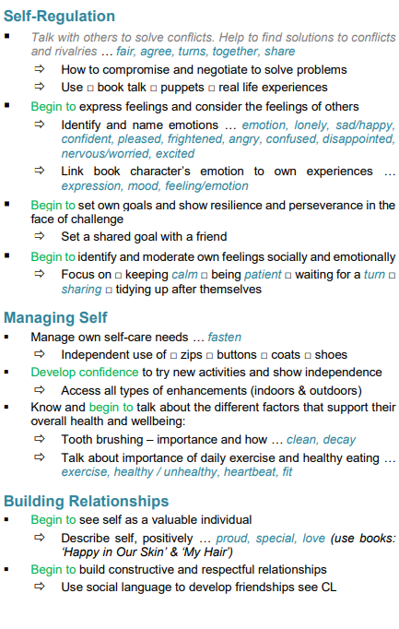 | 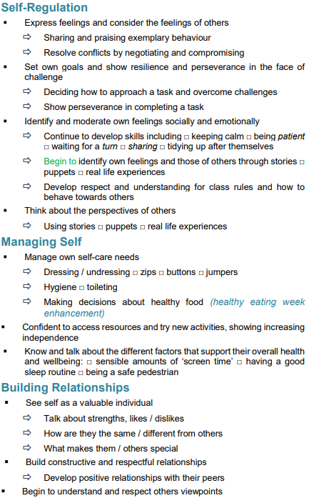

PHYSICAL DEVELOPMENT: □ Gross Motor Skills □ Fine Motor Skills
Educational Programme: Physical activity is vital in children’s all-round development, enabling them to pursue happy, healthy and active lives. Gross and fine motor experiences develop incrementally throughout early childhood, starting with sensory explorations and the development of a child’s strength, co-ordination and positional awareness through tummy time, crawling and play movement with both objects and adults. By creating games and providing opportunities for play both indoors and outdoors, adults can support children to develop their core strength, stability, balance, spatial awareness, co-ordination and agility. Gross motor skills provide the foundation for developing healthy bodies and social and emotional well-being. Fine motor control and precision helps with hand-eye co-ordination which is later linked to early literacy. Repeated and varied opportunities to explore and play with small world activities, puzzles, arts and crafts and the practise of using small tools, with feedback and support from adults, allow children to develop proficiency, control and confidence.
Autumn | Spring | Summer
Learning Priorities: Linked to Development Matters 2021
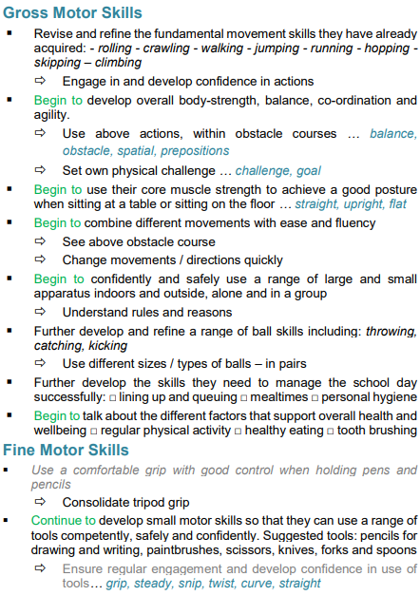 | 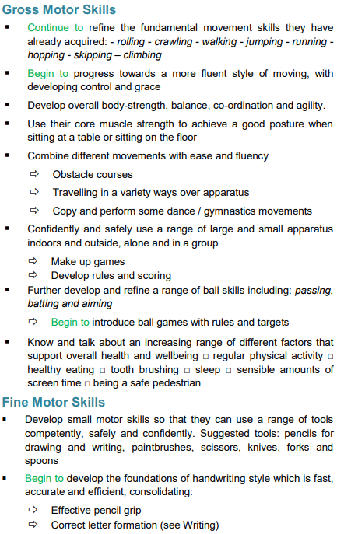

LITERACY: □ Reading - Comprehension □ Reading - Word Reading □ Writing
Educational Programme: It is crucial for children to develop a life-long love of reading. Reading consists of two dimensions: language comprehension and word reading. Language comprehension (necessary for both reading and writing) starts from birth. It only develops when adults talk with children about the world around them and the books (stories and non-fiction) they read with them, and enjoy rhymes, poems and songs together. Skilled word reading, taught later, involves both the speedy working out of the pronunciation of unfamiliar printed words (decoding) and the speedy recognition of familiar printed words. Writing involves transcription (spelling and handwriting) and composition (articulating ideas and structuring them in speech, before writing)

Autumn |  | Spring |  | Summer
Learning Priorities: Linked to Development Matters 2021
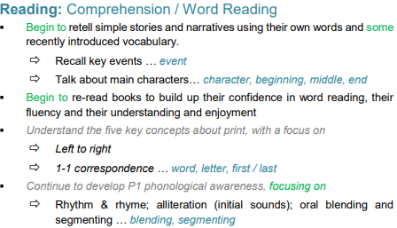  Little Wandle:  Autumn 1:Phase One / Two Little Wandle.Graphemes:  s a t p i n m d g o c k ck e u r h b f l  Tricky words: is I the  Autumn 2: Phase Two Little Wandle.Graphemes:  ff ll ss j v w x y z zz qu ch sh th ng nk  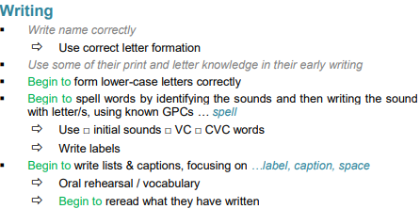  Tricky words: as and has his her go no to into she he of we me be |  | 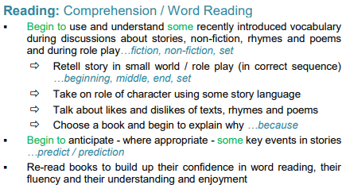  Little Wandle:  Spring 1: Phase 3 Little Wandle.Graphemes:  ai ee igh oa oo oo ar or ur ow oi ear air er  Tricky words: was you they my by all are sure pure  Spring 2: Phase 3 Little Wandle.Graphemes: Review Phase 3  Tricky words:Review the words taught so far  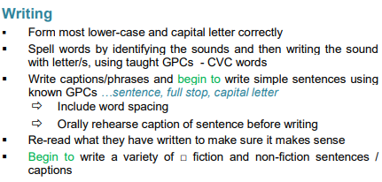 |  | 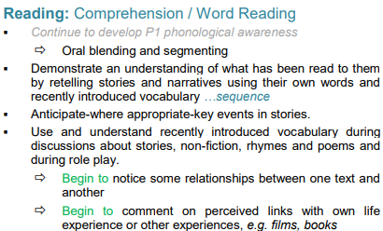  Little Wandle:  Summer 1: Phase 4 Little Wandle. Learning in Phonics:  Short vowels with adjacent consonants, CVCC CCVC CCVCC CCCVC CCCVCC. Longer words and compound words  Tricky words: said so have like some come love do were here little says there when what one out today.  Summer 2: Phase 4 Little Wandle.Learning in Phonics: Phase 3 long vowel graphemes with adjacent consonants CVCC CCVC CCCVC CCV CCVCC. Words ending in suffixes: –ing, –ed /t/, –ed /id/ /ed/, –ed /d/ – er, –est. Longer words and compound words.  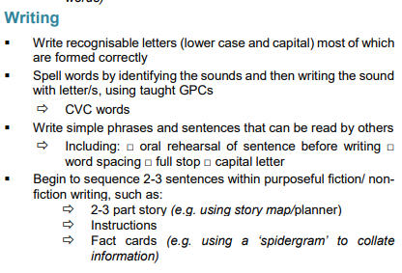  Tricky words: Review all taught so fa
MATHEMATICS: □ Numerical Pattern □ Number
Educational Programme: Developing a strong grounding in number is essential so that all children develop the necessary building blocks to excel mathematically. Children should be able to count confidently, develop a deep understanding of the numbers to 10, the relationships between them and the patterns within those numbers. By providing frequent and varied opportunities to build and apply this understanding - such as using manipulatives, including small pebbles and tens frames for organising counting - children will develop a secure base of knowledge and vocabulary from which mastery of mathematics is built. In addition, it is important that the curriculum includes rich opportunities for children to develop their spatial reasoning skills across all areas of mathematics including shape, space and measures. It is important that children develop positive attitudes and interests in mathematics, look for patterns and relationships, spot connections, ‘have a go’, talk to adults and peers about what they notice and not be afraid to make mistakes.

Autumn | Spring |  | Summer
Learning Priorities: Linked to Development Matters 2021
Autumn 1:  Early Mathematical Experiences  Counting rhymes and songs  Explore counting skills and knowledge  Classifying objects based on one attribute:  •Matching sets  •Comparing objects and sets. Subitise different arrangements (identify when a set doesn’t need to be counted)  •Ordering objects and sets Number recognition within 3/finger patterns.  2D Shapes.  Whole and parts  Pattern and early number  Recognise, describe, copy and extend colour and size patterns  Represent the numbers 1 to 3  Estimate and check by counting.  Recognise numbers in the environment.  Autumn 2:  Numbers within 5  Counting rhymes and songs  Different arrangements of numbers within 5 (conceptual subitizing)  One more  Order numbers 1 – 5 Composition of numbers within five  Explore zero  Use the language of comparison when comparing sets of objects  Measures  Compare, discuss and explore capacity, weight and lengths  Shape and sorting  Describe, and sort 2-D  Begin to describe position  Select shapes in order to develop spatial reasoning skills (copy shape pictures)  Compose shapes  Calendar and time  Days of the week  Sequence daily events | Spring 1:  Numbers within and beyond 5  Counting rhymes and songs  Order numbers  Track games  Subitising  Count sequence cardinality (how many in a set) and ordinality (place numbers in a sequence)  Staircase pattern  Represent, order and explore numbers to seven  One more or fewer  Sort odd and even according to shape  Identify when two sets are equal and unequal  Verbal count beyond 20  Doubling  Connecting doubles (two equal groups) to finger pattern  Measures  Estimate, compare, discuss and explore capacity, weight and lengths  Spring 2:  Numbers within 7  Counting rhymes and songs  Identify when two sets are equal and unequal when comparing numbers  Count up to 7 objects Represent, order and explore numbers to 7  One more or fewer  Subitising for numbers beyond 5  Connect quantities to numerals  Parts: missing parts for numbers within 5  Structure of the numbers 6 and 7 as 5 and a bit  Shape and sorting  Describe, and sort 2-D & 3-D shapes  Compose and decompose shapes  Describe position accurately  Select and rotate shapes to develop spatial reasoning skills (create shape pictures)  Calendar and time  Days of the week  Sequence daily events  Seasons |  | Summer 1:  Numbers within 10  Counting rhymes and songs  Tens frames  Doubling  Doubling represented on tens frames  Measures  Describe capacities  Compare volumes  Compare weights  Estimate, compare and order lengths  Shape and pattern  Describe and sort 2-D and 3-D shapes in different ways  Compose and decompose shapes seeing numbers within shapes  Recognise, complete and create patterns  Describe position accurately  Calendar and time  Days of the week  Sequence of events  Seasons  Summer 2:  Depth of numbers within 10  Counting rhymes and songs  Tens frames  Recognise and extend patterns  Count forwards and backwards  Compare numbers and quantities  Subitsing – identify when sets can be subitized or need to be counted  Subitsing – conceptual subitizing using a rekenrek  One more one less  Numbers beyond 20  Counting larger numbers beyond 20 (actions and sounds)  Estimate and count  Shape and pattern  Apply number, shape and measures knowledge  Select, rotate and manipulate shapes.  Measures  Estimate, order, compare, discuss and explore capacity, weight and lengths
UNDERSTANDING THE WORLD □ Past and Present (KS1: History)
Educational Programme: Understanding the world involves guiding children to make sense of their physical world and their community. The frequency and range of children’s personal experiences increases their knowledge and sense of the world around them – from visiting parks, libraries and museums to meeting important members of society such as police officers, nurses and firefighters. In addition, listening to a broad selection of stories, non-fiction, rhymes and poems will foster their understanding of our culturally, socially, technologically and ecologically diverse world. As well as building important knowledge, this extends their familiarity with words that support understanding across domains. Enriching and widening children’s vocabulary will support later reading comprehension.
Autumn | Spring |  |  |  | Summer
Learning Priorities: Linked to Development Matters 2021
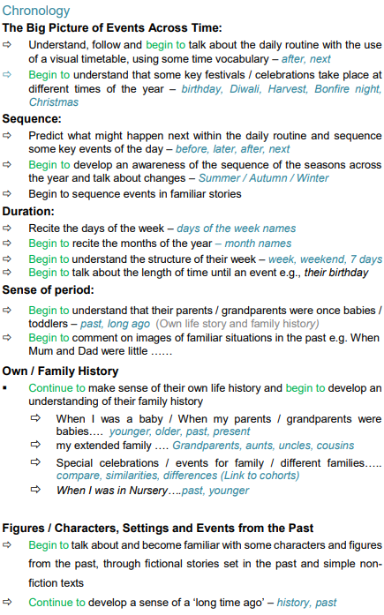 | 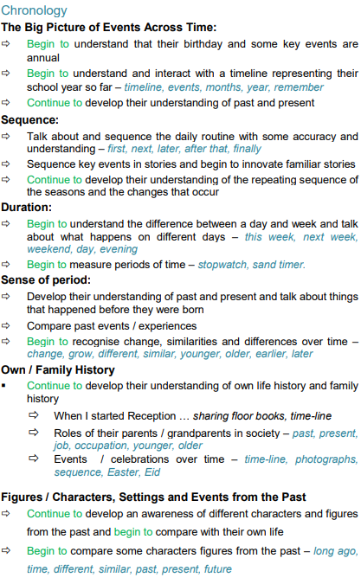 |  |  |  | 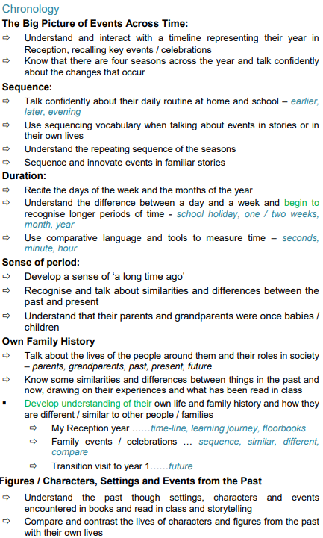

UNDERSTANDING THE WORLD □ People, Culture & Communities (KS1: R.E )
Educational Programme: Understanding the world involves guiding children to make sense of their physical world and their community. The frequency and range of children’s personal experiences increases their knowledge and sense of the world around them – from visiting parks, libraries and museums to meeting important members of society such as police officers, nurses and firefighters. In addition, listening to a broad selection of stories, non-fiction, rhymes and poems will foster their understanding of our culturally, socially, technologically and ecologically diverse world. As well as building important knowledge, this extends their familiarity with words that support understanding across domains. Enriching and widening children’s vocabulary will support later reading comprehension.
Autumn | Spring | Summer
Learning Priorities: Linked to Development Matters 2021
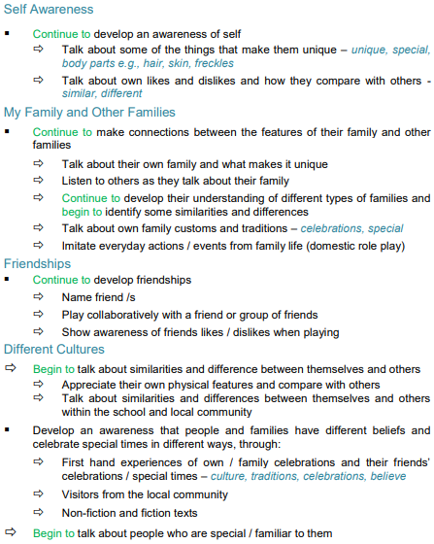 | 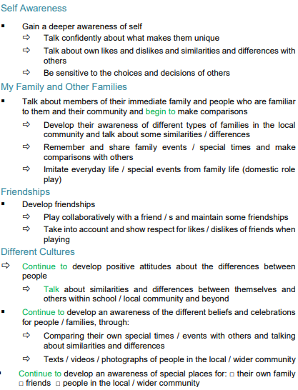 | 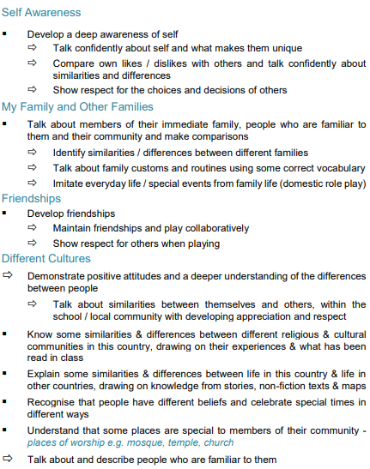

UNDERSTANDING THE WORLD □ People, Culture & Communities (KS1: Human Geography) □ Natural World (KS1: Physical Geography)
Educational Programme: Understanding the world involves guiding children to make sense of their physical world and their community. The frequency and range of children’s personal experiences increases their knowledge and sense of the world around them – from visiting parks, libraries and museums to meeting important members of society such as police officers, nurses and firefighters. In addition, listening to a broad selection of stories, non-fiction, rhymes and poems will foster their understanding of our culturally, socially, technologically and ecologically diverse world. As well as building important knowledge, this extends their familiarity with words that support understanding across domains. Enriching and widening children’s vocabulary will support later reading comprehension.
Autumn | Spring | Summer
Learning Priorities: Linked to Development Matters 2021
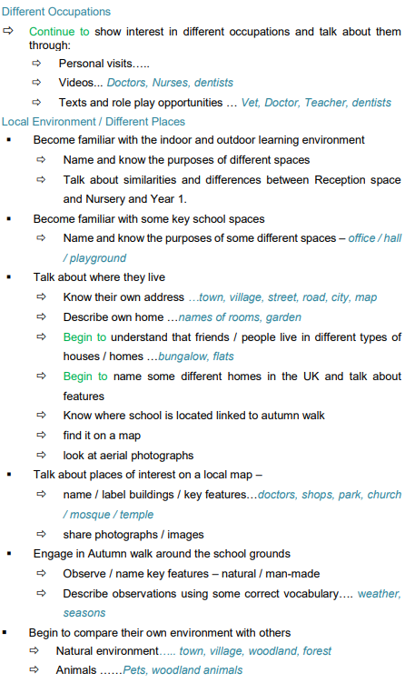 | 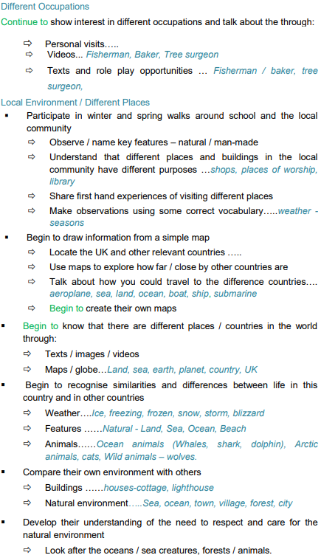 | 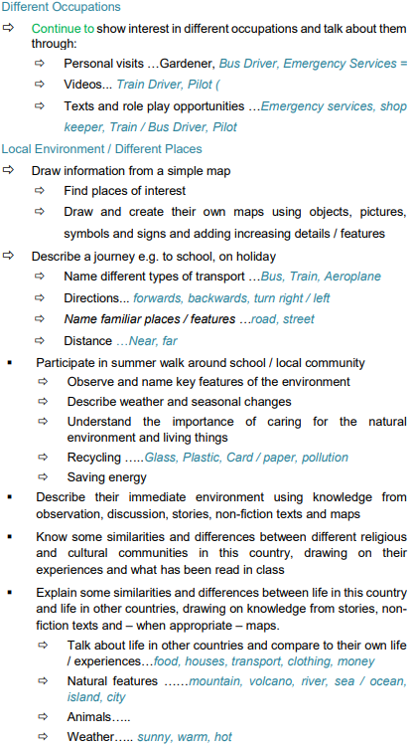

UNDERSTANDING THE WORLD □ Natural World (KS1: Science)
Educational Programme: Understanding the world involves guiding children to make sense of their physical world and their community. The frequency and range of children’s personal experiences increases their knowledge and sense of the world around them – from visiting parks, libraries and museums to meeting important members of society such as police officers, nurses and firefighters. In addition, listening to a broad selection of stories, non-fiction, rhymes and poems will foster their understanding of our culturally, socially, technologically and ecologically diverse world. As well as building important knowledge, this extends their familiarity with words that support understanding across domains. Enriching and widening children’s vocabulary will support later reading comprehension.
Autumn | Spring | Summer
Learning Priorities: Linked to Development Matters 2021
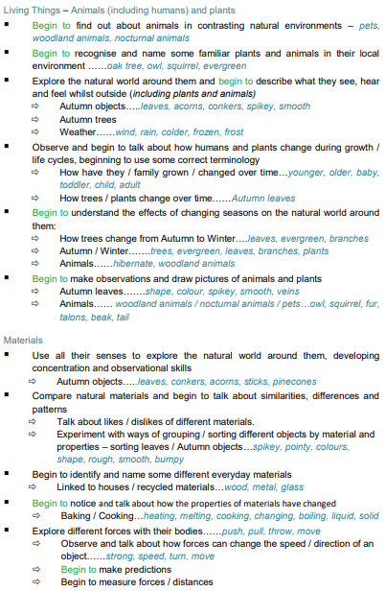 | 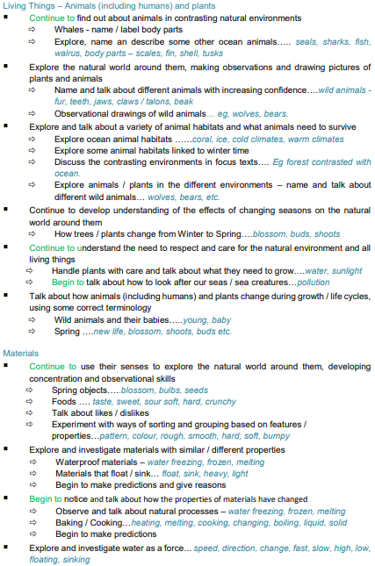 | 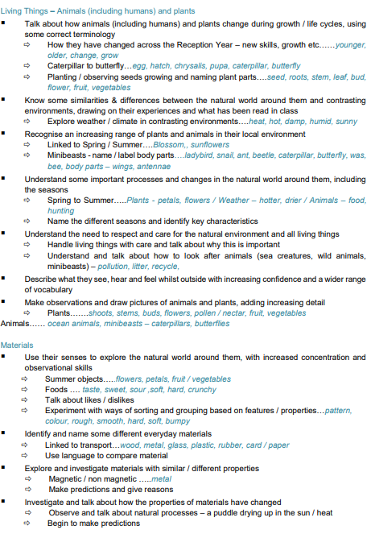

EXPRESSIVE ARTS & DESIGN: □ Creating with Materials (KS1 Art & Design / DT)
Educational Programme: The development of children’s artistic and cultural awareness supports their imagination and creativity. It is important that children have regular opportunities to engage with the arts, enabling them to explore and play with a wide range of media and materials. The quality and variety of what children see, hear and participate in is crucial for developing their understanding, self-expression, vocabulary and ability to communicate through the arts. The frequency, repetition and depth of their experiences are fundamental to their progress in interpreting and appreciating what they hear, respond to and observe.
Autumn | Spring | Summer
Learning Priorities: Linked to Development Matters 2021
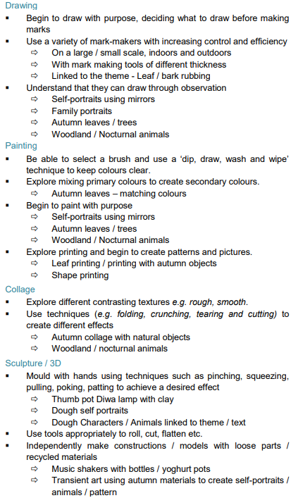 | 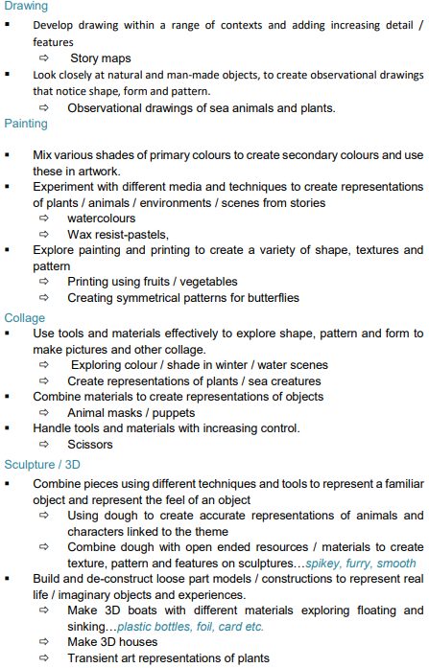 | 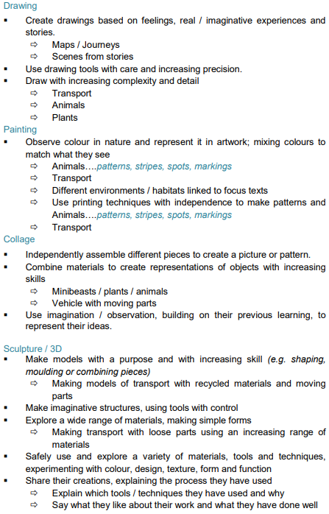

EXPRESSIVE ARTS & DESIGN: □ Being Imaginative & Expressive (KS1 Music / Performing Arts)
Educational Programme: The development of children’s artistic and cultural awareness supports their imagination and creativity. It is important that children have regular opportunities to engage with the arts, enabling them to explore and play with a wide range of media and materials. The quality and variety of what children see, hear and participate in is crucial for developing their understanding, self-expression, vocabulary and ability to communicate through the arts. The frequency, repetition and depth of their experiences are fundamental to their progress in interpreting and appreciating what they hear, respond to and observe.
Autumn | Spring | Summer
Learning Priorities: Linked to Development Matters 2021
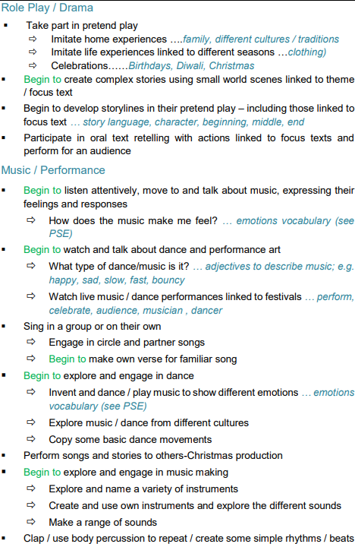 | 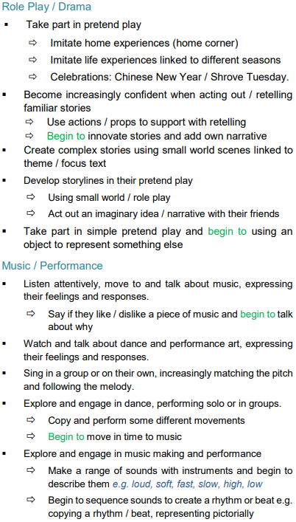 | 