Year 5 Home Learning
WB 08.02.21
English |  | How long to spend
Spelling: | Spelling: This week’s focus is how to use the prefix tele- and auto-.  Use a dictionary to check that you know what each of the words mean.  Practise spelling these words each day using some of the given strategies.  There will be a daily Purple Mash spelling practise of these words. | 15 minutes a day
  signal | resign | signature
  assignment | designation | design
  resigned | signalling | Designate
  redesign
Reading: | Each day on Purple Mash you will be given a text to read and a task to complete. Make sure you complete this daily so that you can keep track of the story.    Daily Reading – It is important that you read on your own for at least 15 minutes each day. You have been set 4 books each week to read on Myon. You can read these in any order and will be changed weekly. Make sure that you quiz on Accelerated Reading after you have finished reading each book.   | 15 minutes a day  15 minutes daily
Writing – Instructions
This week we will be making scones

You will need some basic ingredients to carry out Tuesday’s lesson

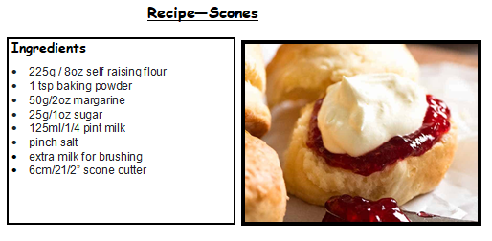

Monday | LO: To identify features of an instruction text  Success Criteria  * Title  * Correct names for things  * List of requirements/equipment at the beginning  * Imperative verbs  * Present tense  * Chronological order  * Diagrams/illustrations (if appropriate)  * Time connectives  Input  Watch the video linked with the 2do. https://youtu.be/KtpcM7W_TIo  Activity  Using the pens on Purple Mash, can you identify the features of the instruction text?  You will need to highlight all the features listed in this key  Key  * Title  * Correct names for things  * List of requirements/equipment at the beginning  * Imperative verbs  * Present tense  * Chronological order  * Diagrams/illustrations (if appropriate)  * Time connectives | 1 hour
Tuesday | LO: To follow instructions  .  Success Criteria  Listen carefully to each instruction  Identify the imperative verbs  Use equipment safely  Input  Watch the video linked with the 2do. https://youtu.be/JmXkm7EW01s  Activity  Follow the instructions carefully on the recipe card and most importantly enjoy making and eating your scones.  Can you add some photos to the Purple Mash Activity? We would love to see your scones. | 1 hour
Wednesday | LO: To use time connectives  Success Criteria  Identify time connectives.  Join two parts of a sentence using a time connective.  Choose appropriate time connectives in a sentence.  Independently write sentences using a time connective  Input  Watch the video linked with the 2do. https://youtu.be/OYPTSCQHQac  Activity  Using the Mash Cam activity on Purple Mash, can you write your own version of the instructions that you followed on Tuesday. | 1 hour
Thursday | LO: To plan a set of instructions  Success Criteria  Make notes about your new set of instructions in the planning grid.  Add key Openers, connectives and imperatives to your plan  Input  Watch the video linked with the 2do. https://youtu.be/wNcxZaL98_4  Activity  Using the template on Purple Mash can you complete a plan for your alternative scones? | 1 hour
Friday | LO: To write a set of instructions  Success Criteria  Instructions will have:  *Title  * correct names for things  * list of requirements/equipment at the beginning  *imperative verbs  *Present tense  *Chronological order  *diagrams/illustrations (if appropriate)  * time connectives  Input  Watch the video linked with the 2do. https://youtu.be/ndnHpSLln48  Activity  Using the template on Purple Mash, can you write a detailed set of instructions for your alternative scone recipe?  Why don’t you have a go at making this and let us know whether it was tasty? | 1 hour
Handwriting: | Please continue to practise your handwriting every day. Use tips on our website to help you.  Practice the spellings with the letter string ‘sign’ | 10 minutes a day
Maths: Fractions and Decimals
Mental maths: | Practise all your times tables on TT Rockstars each day  Can you be the greatest Rock Star in Year 5?   | 10 minutes a day
Monday | LO - To relate fractions to decimals (tenths/hundredths)  Starter  Daily Fluent in Five for given number – Todays number is 232  + 10, -10, x 10, x 100, ÷ 10, ÷ 100, Double it, Half it.  Input  Watch the video on the 2do link about comparing fractions and decimals https://youtu.be/MKh9wCzyrTo  Activity  Complete your work on Purple Mash and send it back to your teacher.  Success Criteria  To understand what a tenth of a number is.  To convert decimals to fractions.  To multiply the decimal by 10 (moving 1 place to the left) to convert it into a fraction of 10.  To multiply the decimal by 100 (moving 2 places to the left) to convert it into a fraction of 100
Tuesday | LO - To order decimals  Starter –  Daily Fluent in Five for given number – Todays number is 78  + 10, -10, x 10, x 100, ÷ 10, ÷ 100, Double it, Half it.  Input  Watch the video on the 2do link about how to order decimals  https://youtu.be/Q3t8LqkOUtA  Activity  Complete your work on Purple Mash and send it back to your teacher.  Success Criteria  Understand place value of a decimal number  Understand the purpose of a place holder  Order decimals from smallest to largest. | 1 hour
Wednesday | LO - To round decimals  Starter  Daily Fluent in Five for given number – Todays number is 109  + 10, -10, x 10, x 100, ÷ 10, ÷ 100, Double it, Half it.  Input  Watch the video on the 2do link about how to round decimals  https://youtu.be/D8ygAjQ9W20  Activity  THE ACTIVITY TODAY IS LBQ  www.lbq.org/task  The code will be on Purple Mash as well as the Class 11 and Class 12 blogs.  Once you have completed your LBQ task, please can you complete the exta activity on Purple Mash  Success Criteria  Understand place value of a decimal number  Understand that if the tenth is 4 or less then it is rounded down.  I know that if the tenth is 5 or more it is rounded up. | 1 hour
Thursday | Thursday – To relate fractions, decimals and percentages  Starter –  Daily Fluent in Five for given number – Todays number is 225  + 10, -10, x 10, x 100, ÷ 10, ÷ 100, Double it, Half it.  Input  Watch the video on the 2do link about how to relate fractions, decimals and percentages. https://youtu.be/4Kj6p7tUrhM  Activity  Complete your work on Purple Mash and send it back to your teacher.  Success Criteria  To understand what a tenth of a number is.  To convert decimals to fractions.  To multiply the decimal by 10 (moving 1 place to the left) to convert it into a fraction of 10.  To multiply the decimal by 100 (moving 2 places to the left) to convert it into a fraction of 100  To change a decimal into a percentage x 100 | 1 hour
Friday | LO - To match fractions, decimals and percentages  Starter  Daily Fluent in Five for given number – Todays number is 171  + 10, -10, x 10, x 100, ÷ 10, ÷ 100, Double it, Half it.  Input  Watch the video and listen carefully to the input. https://youtu.be/WV9G9YH_r_s  Activity  Complete your work on Purple Mash and send it back to your teacher. You will need to use all the skills that you have been working on this week to match the fractions, decimals, percentages and pictorial representations.  Success Criteria  To understand what a tenth of a number is.  To convert decimals to fractions.  To multiply the decimal by 10 (moving 1 place to the left) to convert it into a fraction of 10.  To multiply the decimal by 100 (moving 2 places to the left) to convert it into a fraction of 100  To change a decimal into a percentage x 100 | 1 hour
Curriculum
Design Technology: | We are making scones this week and during our Literacy lessons we will be planning a new scone. Why don’t you have a go at making your new scone and share your pictures with us.  Activity  We want you to do some research about the origins of flour and how it goes wheat in a field to a delicious sweet treat.  There is a video and activity on Purple Mash to complete.   | 1 hour
Science  States of Matter | LO: To investigate new materials  This week in Science you will mixing house hold items together to make new materials. If you don’t have these items in, you can search online for video clips which will show you similar results.  There is an activity to complete on Purple Mash.    EXTRA ACTIVITY  Chester Zoo are running virtual visits to the zoo via their YouTube Channel. If you get a chance have a look at the fabulous work that they do with the animals.  https://www.youtube.com/user/OfficialChesterZoo   | 1 hour
Geography | The Loire River  Your task this week is to find out about the Loire River in France. There is a task to complete on Purple Mash.  Use this website as a guide  https://kids.britannica.com/kids/article/Loire-River/346162  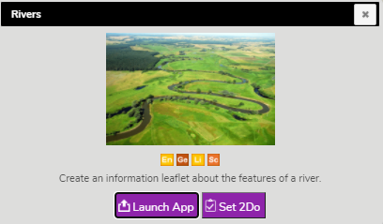 | 60 minutes
Computing | 2code – Purple Mash  You have been set a task on Purple Mash involving coding. Can you complete the coding tasks based on a football acivity?  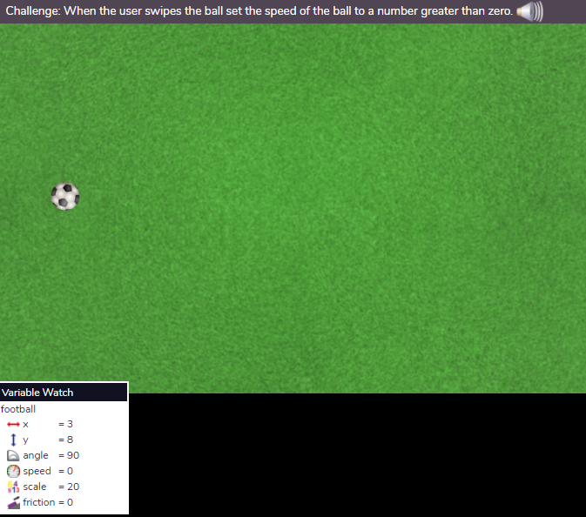  You will need to watch the videos and carry out the activities that go with each section.
PE | PE with Joe Wicks  Joe Wicks will be taking our PE sessions again throughout the latest lockdown. Make sure you are up and ready from Monday 11th January at 9:00 to take part in the exercise with the Body Coach.  He will be streaming live on his You Tube channel https://www.youtube.com/user/thebodycoach1 every Monday, Wednesday and Friday.  Yoga Bugs  Another way you stay fit and heathy is by taking part in these Yoga sessions.  Visit the following website https://vimeo.com/showcase/7488612 and use the password schoolbugs321*   | 3 Times a week
Music | Each week Mrs Cermac will be uploading a new lesson for you to do at home on YUMU. She is also going to be continuing with the class competitions. Class 11 have been the winners for a number of weeks. Let’s see if Year 5 can continue to be in the lead this term. Also remember to NOT change the password, even if prompted because this will restrict everyone’s access.  Class 11  Username: p1351529  Password: orchid  Class 12  Username: p1351500  Password: banana | 30 minutes

We are looking forward to seeing what you have been up to and feeding back on all your learning. If you are having any issues with anything, please send an e-mail on Purple Mash and we will get back to you as soon as we can.

Thank you for your support.
Mrs Baguley, Mrs Akroyd and Mr Bottomley

Spelling Strategies

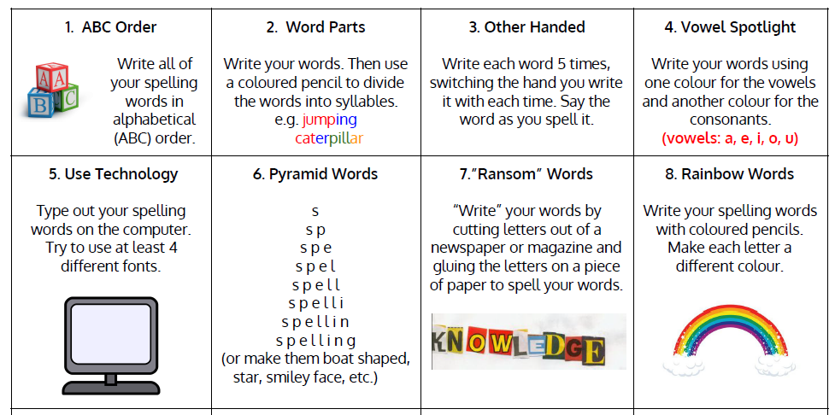
Use some of these strategies to help you practise your spellings.

