Home Learning – Learning Base 2- wk bg – 6th September 2021
English – Communication (Speaking and listening)
Monday | During Literacy the children will be looking at different pobble 365 pictures related to the topic. Please talk to your child about these pictures, describe what they see and ask and answer questions to gain more information. This week the picture is  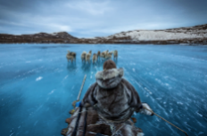https://www.pobble365.com/arctic-journey/  What do you notice?  Parents – please take turns with your child to say what you notice in the picture  Resources –Pobble picture
Tuesday | What are the dogs and the man on?  What is in front of them?  What is the blue underneath them?  Say “I can see ________” using the CIP words  Resources –Pobble picture and Concept in Print pictures (CIP)
Wednesday | Where are they going?  What is the man sitting on?  Watch the video of a sledge adventure –  https://www.youtube.com/watch?v=QeDv3hVcc8A – dog pulling sledge  https://www.youtube.com/watch?v=cjluQyv2Le8 – moving across snow  Talk about what you notice  Resources – Pobble picture and videos
Thursday | Can you draw what they are looking at?  Can they see anything under the ice?  What animals live in the sea?  Draw what they might be able to see.  Resources – Pictures of different animals under the sea
Friday | Describe your drawing of what they could see under the sea.  “The man saw the fish”  “The fish are swimming in the sea”  Resources – Pictures of different animals under the sea
Spelling/ phonics
Monday | Please use the phoneme mat provided to recap the sounds that your child recognises.  Take turns with your child to say and find different sounds.  Touch the letter Aa and say “a”.  Resources – Phoneme mat (alphabet)
Tuesday | Look at the individual letters (cut out a set to match), say the sound selected and find/match to the phoneme mat. Say the sound  Resources – Phoneme mat (alphabet) / individual letters
Wednesday | Play find the ____ game.  Place some of the letters out and say “find me the ____”, child collects the selected sound  Resources – Individual letters
Thursday | USE - /m/a/s/d/t/ and create these words  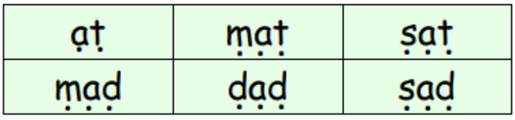  USE m / a / s / d / t / i / n / p / g / o /  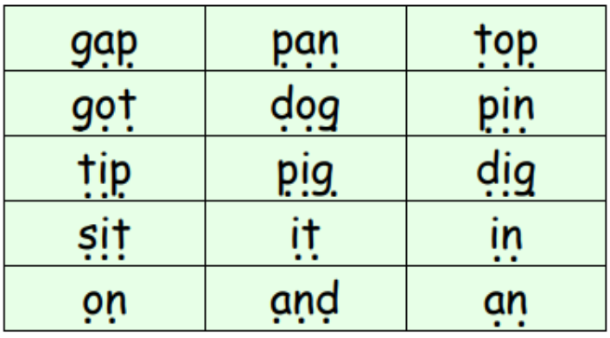  USE m / a / s / d / t / i / n / p / g / o / c / k / u / b / f / e /  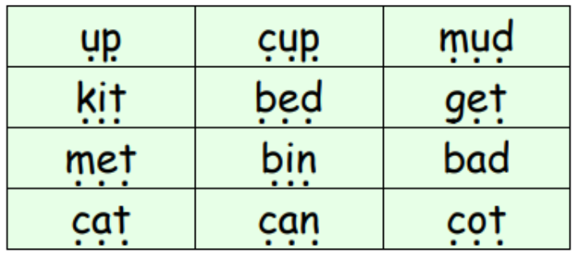  USE m / a / s / d / t / i / n / p / g / o / c / k / u / b / f / e / l /h /sh /  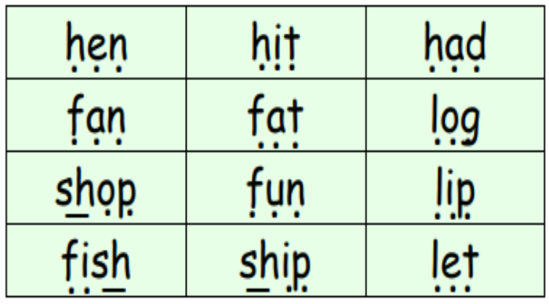
Friday | Say the words for your child to make (from the previous lists)  Child will listen, say the sounds in order and make the word  Resources – words, individual letters
Websites to support phonics learning
https://www.verywellfamily.com/best-free-educational-websites-for-kids-3129084
- Sesame Street - letters - https://www.sesamestreet.org/games
- Starfall- sounds - https://www.starfall.com/h/
- Phonicsplay - https://www.phonicsplay.co.uk
https://www.topmarks.co.uk/ - games for sounds
https://www.ictgames.com/ - games for literacy
Writing
Monday |  Do 5 exercises daily  - https://teachhandwriting.co.uk/handwriting-warm-up-exercises.html  Please practice your child’s full name so that all the letters are formed correctly.  Please use the RWI (alphabet) sheet provided in your home learning pack.  Say the letter formation as you write the letter eg. “round the apple and down the leaf” when writing the letter /a/.  Say the letter and sound of the letters in your child’s name. Form the letter correctly.  Resources – RWI letter formation sheet, child’s name card
Tuesday | Say a letter and sound.  Child to form the letter correctly.  Practice writing all the letters of the alphabet.  Say the letter name and sound.  Resources – RWI letter formation sheet
Wednesday | Use the words from spelling for your child to write.  Say the word eg. map, show on your fingers the sounds /m/a/p/, say word again – map  Resources – words to write – map, tin etc
Thursday | Using the drawing of what the man saw under the ice, look at the CIP words and write on your picture to describe it – man, sledge, ice, fish  Resources – CIP words
Friday | Write sentences to describe where they are going  “The man is looking at the fish in the sea”  “The fish are swimming in the sea”  Resources – CIP words to support ideas
Websites to support writing
https://www.abcya.com/grades/prek
http://www.funbrainjr.com/search_games.html
Reading
Monday | Please continue reading the books that have been sent home.  Please share your child’s reading book.  Please talk about the pictures and what is happening in the story.  Encourage your child to read each word  Resources – reading books
Tuesday | Please listen, share and ask questions about the reading books sent home.  Talk about who is in the story?  What is happening?  What do they think will happen next?  Look at the initial letters and read the text in the book
Wednesday | Bugclub - Please log in and read the books that have been selected for your child at their level of learning  - Username and Password given  Resources – https://www.activelearnprimary.co.uk/login?c=0
Thursday | Register and access free books - https://home.oxfordowl.co.uk/reading/reading-schemes-oxford-levels/read-write-inc-phonics-guide/  - parents to use for home learning  Resources - https://www.oxfordowl.co.uk/
Friday | Myon free books. Please log in and look at the books available. Share the books  Listen to the tricky word song - https://www.youtube.com/watch?v=TvMyssfAUx0  Resources – www.myon.co.uk. and websites
Maths
Monday | Order the numbers 1-10.  Remove a number and find the missing number.  Find 1 more than and 1 less than. Use numbers 1-20 when confident with 1-10  Resources – individual numeral and number lines
Tuesday | Practice writing numerals to 10 and numerals 1-20  Say a number, child finds on the number line and writes and says the numeral  Repeat with other numbers  Resources – number lines
Wednesday | Look at the numerals. Say the numerals in order. Mix them up and say the numeral. Select a number and count out the correct amounts  Resources – Number lines, individual numerals
Thursday  Friday | Please continue to practically count out amounts of objects.  Look at the numerals 1-20 and count out the correct amount of objects.  Extend by adding and subtracting numbers up to 10 – I have 10 sweets and give 5 to my mum, I have 5 left.  Resources – Number lines, individual numerals ,
Websites to support maths learning
https://www.verywellfamily.com/best-free-educational-websites-for-kids-3129084
- Jack Hartman count to 100 -
- PBS Kids - counting songs - https://pbskids.org/
https://www.starfall.com/- counting
- CoolMath - all maths concepts
https://www.topmarks.co.uk/ - games for maths
https://www.ictgames.com/ - games for maths
https://www.abcya.com/grades/prek - maths games
http://www.funbrainjr.com/searchgames.html
Curriculum
Music | The music service have added lessons online. Go to https://www.GMmusiconline.co.uk/yumu  Enter your username and password in the boxes on the screen.  Your username is: p1351527  Your password is: symphony  Click on the different tabs to listen to the songs that your children take part in
On-going project- | This half term the children will be learning about ‘Our World’  This week the children are looking at what animals live in the sea  Research  - What animals live under the sea  - Are there any jobs that people can do under the sea?  Ask your parent to write what you found out about  Research all the places where animals live  Watch the videos and talk about  https://www.youtube.com/watch?v=yzUkFxizqUg – sledging
Sensory
Playdough | Follow the guidance on Dough disco - https://www.youtube.com/watch?v=3K-CQrjI0uY
Meditation / Yoga
Peaceout | Follow the peaceout video - https://www.youtube.com/watch?v=2TFuFd4iFOY

Don’t forget-
We love seeing your home learning.
You can always take a photo and email to school or tweet us!
We are looking forward to seeing what you have been up to.

Mrs.Sullivan-Lomax will re-send the seesaw log in so that you can add information to the learning.

IF YOU TAKE A PHOTO or make a video of your child learning, please send to
info@greenhill.theharmonytrust.org

