Home Learning Year 3 Wb: 25.1.21
English |  | Completed by...
Spelling: | 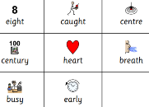 | Daily
Reading: | PLEASE COMPLETE THE ‘star reader’ test on ACCELERETED READING this week.  Log into your MYON account daily and read the set texts daily. Leave your teachers a review once you finish a book to say if you enjoyed it and if you would recommend it to a classmate.  https://www.myon.co.uk/login/index.html?logoutReason=10&returnTo=%2Flibrary%2Fsearch.html  MyON – Books will be added daily. Please quiz on your MyON book too.  Read your reading book every day/night for at least 15 minutes and make a list of any words you are not sure about. You can quiz on your school book on the AR website. | Daily
Writing: | LITERACY – Egyptian Cinderella-Retell  Watch the clip and listen to the story of ‘The Egyptian Cinderella’ =  https://www.bing.com/videos/search?q=Rhodopis+Egyptian+Cinderella&FORM=VDVVXX  Monday  Learning Objective : To create a story map and use subordinating clauses.  Watch the clip to help understand what a subordinate clause is.  https://www.youtube.com/watch?v=BT1HhMcB8aw  Success Criteria  - I can put events in order- opening, build up, dilemma, resolution and ending.  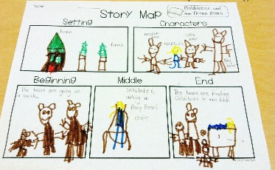  - I can use conjunctions.  - I understand clauses.  - I can use conjunctions to join clauses.  Challenge  Try to include varied description – similes  Tuesday  Learning Objective : To create a draft of the re-tell – COMPLETE THE PURPLE MASH TASK or ON PAPER (take a photo and upload work).  Success Criteria  - To follow the plan (from Mondays work) must have a begin, build up, middle, problem and end, characters, setting  - Capital letters  - Punctuation  - description  - Extended sentences using a conjunction to connect main clause to subordinate clause  Wednesday  Learning Objective : To edit a paragraph of writing (using yesterdays draft). COMPLETE THE PURPLE MASH TASK or ON PAPER (take a photo and upload work).  Success Criteria  - Read out retell.  - To edit following quick fixes – CAPITAL LETTERS, FULL STOPS and FLOW.  - Pronouns (A pronoun is a word that takes the place of a noun. Examples: he, she, it, they, someone, who. Pronouns can do all of the things that nouns can do. They can be subjects, direct objects, indirect objects, object of the preposition, and more).  - Spellings  Thursday COMPLETE THE PURPLE MASH TASK or ON PAPER (take a photo and upload work).  Learning Objective : To redraft a paragraph  Success Criteria  - Pick the paragraph that needs redrafting.  - Read it through.  - Add more/alternative details-up-level:  - use new vocabulary,  - openers,  - conjunctions,  - clauses,  - Re-write the paragraph.  Friday  Learning Objective : Big Write - To write a retell COMPLETE THE PURPLE MASH TASK or ON PAPER (take a photo and upload work).  Success Criteria  - Paragraphs (Opening, build up, dilemma/problem, resolution, ending).  - Sentence openers.  - Description.  - Conjunctions to link clauses.  Challenge  Try to include some speech. | Daily
Handwriting | 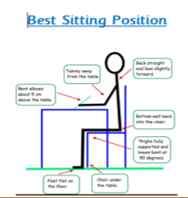  Please practise your joining. Use the spellings above so you can spell all of them correctly and joined up.  https://teachhandwriting.co.uk/handwriting-warm-up-exercises.html  Remember how to sit | Daily
Maths
Maths | TTRockstars – who will win the battle? Class 7 or Class 8? Challenge - How green can you get your heat mat? Just 5 minutes a day can make a big difference. Complete the garage set tasks.  https://play.ttrockstars.com  Fluent in Five this Half Term. Practise these – can you quiz the adults in your house on these? Can they quiz you?  50 + 70 = 120  50 + 80 = 130  50 + 90 = 140  60 + 80 = 140  60 + 90 = 150  70 + 90 = 160  Check Purple Mash. New activities will be added daily.  Maths learning for the next 2 weeks is FRACTIONS  - Each day there will be a video to watch. The teacher will go through that days learning.  - Your activity will be on Purple Mash.  Counting in 4s Number jacks = https://www.youtube.com/watch?v=4SXctAyxZf0  Counting in 8’s = https://www.youtube.com/watch?v=z_BJjR9rdwA  Monday  Learning Objective - Find the matching 'expressions' for describing a fraction. – COMPLETE THE PURPLE MASH TASK.  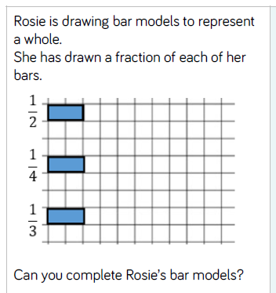  Success Criteria  - Read the question.  - Match the answer.  Challenge  Tuesday  Learning Objective - Select the statements which are true for the Fraction Bars - 1/2, 1/4, 1/3, 1/5 COMPLETE THE PURPLE MASH TASK.  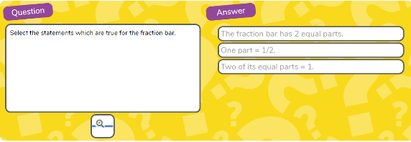  Success Criteria  - Read the question.  - Click on the correct answer(s).  Click on the magnifying glass symbol to see the image bigger.  Wednesday  Learning Objective - Recognise equivalents to ¼, ½, ¾. COMPLETE THE PURPLE MASH TASK.  Success Criteria  - Match the equivalent fractions  - Use the number in the background.  - Drag and drop as many fractions that are equivalent.  Thursday  Learning Objective - Reasoning and problem solving. COMPLETE THE PURPLE MASH TASK.  Success Criteria  - Carefully work through these problems on fractions and record your answers in the spaces provided.  Friday  Learning Objective – Recognising fractions. COMPLETE THE PURPLE MASH TASK.  Success Criteria  - Recognise and find different fractions of a set of objects or quantity. | Daily
Curriculum
P.E   | It really is so important for your physical and mental health to keep moving.  Join Joe Wicks for PE with Joe – you can do this every day on YouTube. We will be doing it in school and when we are at home. Let’s see if we can get fitter in Lockdown!  For a Five Minute workout click here https://www.youtube.com/watch?v=d3LPrhI0v-w  For a longer workout click here https://www.youtube.com/watch?v=tSi2ix1i180  You can let us know on Purple Mash when you have done it.
PSHE   | Have a go at the YOGABUS. These are videos of yoga and relaxation. You can do them with the whole family if you are learning from home. Below is the link and password. Enjoy!  Website link = https://vimeo.com/showcase/7488612  Password = schoolbugs321*
On-going project  Science – (ROCKS AND SOILS) =  Formation of fossils  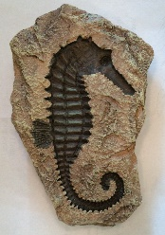 | Our learning this term is about ‘Rocks and Soil’.  TASK  Describe in simple terms how fossils are formed when things that have lived are trapped within rocks.  Complete the PURPLE MASH activity:  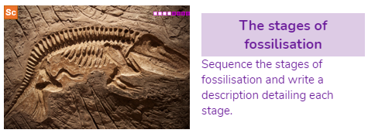
Children’s Mental Health

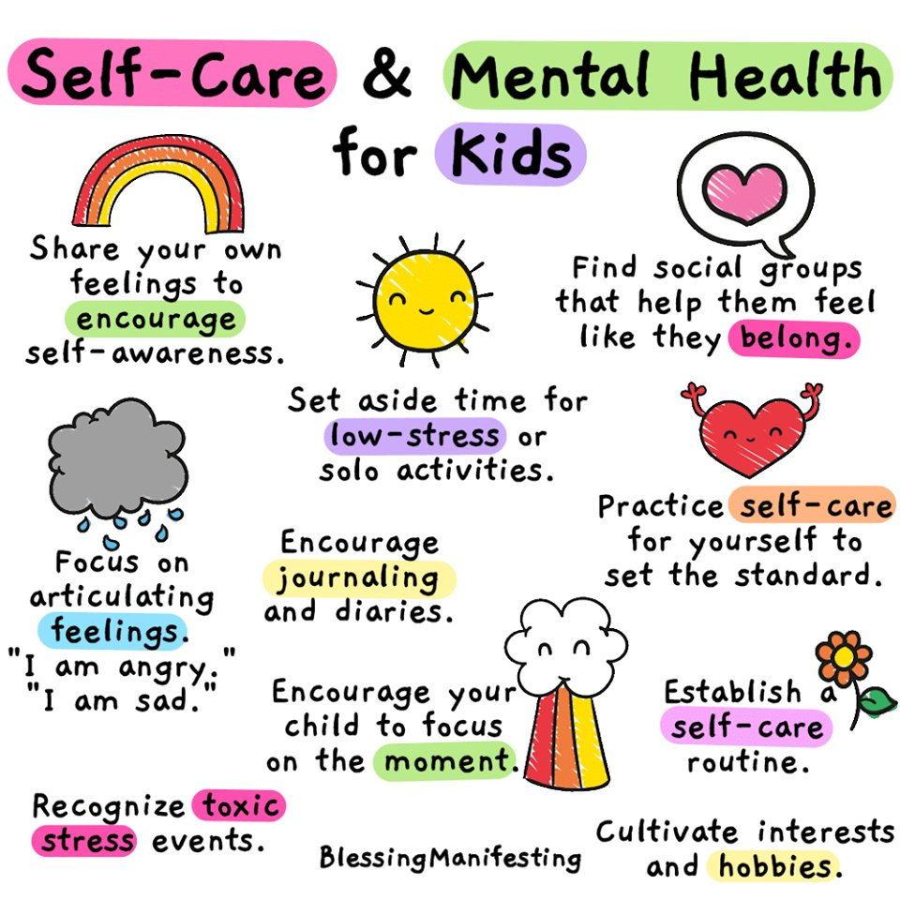

Home learning to be completed each day, so your teacher can respond to your work. Thank you the Year 3 team

