Home Learning Year 3 WB: 18.1.21
English |  | Completed by...
Spelling: | 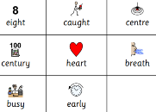  Practise your Common Exception Words – can you learn to write them joined up? Doing this will make it much easier to remember how to spell them.    The spelling focus this week is the ay/ai/eigh/ey/ea sound. There are many different ways to make this sound. Your activity is on Purple Mash.  If you want more help with spelling check out Nessy on Youtube | Thursday
Reading: | Log into your MYON account daily and read the set texts daily. Leave your teachers a review once you finish a book to say if you enjoyed it and if you would recommend it to a classmate.  https://www.myon.co.uk/login/index.html?logoutReason=10&returnTo=%2Flibrary%2Fsearch.html  MyON – Books will be added daily. Please quiz on your MyON book too.  Read your reading book every night and make a list of any words you are not sure about. You can quiz on your school book on the AR website and read new books on the AR website. | Daily
Writing: | 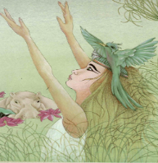  Literacy – Setting description  Monday  Learning Objective – To complete a role on the wall of Rhodopis  Success Criteria - I can explore a character by describing a character’s  *appearance  *likes/dislikes  *attitude  *secrets/dreams  Listen to the story The Egyptian Cinderella https://www.youtube.com/watch?v=rxCH4mO09RA  Today you are going to create a role on the wall of Rhodopis the Egyptian Cinderella. You are going to describe her appearance, what she likes or dislikes, her attitude and her dreams.  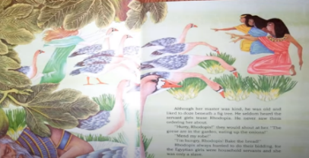  Tuesday  Learning Objective - To explore a scene  Success Criteria – I can draw and describe the scene by  *drawing it  *adding the characters  *label it  *add speech using speech bubbles  Listen to the story again. You are going to draw the scene where Rhodopis is being ordered by the servant girls. Add the characters, label it and use speech bubbles to show what the characters are saying. Your sheet is set on Purple Mash  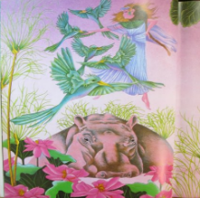  Wednesday  Learning Objective – To write about the setting, using conjunctions  Success Criteria - I can :  *use conjunctions in my writing  *Understand what a conjunction does  *Use some of these conjunctions – When, Also, but, After that, If, So, Because  Watch the video first. Then do the Purple Mash activity. First finish off the sentence starters I have given you using a conjunction and add another idea.  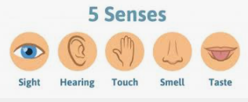  Thursday  Learning Objective - To plan a setting description  Success Criteria – I can  *plan my ideas  *structure my writing  *use my senses  *use adjectives  *similes  Watch the video first. Then do the Purple Mash activity asking you to plan your setting description using your senses.  Friday  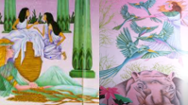  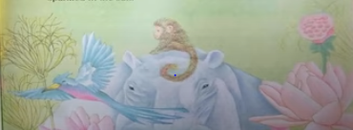  Learning Objective - To write a setting description  Success Criteria - I can  *use different openers  *use my senses  *adjectives  *similes  *Paragraphs  Watch the video first. Then do the Purple Mash activity asking you to write your setting description. | Daily
Handwriting | 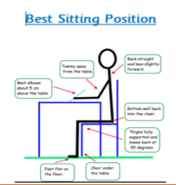  Please practise your joining. Practise with the Common Exception Words and spellings from this week.  Eight, they, obey, vein, weigh, paint, rain, they, okay  Remember how to sit and use the link below for all the warm-up exercises.  https://teachhandwriting.co.uk/handwriting-warm-up-exercises.html | Monday
Maths
Maths | TTRockstars – who will win the battle? Class 7 or Class 8? Challenge - How green can you get your heat mat? Just 5 minutes a day can make a big difference.  https://play.ttrockstars.com  Fluent in Five this Half Term. Practise these – can you quiz the adults in your house on these? Can they quiz you?  50 + 70 = 120 50 + 80 = 130 50 + 90 = 140 60 + 80 = 140  60 + 90 = 150 70 + 90 = 160  Maths learning for this weeks is Measurement – Perimeter  Each day there will be a video to watch on Purple Mash. The teacher will go through that days learning. Your activity will be on Purple Mash.  Monday – Watch the BBC Bitesize clip for a video explanation of perimeter https://www.bbc.co.uk/bitesize/topics/zvmxsbk/articles/zsr4k7h Once you have watched the video, you can do the quiz at the bottom of the screen. When you hand in your learning today, let us know your quiz score.  Learning Objective – To add lengths to find the perimeter.  Success Criteria –  - Look at the length given and use this to work out the length not given – on a rectangle the opposite sides are equal in length.  - Add the length of each side to get the perimeter measurement.  Tuesday  Learning Objective - To add lengths to find the perimeter.  Success Criteria –  - Look at the length given  - Add the length of each side to get the perimeter measurement.  For more challenge click here https://classroom.thenational.academy/lessons/to-calculate-perimeters-of-2d-shapes-in-mixed-units-6crp2e?activity=video&step=1  Wednesday  Learning Objective – To find the perimeter of irregular shapes.  Success Criteria –  - Look at the length of each side  - Add the lengths of each side to find the perimeter  Thursday  Learning Objective – To find the perimeter of shapes.  Success Criteria –  - Draw your own shapes using 8 of the cm squares.  - Count the cm squares around the perimeter (edge) of your shape  - Write your answer  Friday  Learning Objective – To solve word problems involving perimeter.  Success Criteria –  - Read the problem.  - Discuss it with someone to help you understand it – you can even talk to yourself to do this – it works!  - Draw pictures, act it out – anything you need to do to help you understand it. You are using your comprehension skills here.  - Write your working out down  - Write your answer. | Daily
Curriculum
PE/PSHE  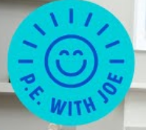 | It really is so important for your physical and mental health to keep moving.  Join Joe Wicks for PE with Joe – you can do this every day on YouTube. We will be doing it in school and when we are at home. Let’s see if we can get fitter in Lockdown!  For a Five Minute workout click here https://www.youtube.com/watch?v=d3LPrhI0v-w  For a longer workout click here https://www.youtube.com/watch?v=tSi2ix1i180  You can let us know on Purple Mash when you have done it. | Daily
Music | Your Music lesson video for this week is on YUMU. There is a great song called ‘Tutankhamun,’ which you will love. J You all have your logins and remember you are NOT to change the password, otherwise you will lock everyone else out. Enjoy!
On-going project  Ancient Egypt  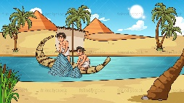 | Our learning this term is about Ancient Egypt.  Use your research skills to find out information for the task –  TASK – To research facts about an Egyptian Pharaoh - Cleopatra.  There is a Power Point of information on Purple Mash to help you, there is information on the 2Do and you could visit this site and scroll down to watch a video about Cleopatra. https://www.bbc.co.uk/programmes/articles/1FTdDbnS92CMPBZBHlPblFG/everything-you-didn-t-know-about-cleopatra  Complete the PURPLE MASH activity: | Tuesday
RE | What makes you joyful?  Complete the Purple Mash activity thinking about what makes you feel good/joyful/elated/happy.  This can be anything. Please give details about what and why. Examples are – family, music, playing, singing, running, bouncing on a trampoline etc. | Wednesday
Science  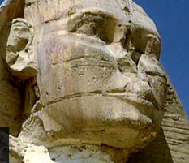 | Watch the video about the different kinds of rocks and how they were formed then you can test your knowledge with the quiz.  https://www.bbc.co.uk/bitesize/topics/z9bbkqt/articles/zsgkdmn  There a lots of short video clips about different rock types and how they are used.  https://www.bbc.co.uk/bitesize/topics/z9bbkqt/resources/1  Can you see any rocks in your garden or when you go for a walk? How are they being used?  Then complete the Purple Mash activity - Types of Rock  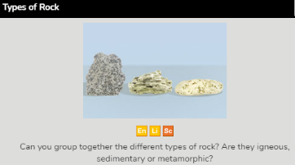 | Friday
Home learning to be completed each day, so your teacher can respond to your work. Thank you from the Year 3 Team.

