Home Learning – Learning Base 2 - wk bg – 6th and 13th March 2023
English
This week the children will be looking at
‘The pobble picture – Buildings and gardens in India’.
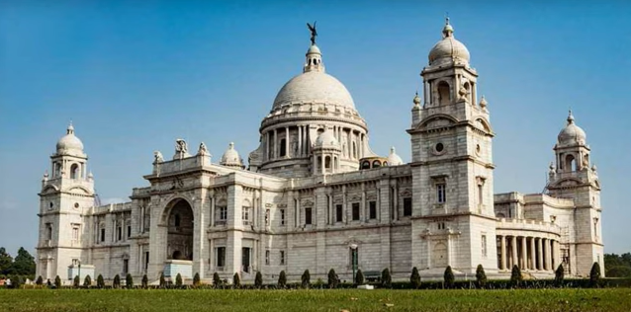
Pobble picture – Famous gardens and buildings in India
https://www.youtube.com/watch?v=WD1tJJ7vByQ – videos
look at the Victoria memorial in India

Parents
- Talk to your child about ‘the Victoria Memorial in India..
- Have they seen anything like that before?
- Do it look familiar to a building in London/ England?
- What shapes can they see in the gardens?
Look at the phonics word list AND key word list that is for your child (individual words to learn)
These are the sounds that your child is learning in class at the moment

Parents
- read the list
- say the word in context eg- red. The apples are red.
- say each word and if needed, say the sounds in the words
- encourage your child to write the word

 Do 5 exercises daily
- https://teachhandwriting.co.uk/handwriting-warm-up-exercises.html
Please practice your child’s full name so that all the letters are formed correctly.
Please use the RWI (alphabet) sheet provided in your home learning pack.
Say the letter formation as you write the letter eg. “round the apple and down the leaf” when writing the letter /a/.
Say the letter and sound of the letters in your child’s name. Form the letter correctly.
Parents
- Do this every day for the correct formation of all the letters of the alphabet
THIS will be updated to the new handwriting scheme shortly
Please read your child’s reading book at home.
Talk to them about what is happening in their book
Write words from their book for your child to write

Parents
– Please read the books everyday
- PLEASE write in your child’s yellow book to inform Mrs.Sullivan-Boardman

Maths
EVERY week, your child in the Learning base will be accessing Maths learning at their own level of development.
PLEASE
Give your children some maths problems to solve
- If I had 15 sweets and I ate 2 of them, how many would I have left?
- If I bought 6 apples and 12 pears, how many pieces of fruit would I have altogether?

Parents
- think of different problem solving calculations
- help your child to visualise the problem by drawing it
- DO THIS EVERYDAY with different items

TOPIC – Gardens and buildings in India
Your child will be learning about the different gardens and buildings in India
During Literacy, they are looking at ‘The Victoria memorial in India’
Please watch the other videos and talk about what you notice in India

https://www.youtube.com/watch?v=OleS4iyWOwk – video
https://www.youtube.com/watch?v=ifgN7WmK-Hs – video
https://www.youtube.com/watch?v=sHUhzOXYwAg – view inside

Parents
-Talk about what you notice
- Describe
- Create in different ways
Drawing. Painting, Collage, Junk modelling
Curriculum – Music
The music service have added lessons online. Go to https://www.GMmusiconline.co.uk/yumu
Enter your username and password in the boxes on the screen.
Your username is: p1351527
Your password is: symphony
Click on the different tabs to listen to the songs that your children take part in

Don’t forget-
info@greenhill.theharmonytrust.org OR Add to your child’s seesaw account
Reminders
PLEASE could you also ‘Seesaw’ to send photos or videos of what your child is learning and doing at home.

Purplemash homework – use your log in details

