Home Learning Reception- WB:14th December 2020
English |  | Completed by...
Spelling/Phonics: | This week in phonics we will be recapping the sounds s a t p I n  https://www.bbc.co.uk/bitesize/topics/zcqqtfr This is a link to a phonics BBC bitesize page with videos to demonstrate each sound we will be teaching during phase 2 and how to pronounce them correctly. In phonics we are looking at lots of CVC words with the children such as cat and dog. We name each sound we can see in the word and then say them using robot arms to try and get the children to orally blend the word. Get them to show you how we do it.  Can you complete the sorting activity by cutting out the pictures and matching them to the correct initial sound?  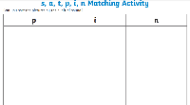  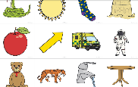 | January 5th
Reading: | Please read with your child at least 3 times this week and when you have done this write in their yellow Reading Diary so your child can get stickers from their teacher to celebrate their great reading.  Can you share your favourite book with a grown up at home?  What is your favourite part of the book?  Attached to your last week’s home learning pack was your Bug Club Password and login. On this interactive site you will find books for your child to read linked to their current phonics phases and some fun activities. There is a parents section to show you how to help your child.  Over the holidays can you read with your child at least 10 times? | Ongoing all holiday
Writing: | Can you write your name? Please practise writing your child’s name with them using the correct pencil grip and the correct letter formation shown on the sheet below.  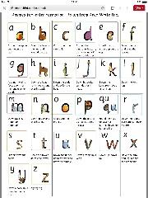  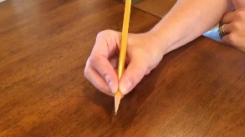  Can you practise writing the letters we have learnt in phonics this term.There is Holiday writing booklet for you to help your child to complete over the holidays with letters , tricky words, and some sentences. | Every day
Maths:
Maths | This week we have been doing lots of learning about shapes. Can you help your child to create a shape picture using circles, triangles, rectangles and squares? | January 5th
Curriculum
The World | Our Next topic is Traditional Tales  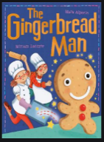  Using the book that Santa gave to your child can you tell the story of The Gingerbread Man using words and pictures? There is a story board below to help you. | January 5th

Don’t forget- we love seeing your home learning. You can always take a photo and email to school or tweet us! We are looking forward to seeing what you have been up to.
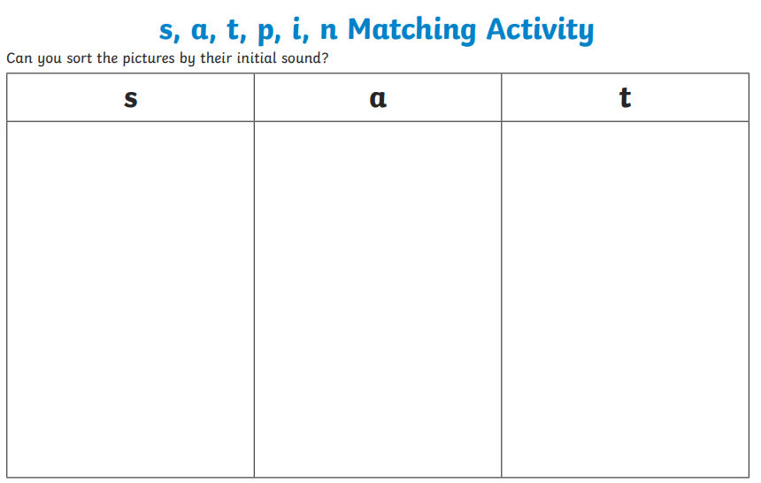

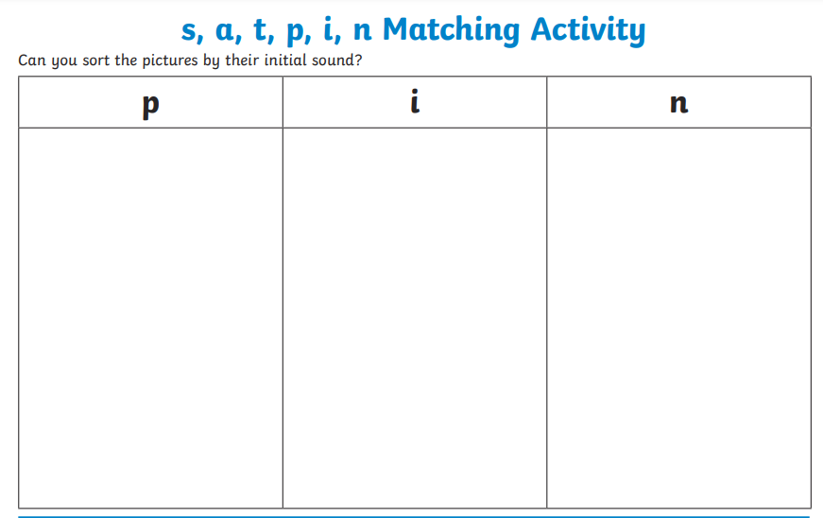

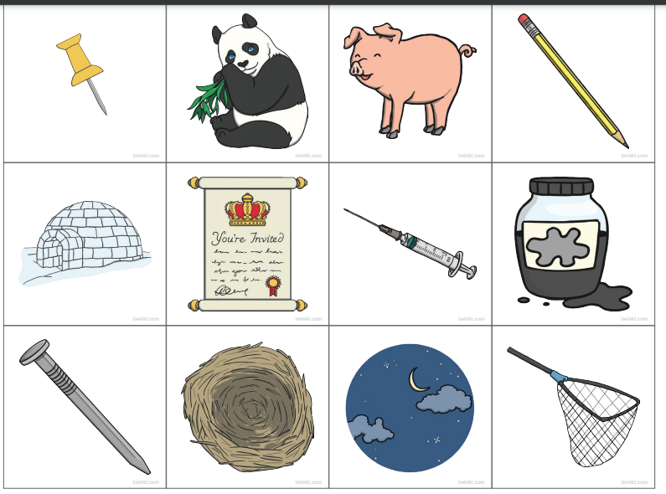
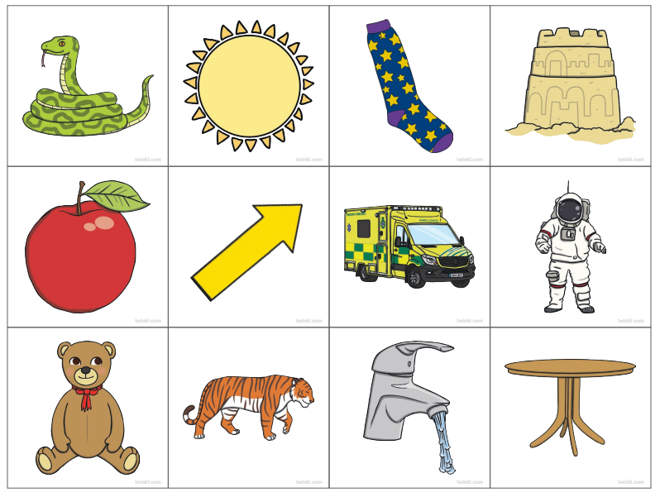
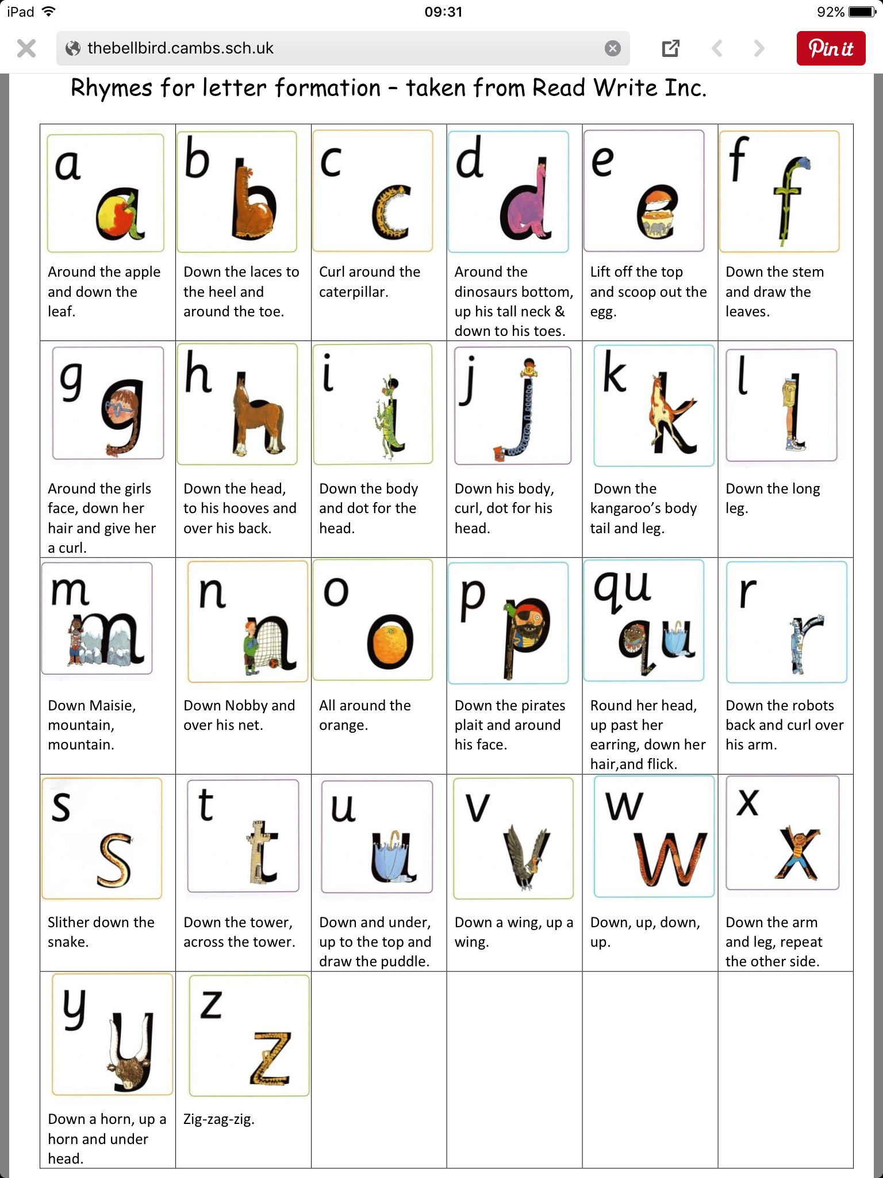
Can you create a shape picture using circles, triangles. squares and rectangles?

The Gingerbread Man
