Learning Base 2 News
Autumn 2 2019
We are ready for a new term full of exciting learning.

Our new topic……..Buildings
During our topic this half-term we will be looking at ‘Buildings’. We will be looking the buildings that are in our local area and what buildings are in our country.
We will also be looking at and talking about where we live and what we like and dislike about the local area around our homes during our local area walk.


How you can help at home…
*PLEASE continue to talk about what you notice in the world around you and what is happening in the country that you live. Please also continue to talk about what they are learning in school as this really embeds their learning.
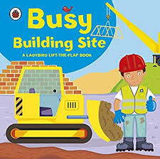
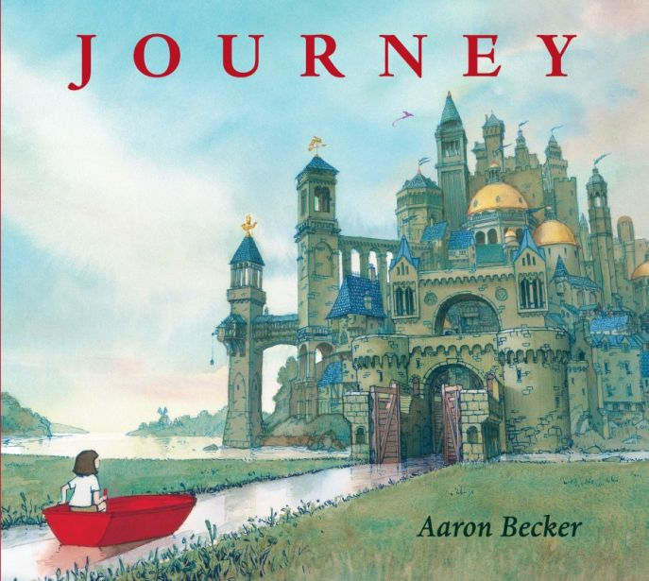
In Literacy…
The children will be looking at fiction and non-fiction books about ‘Building sites’, ‘Build a house’, ‘The building site’, ‘Homes’. ‘Animal homes’ and ‘Homes around the world’

How you can help at home…
*Read every day with your child. This can be reading the story to them and asking questions to check their understanding or asking them to tell you the story from the pictures.
*Give your child the opportunities to talk about what they have done during school.
They provide talking points with your child.
*Go to the library and share the class books and others.

In Maths
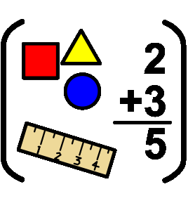
The children will continue to look at recognising numbers and learning how to count objects. We will also be learning about 2D shapes.
The children will be looking at length and height of different objects as well as learning about weight.

How you can help at home…
- Encourage your children to read numbers they see around them and count using fingers.
- Model counting when setting the table, playing games, walking (number of steps), counting cars.
- Make up maths problems for your children to solve eg. If I have 3 biscuits and I give 1 to a friend, how many will I have left?
- Talk about and compare objects you find around your home eg. Which is the tallest, shortest, longest?

Reminders
Inform school if you have any appointments.

Dance will be on a Wednesday and P.E will be on Friday. Please make sure they have a white t shirt and black shorts/joggers and pumps or trainers.
PE kits can stay in school all week as the children will also regularly take part with other physical learning eg. Pirate island, working towards walking the daily mile.
Could all parents please bring in a full change of clothes in a labelled bag
Thank you for your continued support.

