
Home Learning Year 1 Friday 17th July 2026
English |  | Completed by...
Spelling/Phonics:  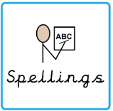 | This week we have been revitising  Mb, kn, tch  Because busy beautiful hour any many through | 3 times a week
Reading:  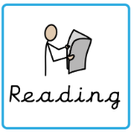 | Read to adult or older sibling 3 times this week! Don’t forget to get your adult to sign they have read with you! | 3 times a week
Core learning
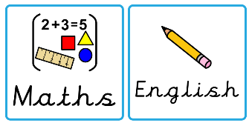  Maths/or Writing | Purple Mash 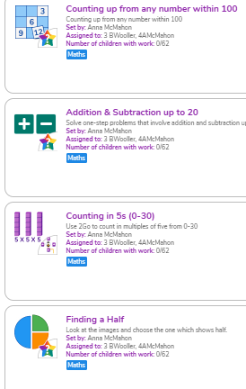  (These are optional homeworks for over the Summer as requested by some parents on parents evening) | OPTIONAL
Curriculum
  Foundation | Your child will be set home learning from their new teacher (Miss Coyle) from class 5 (daffodil class). Please look our for the home learning to be completed over the summer. | Sep 2026

