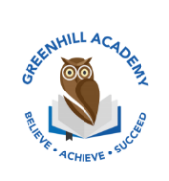
Home Learning Year 1 Friday 5th June 2026
English |  | Completed by...
Spelling/Phonics:  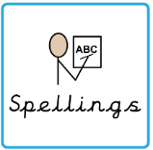 | This week we have been learning  -ing -es ue/ue ew/ew au aw wr and ou.  Tricky words:  Eye, people, because, water, once | 3 times a week
Reading:  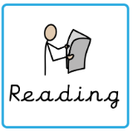 | Read to adult or older sibling 3 times this week! Don’t forget to get your adult to sign they have read with you! | 3 times a week
Core learning
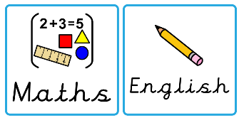  Maths/or Writing | Purple Mash 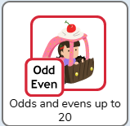 | Wednesday
Curriculum
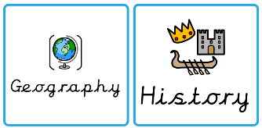  Foundation | We are learning about The Great Fire of London.  Can you create a scene from London in 1666? | July 2026

