
Home Learning Year 1 Friday 22nd May 2026
English |  | Completed by...
Spelling/Phonics:  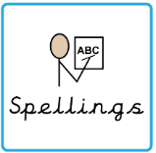 | Please practise the sounds of phase 2, 3 and 5 with your child.  Phonics screening will start after half term. | 3 times a week
Reading:   | Read to adult or older sibling 3 times this week! Don’t forget to get your adult to sign they have read with you! | 3 times a week
Core learning
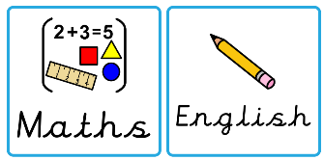  Maths/or Writing | Purple Mash 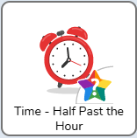  | Wednesday
Curriculum
  Foundation | We will be learning about The Great Fire of London.  Can you create a scene from London in 1666? | July 2026

