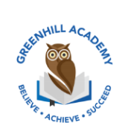
Home Learning Year 3 Friday 17th April 2026
English |  | Completed by...
Spelling/Phonics:  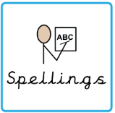 | Weekly spellings in spelling book. | Thursday
Reading:  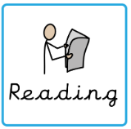 | Read to adult or older sibling 3 times this week! Don’t forget to get your adult to sign they have read with you!  Why not answer this question after reading:  Write a sentence explaining what has happened. | 3 times a week
Core learning
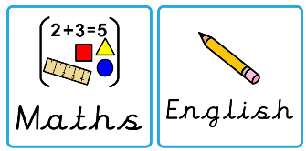  Maths/or Writing | Addition recap  Purple Mash | Wednesday
Curriculum
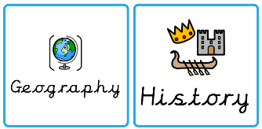  Foundation | This half term we will be learning all about the Mayans. Could you create a project such as a poster, Powerpoint Presentation or fact file? Or maybe create a temple like the one in Chichen Itza or design a traditional Mayan mask.  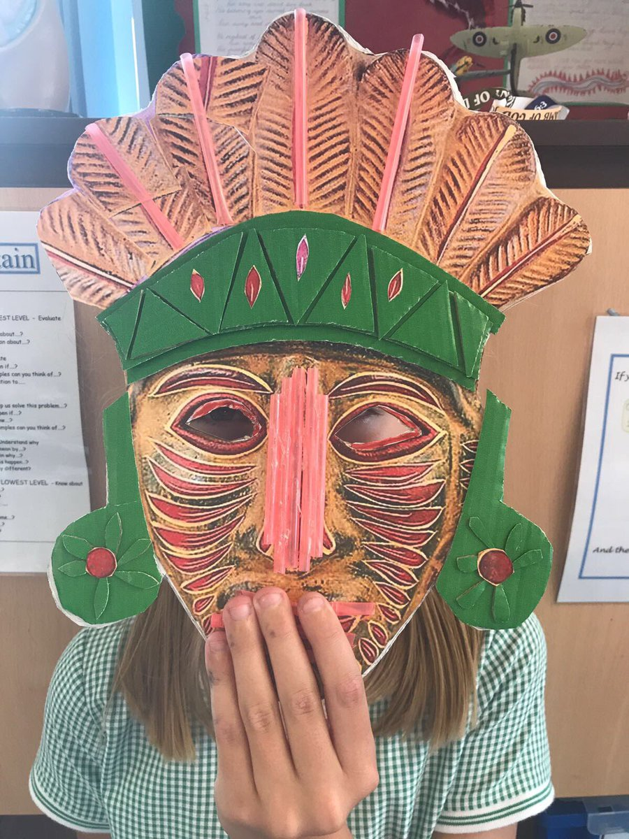  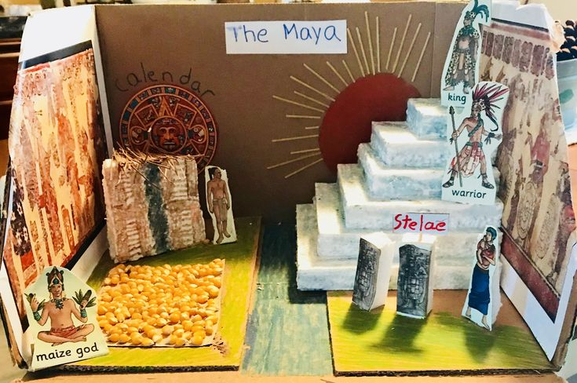  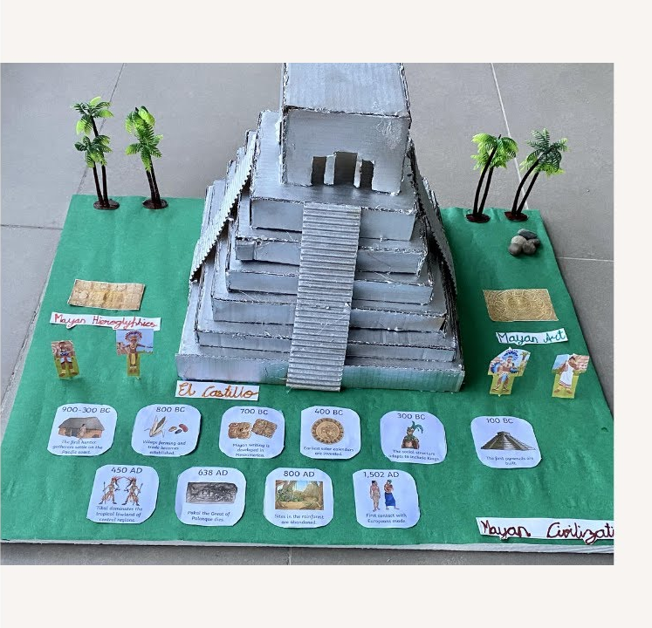 | On going- Due 22nd May 2026

