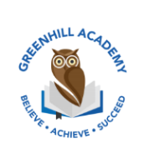
Home Learning Year 1 Friday 27th March2026
English |  | Completed by...
Spelling/Phonics:  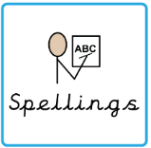 | This week, we have learned the sounds:  a (or – ball), o (a – wasp), ear (air – pear)  These are the tricky words:  Who, whole, because, eye, people, thought, though  Can you spot any of these sounds in your reading books? | 3 times a week
Reading:  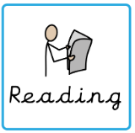 | Read to adult or older sibling 3 times this week! Don’t forget to get your adult to sign they have read with you! | 3 times a week
Core learning
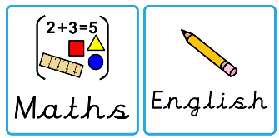  Maths/or Writing | Purple Mash 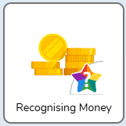 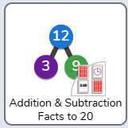 | Wednesday
Curriculum
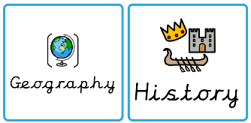  Foundation | We will be learning about Africa after half term.  Can you create poster about Kenya?  Think about where Kenya is in Africa, the flag, animals that live there, schools and the weather. | May 2026

