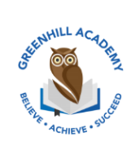
Home Learning Year 1 Friday 6th March2026
English |  | Completed by...
Spelling/Phonics:  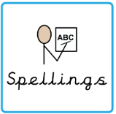 | This week, we have learned the sounds:  Ow, oe, o_e, ou, o and oa  These are the tricky words:  People, your, their, thought, through, friend, work  Can you spot any of these sounds in your reading books? | 3 times a week
Reading:  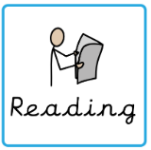 | Read to adult or older sibling 3 times this week! Don’t forget to get your adult to sign they have read with you! | 3 times a week
Core learning
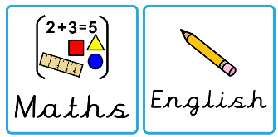  Maths/or Writing | Purple Mash 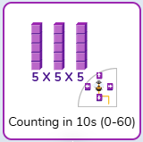 | Wednesday
Curriculum
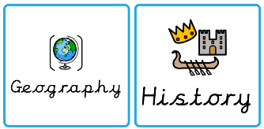  Foundation | We will be learning about castles after half term.  Can you create a castle at home and label the different parts?  We will share these at the end of term in our fantastic finish. | March 2026

