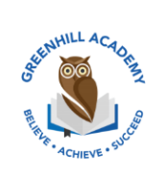
Home Learning Year 3 Friday 27th February 2027
English |  | Completed by...
Spelling/Phonics:  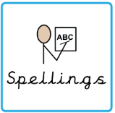 | Practice spellings in your spelling book. | Wednesday
Reading:  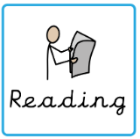 | Read to adult or older sibling 3 times this week! Don’t forget to get your adult to sign they have read with you!  Why not answer this question after reading:  How do the characters feel? Why? | 3 times a week
Core learning
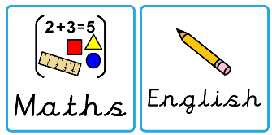  Maths/or Writing | Can you answer the questions about Place Value?  Purple Mash | Wednesday
Curriculum
  Foundation | This half term we will be learning all about the Noble Nile you create a project such as a poster, Powerpoint Presentation or fact file?  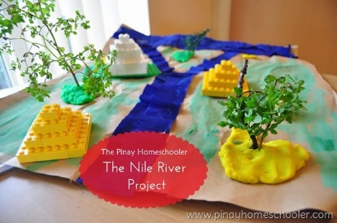  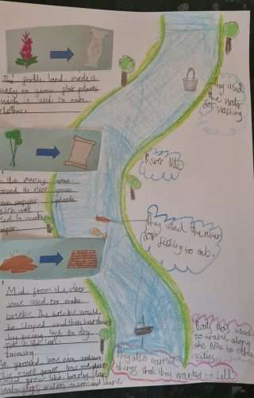 | On going- Due 27th March 2026

