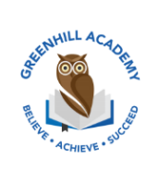
Home Learning Year 1 Friday 12th February 2026
English |  | Completed by...
Spelling/Phonics:  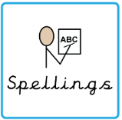 | This week, we have learned the sounds:  Le al ve c  These are the tricky words:  Mrs Mrs Ms ask call and school  Can you spot any of these sounds in your reading books? | 3 times a week
Reading:  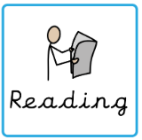 | Read to adult or older sibling 3 times this week! Don’t forget to get your adult to sign they have read with you! | 3 times a week
Core learning
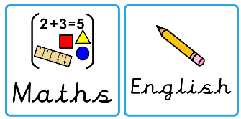  Maths/or Writing | Purple Mash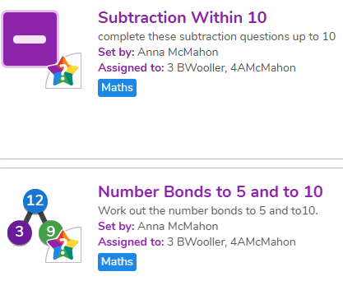 | Wednesday  25.5.26
Curriculum
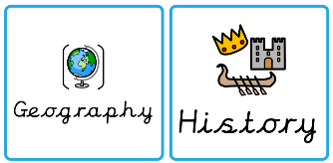  Foundation | We will be learning about castles after half term.  Can you create a castle at home and label the different parts?  We will share these at the end of term in our fantastic finish. | March 2026

