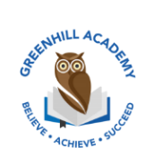
Home Learning Year 1 Friday 23rd January 2026
English |  | Completed by...
Spelling/Phonics:  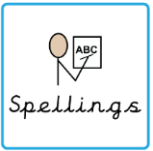 | This week, we have learned the sounds:  Ue (blue), u (unicorn), o (go), i_e (time), o_e (home)  These are the tricky words:  Here, today, one, their, people, oh, Mr, Mrs, Ms, ask, could, would  Can you spot any of these sounds in your reading books? | 3 times a week
Reading:  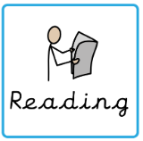 | Read to adult or older sibling 3 times this week! Don’t forget to get your adult to sign they have read with you! | 3 times a week
Core learning
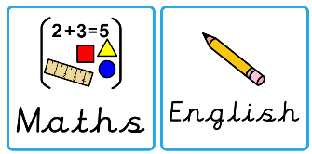  Maths/or Writing | Purple Mash  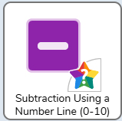 | Wednesday
Curriculum
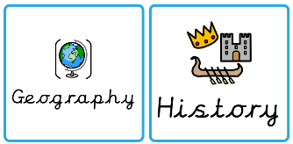  Foundation | We will be learning about Great Britain in our Geography after half term.  Can you research one landmark in Great Britain and make a poster? | 5th Feb 2025

