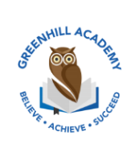
Home Learning Year 1 Friday 19st December 2025
English |  | Completed by...
Spelling/Phonics:  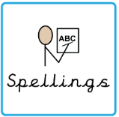 | This week, we have learned to “grow the code”  ie i i_e igh  a ay ai a_e  oa o o_e  ew u_e u ue oo  e ie e_e ea ee  These are the tricky words:  want could your people their  Can you spot any of these sounds in your reading books? | 3 times a week
Reading:  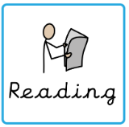 | Read to adult or older sibling 3 times this week! Don’t forget to get your adult to sign they have read with you! | 3 times a week
Core learning
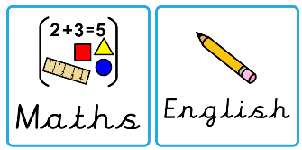  Maths/or Writing | Purple Mash  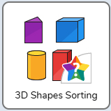 | Wednesday
Curriculum
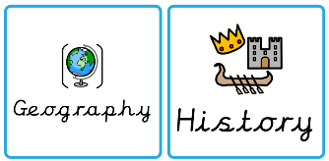  Foundation | We will be learning about Great Britain in our Geography after half term.  Can you research one landmark in Great Britain and make a poster? | 5th January 2025

