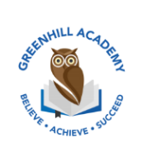
Home Learning Year 1 Friday 12st December 2025
English |  | Completed by...
Spelling/Phonics:  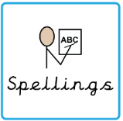 | This week, we have learned to “grow the code”  ie i i_e igh  a ay ai a_e  oa o o_e  ew u_e u ue oo  e ie e_e ea ee  These are the tricky words:  House mouse water want they pure sure could would should our some come love your people their oh Mr Mrs Ms were there little here today one their when what want  Can you spot any of these sounds in your reading books? | 3 times a week
Reading:  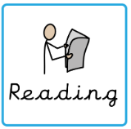 | Read to adult or older sibling 3 times this week! Don’t forget to get your adult to sign they have read with you! | 3 times a week
Core learning
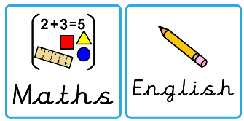  Maths/or Writing | Purple Mash  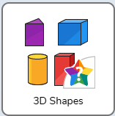 | Wednesday
Curriculum
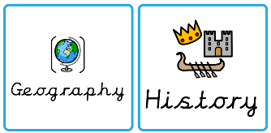  Foundation | We will be learning about Great Britain in our Geography after half term.  Can you research one landmark in Great Britain and make a poster? | 5th January 2025

