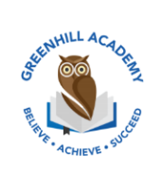
Home Learning Year 5 – Friday 12th December 2025
English |  | Completed by...
Spelling/Phonics/ Grammar:  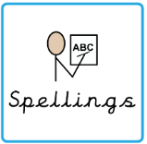 | Using an apostrophe correctly- Purple mash task. | Wednesday
Reading:  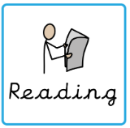 | Read to adult or older sibling 3 times this week! Don’t forget to get your adult to sign in your reading diary when they have read with you!  Why not answer this question after reading:  Can you summarise your chapter in 5 sentences? | 3 times a week
MyOn task: | Read Our Home Planet: Earth. Choose some interesting facts from the book and create your own fact file about the Earth. | Wednesday
Core learning
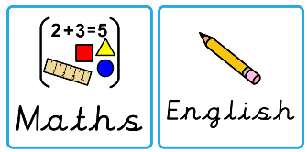  Maths/or Writing | Maths – Sumdog each night | Wednesday
Curriculum
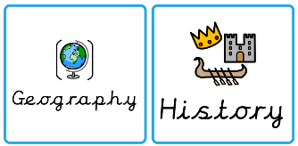  Foundation | Our Marvellous Maps Project…  Over this next half term, we would like you to complete a project on what you have learnt in our topic lessons. Be as creative as possible. Think about the layout, whether you want to do it on your iPad, as a piece of artwork or as a fact file. We look forward to seeing them before we break up for the Christmas holidays. | On going

