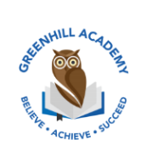
Home Learning Year 1 Friday 5th December 2025
English |  | Completed by...
Spelling/Phonics:  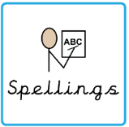 | This week, we have recapped all the sounds of phase 2,3 and 5  and the tricky words:  could would should our house mouse water  Can you spot any of these sounds in your reading books? | 3 times a week
Reading:  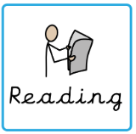 | Read to adult or older sibling 3 times this week! Don’t forget to get your adult to sign they have read with you! | 3 times a week
Core learning
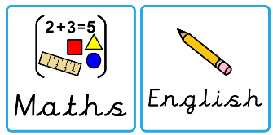  Maths/or Writing | Purple Mash  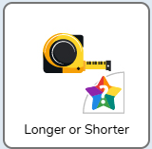 | Wednesday
Curriculum
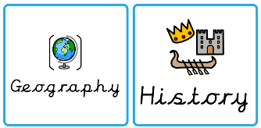  Foundation | 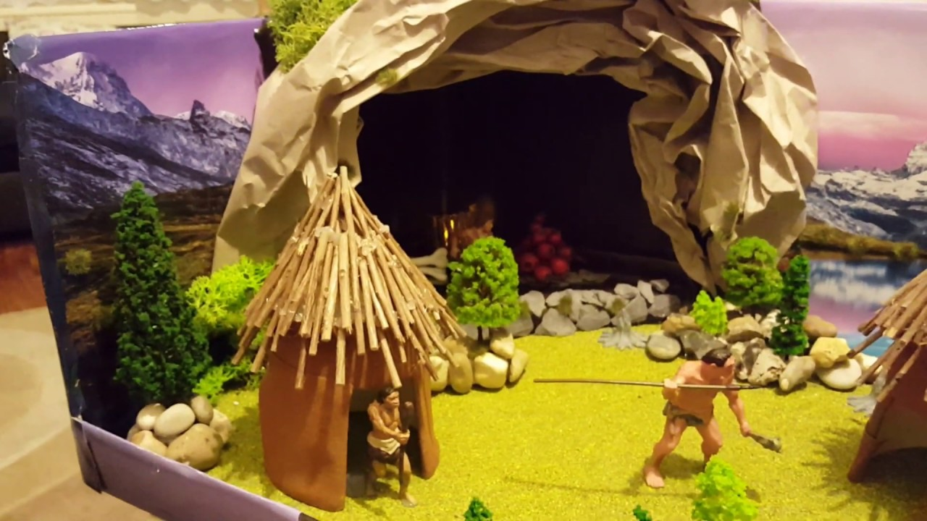  This half term we will be learning all about dinosaurs. Could you create a project such as a poster, Powerpoint Presentation or fact file? Or maybe draw some dinosaurs  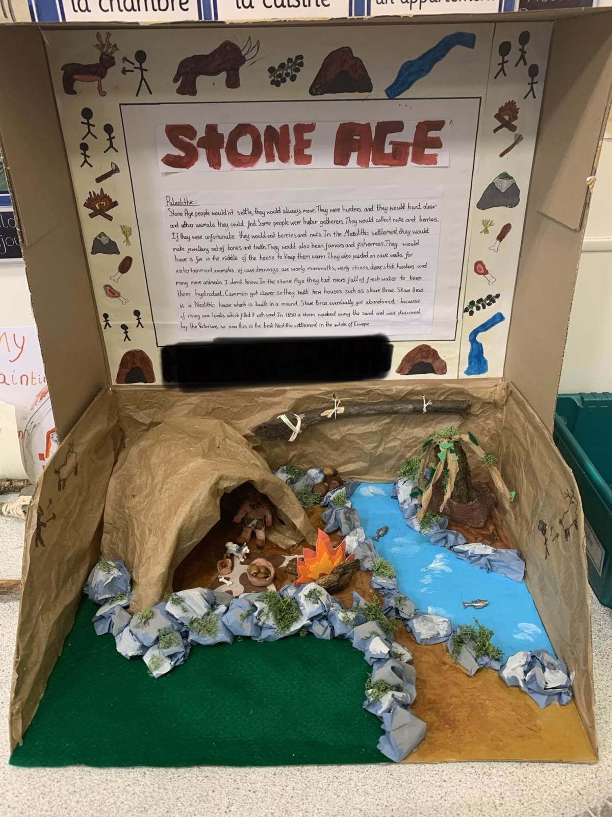  or create a dinosaur scene in a shoebox? | On going- Due 19th December 2025

