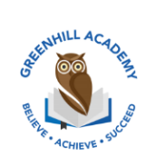
Home Learning Year 5 – Friday 28th November 2025
English |  | Completed by...
Spelling/Phonics:  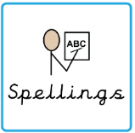 | Year 5 spelling | Wednesday
Reading:  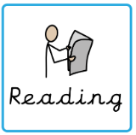 | Read to adult or older sibling 3 times this week! Don’t forget to get your adult to sign in your reading diary when they have read with you!  Why not answer this question after reading:  Can you summarise your chapter in 5 sentences? | 3 times a week
MyOn task: | Read and quiz on 'The Loch Ness Monster'. Make links between the story of the sea serpent's daughter and the loch ness monster.  Make links between the story of the sea serpent's daughter and the loch ness monster. | Wednesday
Core learning
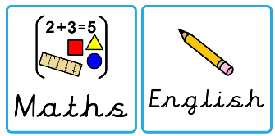  Maths/or Writing | Maths – complete at least 10 minutes each night on TTrockstars. | Wednesday
Curriculum
  Foundation | Our Marvellous Maps Project…  Over this next half term, we would like you to complete a project on what you have learnt in our topic lessons. Be as creative as possible. Think about the layout, whether you want to do it on your iPad, as a piece of artwork or as a fact file. We look forward to seeing them before we break up for the Christmas holidays. | On going

