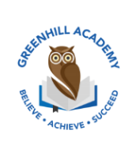
Home Learning Year 1 Friday 21st November 2025
English |  | Completed by...
Spelling/Phonics:  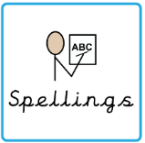 | This week, we have learned the sounds:  a_e, e_e, i_e, o_e and u_e  These are split digraphs.  and the tricky words:  could, would, should  Can you spot any of these sounds in your reading books? | 3 times a week
Reading:  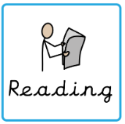 | Read to adult or older sibling 3 times this week! Don’t forget to get your adult to sign they have read with you! | 3 times a week
Core learning
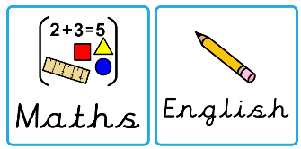  Maths/or Writing | Purple Mash  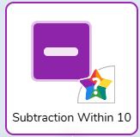 | Wednesday
Curriculum
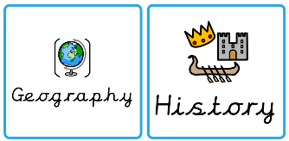  Foundation | 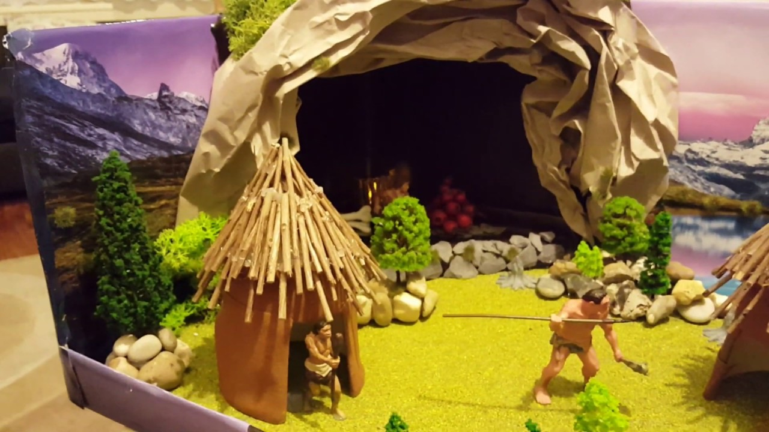  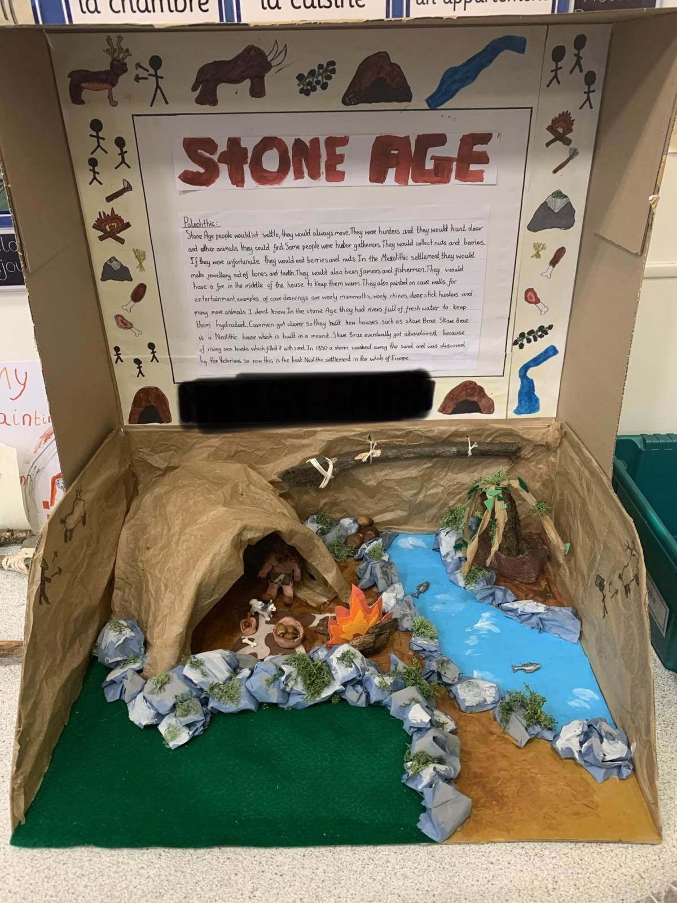  This half term we will be learning all about dinosaurs. Could you create a project such as a poster, Powerpoint Presentation or fact file? Or maybe draw some dinosaurs or create a dinosaur scene in a shoebox? | On going- Due 19th December 2025

