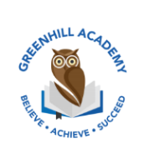
Home Learning Year 5 – Friday 14th November 2025
English |  | Completed by...
Spelling/Phonics:  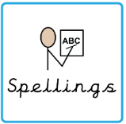 | Year 5 spellings | Wednesday
Reading:  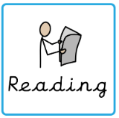 | Read to adult or older sibling 3 times this week! Don’t forget to get your adult to sign in your reading diary when they have read with you!  Why not answer this question after reading:  Can you summarise your chapter in 5 sentences? | 3 times a week
MyOn task: | MyON – Read the NewsRound article – Trump Vs Harris by copying the link into your web browser  Trump vs Harris: Everything you need to know about US Election - BBC Newsround | Wednesday 13th November
Core learning
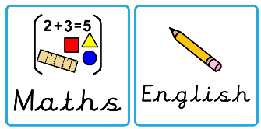  Maths/or Writing | Maths – find the equivalent fraction. | Wednesday 13th November
Curriculum
  Foundation | Our Marvellous Maps Project…  Over this next half term, we would like you to complete a project on what you have learnt in our topic lessons. Be as creative as possible. Think about the layout, whether you want to do it on your iPad, as a piece of artwork or as a fact file. We look forward to seeing them before we break up for the Christmas holidays. | On going

