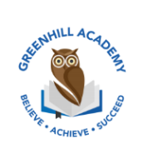
Home Learning Year 5 – Friday 10th October 2025
English |  | Completed by...
Spelling/Phonics:  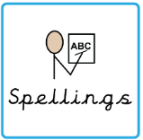 | Practice your Y5 spellings. | Wednesday
Reading:  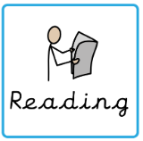 | Read to adult or older sibling 3 times this week! Don’t forget to get your adult to sign in your reading diary when they have read with you!  Why not answer this question after reading:  Can you summarise your chapter in 5 sentences? | 3 times a week
Core learning
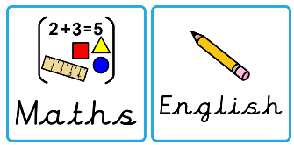  Maths/or Writing | Literacy-  To research William Shakespeare and write a paragraph about his life. | Wednesday
Curriculum
  Foundation | Our Tudor Project…  Over this half term, we would like you to complete a project on what you have learnt in our topic lessons. Be as creative as possible. Think about the layout, whether you want to do it on your iPad, as a piece of art work or as a fact file. We look forward to seeing them before we break up for October half term. | On going

