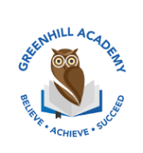**Home Learning Year 5 – *Friday 3rd October 2025***

|  |  |  |
| --- | --- | --- |
| **English** | | **Completed by...** |
| **Spelling/Phonics:** | Read, write and check the spellings for this week. | *Wednesday* |
| **Reading:** | Read to adult or older sibling 3 times this week! Don’t forget to get your adult to sign in your reading diary when they have read with you!  **Why not answer this question after reading:**  **Can you summarise your chapter in 5 sentences?** | *3 times a week* |
| **Core learning** | |  |
| **Maths/or Writing** | Maths-  To practice multiplying by 10, 100 and 1000 mentally.  Complete the multiplication sheet and see how long it takes you. | *Wednesday* |
| **Curriculum** | |  |
| **Foundation** | Our Tudor Project…  Over this half term, we would like you to complete a project on what you have learnt in our topic lessons. Be as creative as possible. Think about the layout, whether you want to do it on your iPad, as a piece of art work or as a fact file. We look forward to seeing them before we break up for October half term. | On going |