s | a | i | d | m | n | f | g | s | o
o | q | w | r | t | y | u | i | o | s
z | x | s | v | b | n | m | a | j | a
r | d | c | g | s | a | i | d | e | i
s | p | l | k | h | b | v | f | w | d
a | s | t | b | s | o | v | c | d | S
i | y | w | s | z | c | x | n | s | b
d | j | s | a | i | d | r | e | o | m
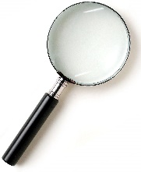
Word Search!
Find said
and so

Word Search!
Find said
and so

s | a | i | d | m | n | f | g | s | o
o | q | w | r | t | y | u | i | o | s
z | x | s | v | b | n | m | a | j | a
r | d | c | g | s | a | i | d | e | i
s | p | l | k | h | b | v | f | w | d
a | s | t | b | s | o | v | c | d | S
i | y | w | s | z | c | x | n | s | b
d | j | s | a | i | d | r | e | o | m





