Wednesday Geography resources
The United Kingdom Map
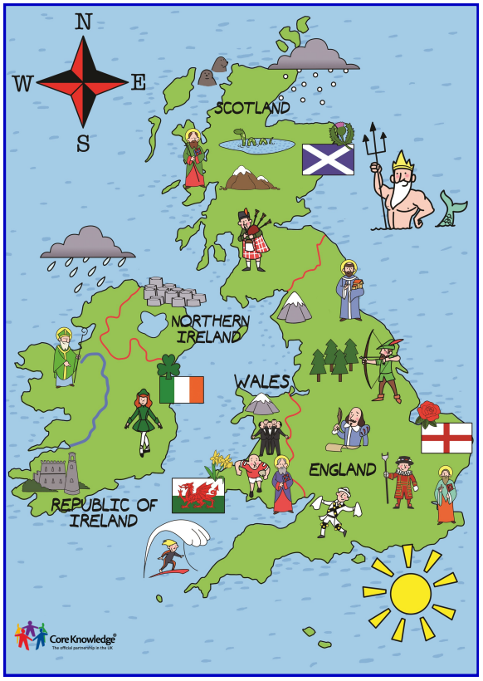

UK map for teaching

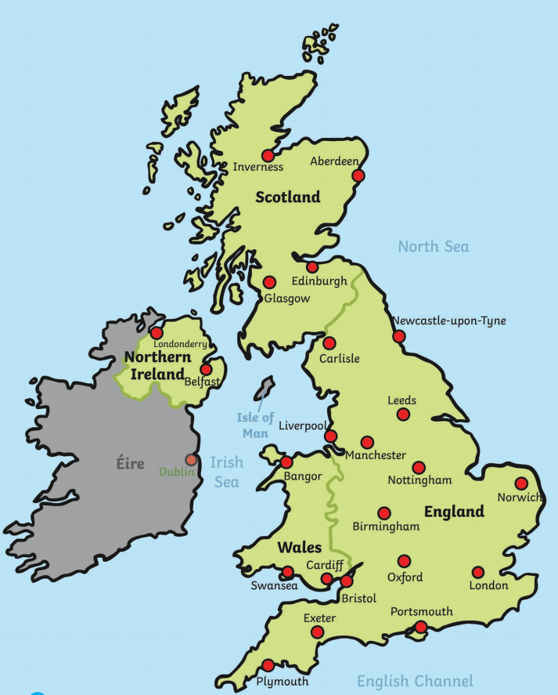

Wales relief map

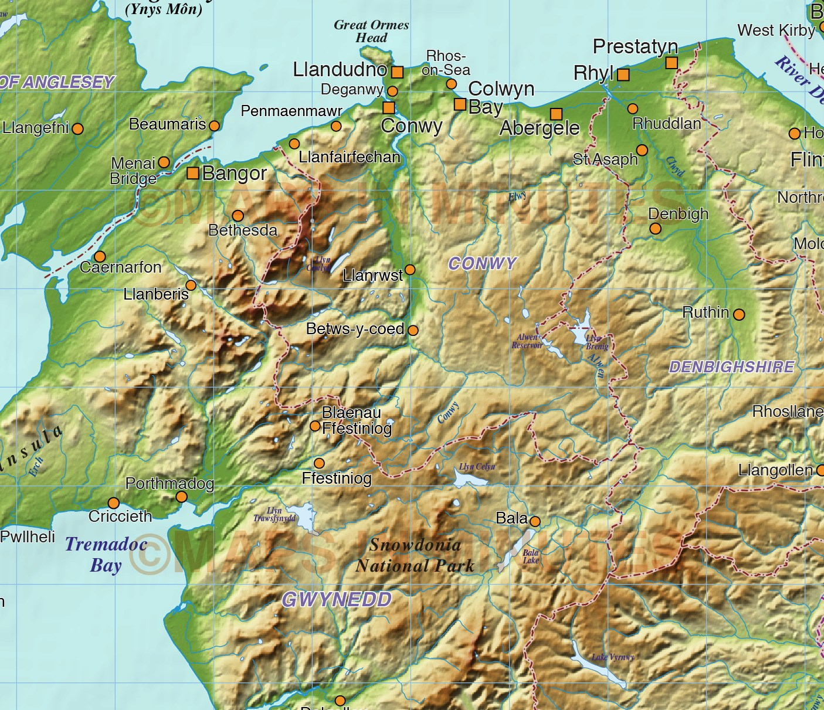

Mountains and valleys in Wales- where are they in the pictures?

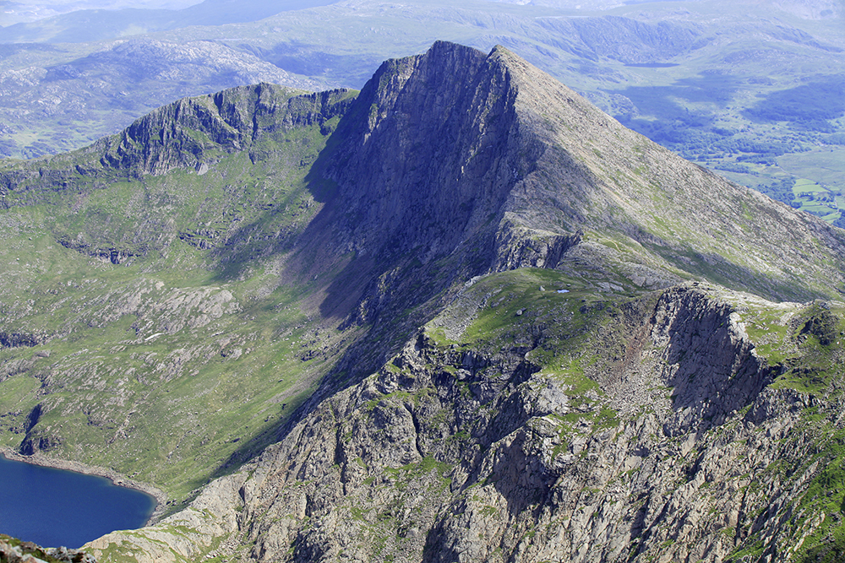
Snowdown

Cadair Idris


Pen y Fan

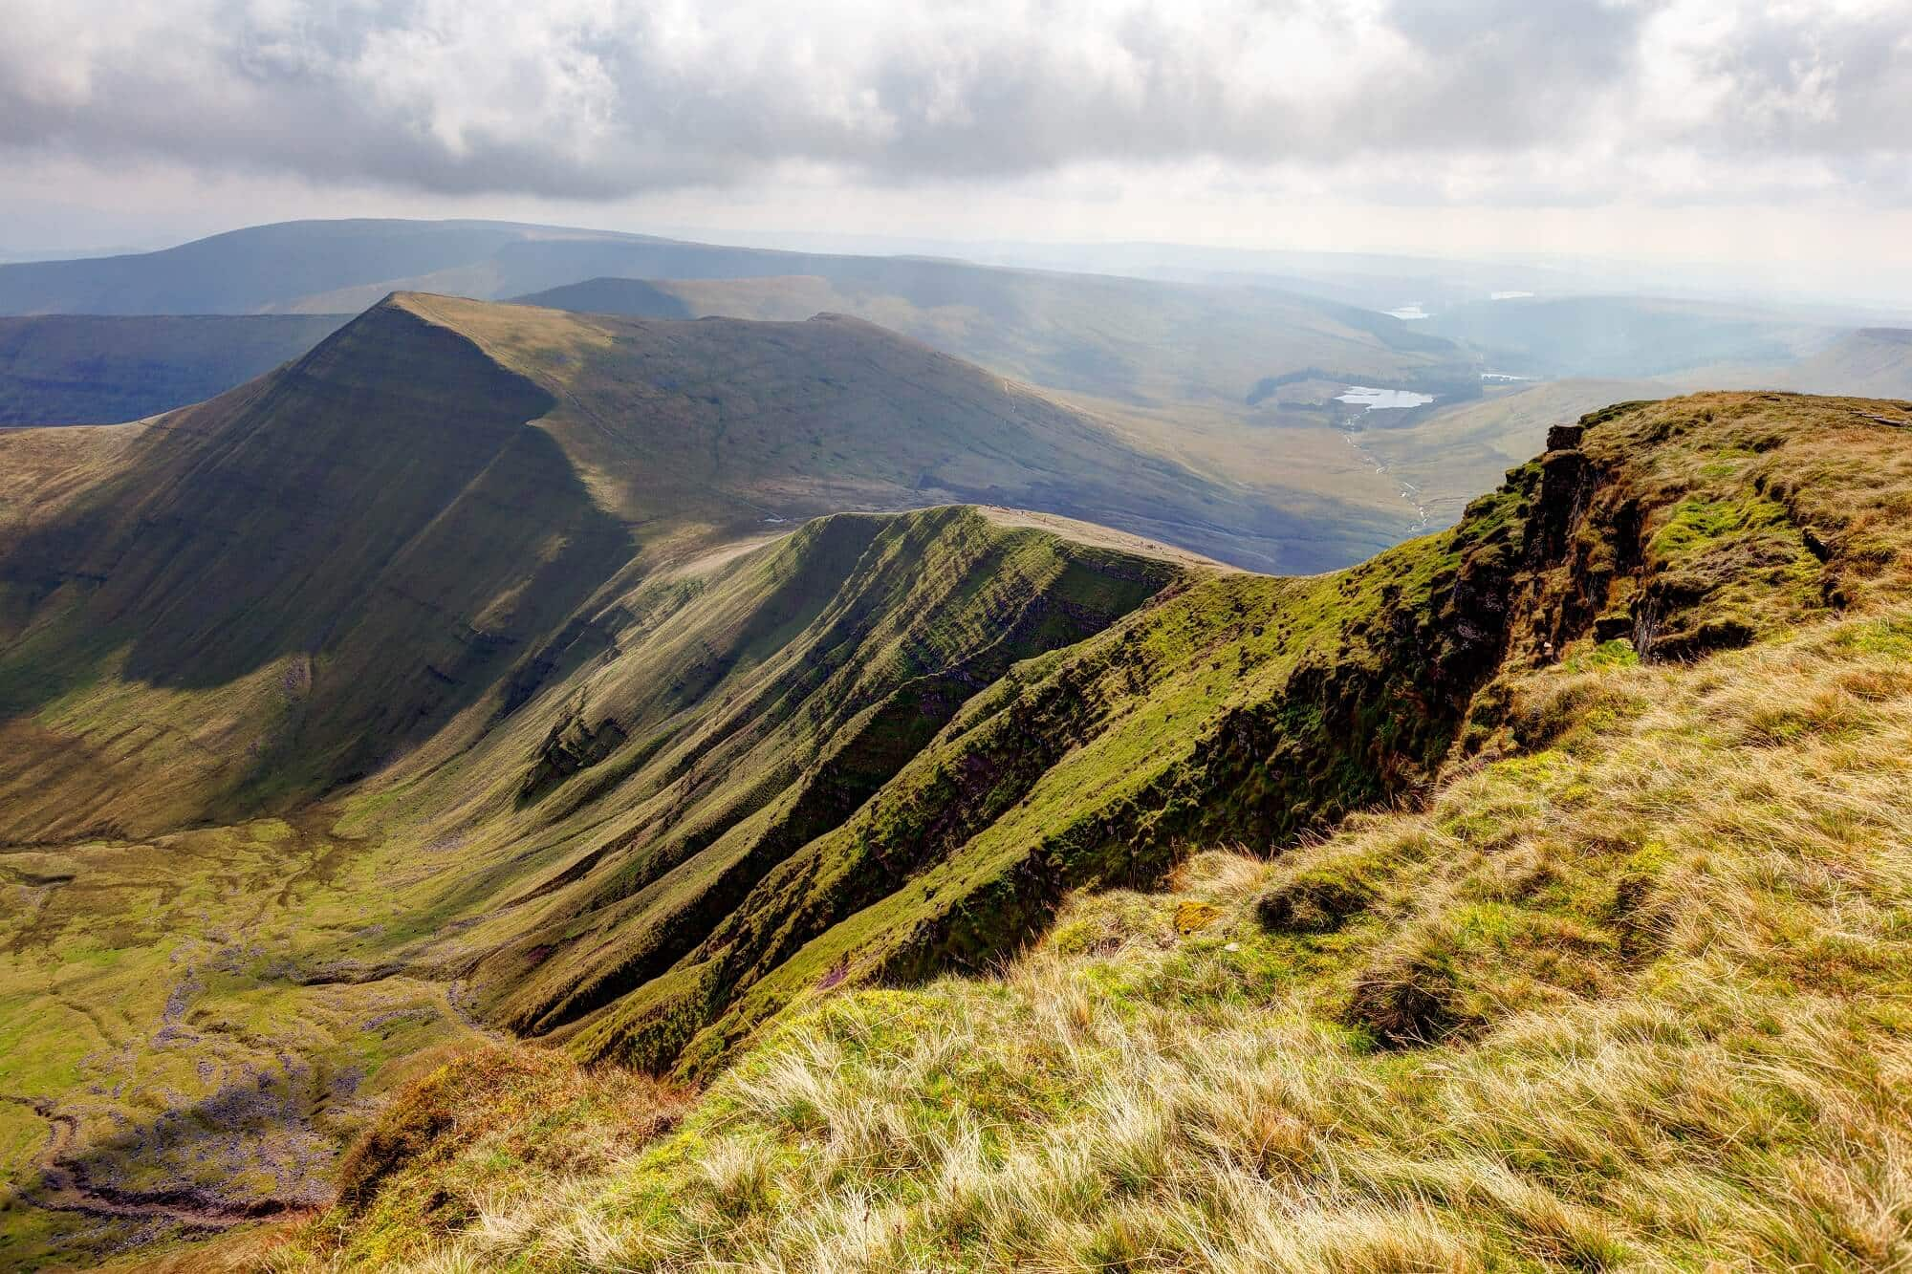

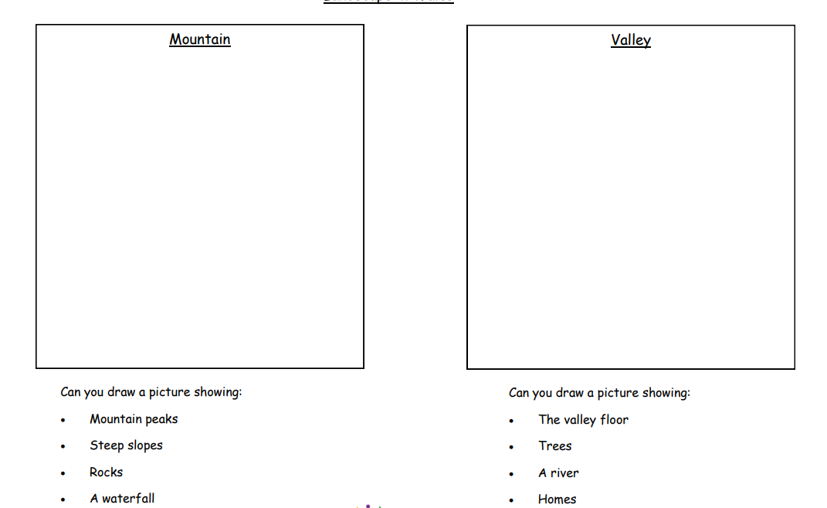

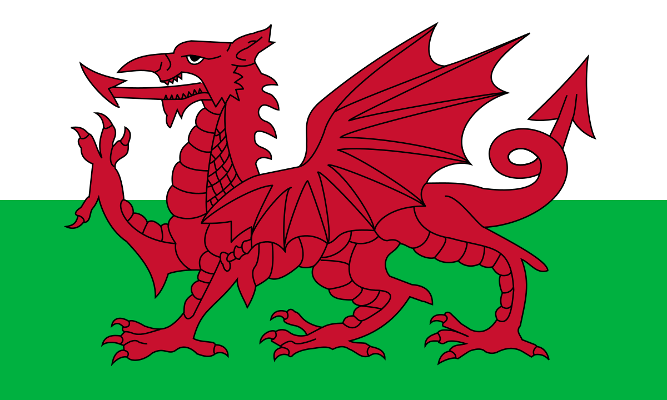

There are many stories of dragons throughout history, and we cannot be sure why the dragon was chosen for the Welsh flag. We do know that Henry Tudor carried a flag depicting the dragon into battle in 1485 at the Battle of Bosworth Field. Many Welsh people today are proud of the red dragon as it symbolises strength and courage.

The Welsh Flag






