
Adverbial Phrase
A Phrase which answers How? Where? or When?

Finish each sentence by adding an Adverbial Phrase:
Where?
The beast dribbled __________________________________________________________________________________

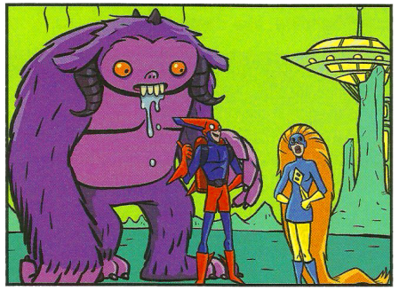

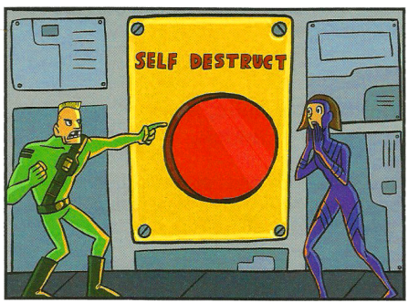
How?
The stupid man pressed the self-destruct __________________________________________________________________________________

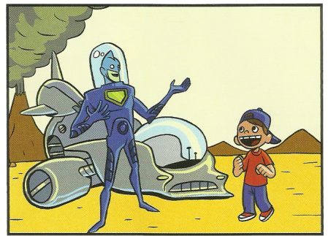
Where?
The alien landed __________________________________________________________________________________

Write a sentence, including an Adverbial Phrase, for each picture:
When?_____________________________________________________________________________Where?_______________________________________________________________________________________

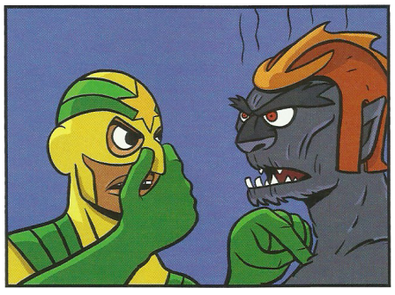

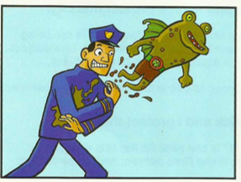
Where?____________________________________________________________________________How?_______________________________________________________________________________________

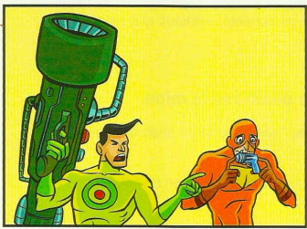
Where?____________________________________________________________________________How?_______________________________________________________________________________________

Where?____________________________________________________________________________How?______________________________________________________________________________ When?_____________________________________________________________________________

