Year 5 Maths Curriculum
Some further information on how we develop children’s fluency with basic number facts
Fluent computational skills are dependent on accurate and rapid recall of basic number bonds to 20 and times-tables facts. At Ashdene we spend a short time every day on these basic facts quickly leads to improved fluency. This can be done using simple whole class chorus chanting. This is not meaningless rote learning; rather, this is an important step to developing conceptual understanding through identifying patterns and relationships between the tables (for example, that the products in the 6× table are double the products in the 3× table). We learn our multiplication tables in this order to provide opportunities to make connections:
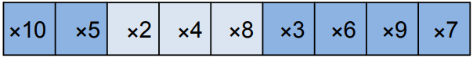
Develop children’s fluency in mental calculation
Efficiency in calculation requires having a variety of mental strategies. In particular, we recognise the importance of 10 and partitioning numbers to bridge through 10. For example: 9 + 6 = 9 + 1 + 5 = 10 + 5 = 15. It is helpful to make a 10 as this makes the calculation easier.
Develop fluency in the use of formal written methods
Teaching column methods for calculation provides the opportunity to develop both procedural and conceptual fluency. At Ashdene we ensure that children understand the structure of the mathematics presented in the algorithms, with a particular emphasis on place value. We use concrete resources to support the development of fluency and understanding. Informal methods of recording calculations are an important stage to help children develop fluency with formal methods of recording. However, it is important that these are only used for a short period, to help children understand the internal logic of formal methods of recording calculations. These are the stepping stones to formal written methods.

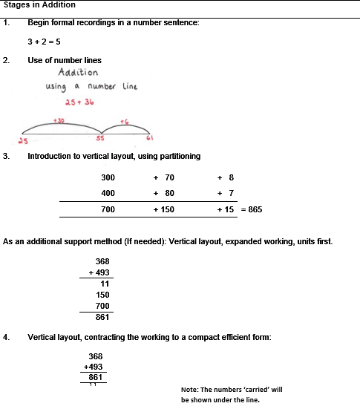 | 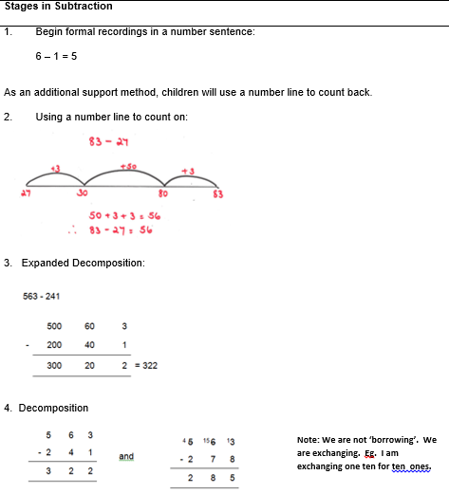

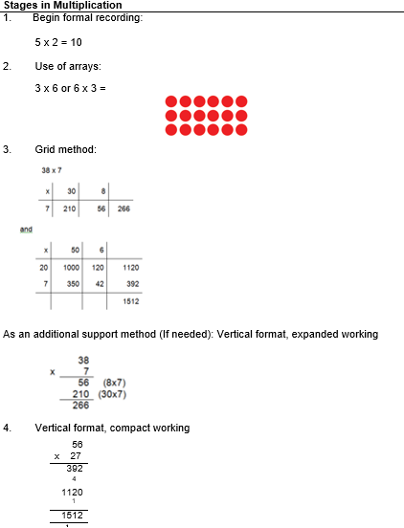 | 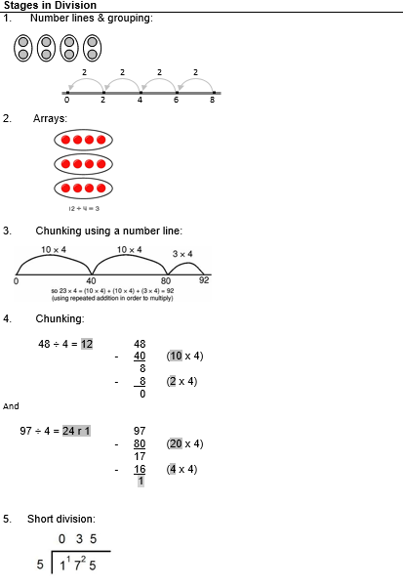

Ashdene Primary School – Maths Curriculum

Purpose of study |  | Mathematics is a creative and highly inter-connected discipline that has been developed over centuries, providing the solution to some of history’s most intriguing problems. It is essential to everyday life, critical to science, technology and engineering, and necessary for financial literacy and most forms of employment. A high-quality mathematics education therefore provides a foundation for understanding the world, the ability to reason mathematically, an appreciation of the beauty and power of mathematics, and a sense of enjoyment and curiosity about the subject.
Aims |  | - become fluent in the fundamentals of mathematics, including through varied and frequent practice with increasingly complex problems over time, so that pupils develop conceptual understanding and the ability to recall and apply knowledge rapidly and accurately  - reason mathematically by following a line of enquiry, conjecturing relationships and generalisations, and developing an argument, justification or proof using mathematical language  - can solve problems by applying their mathematics to a variety of routine and non-routine problems with increasing sophistication, including breaking down problems into a series of simpler steps and persevering in seeking solutions.
Maths at Ashdene |  | At Ashdene in every maths lesson we aim to develop children’s reasoning and problem solving. Furthermore, children develop their mathematical understanding through the use of concrete, pictorial and abstract resourcing which are made available to all children in every lesson. We aim to revisit and review mathematical concepts and make links between them in order to ensure children have a deeper understanding of the maths curriculum.
Year 5

HT5 | Week |  | Mental Maths | Maths Curriculum
HT5 | 1  (4 days) |  | Times Tables 1-12 | Retrieval Week  Fractions/ Decimals and Percentages (Place Value and Equivalence)
HT5 | 2 |  | 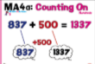 | Decimals – National Curriculum Links  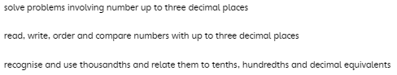
HT5 | 3  (4 days) |  | 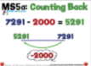
HT5 | 4 |  | 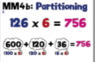
HT5 | 5 |  | 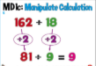 | Converting Units – National Curriculum Links  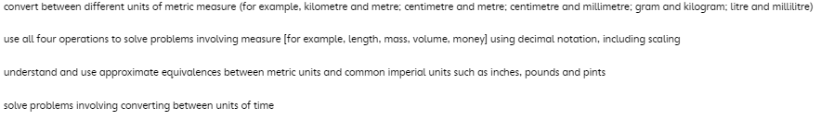
HT5 | 6  (4 days) |  | 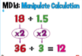
HT6 | Week |  | Mental Maths | Maths Curriculum
HT6 | 1  (4 days) |  | 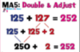 | Retrieval Week  Multiplication and Division Written Methods
HT6 | 2 |  | 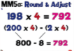 | Multiplication and Division (1) – National Curriculum Links  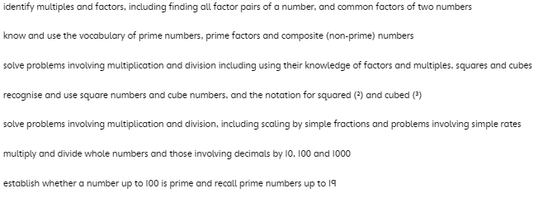
HT6 | 3 |  | 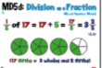
HT6 | 4 |  | 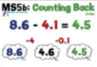 | Geometry – Properties of Shape (1) – National Curriculum Links  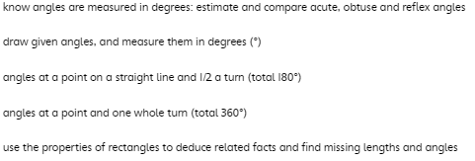  Geometry – Properties of Shape (2) – National Curriculum Links  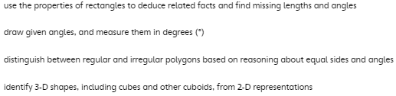
HT6 | 5 |  | Times Tables 1-12
HT6 | 6 |  | Times Tables 1-12 | Retrieval Week  Place Value and the Four Operations
HT6 | 7  (3 days) |  | Times Tables 1-12 | Retrieval Week  Place Value and the Four Operations

