Wellbeing Film Night

Wednesday 12th February
3:25pm – 5:00pm

Children are invited to stay after school to watch an age appropriate film in a classroom.

£4 per child which includes: movie, drink & a hot dog
(or dietary applicable alternative)

***Booking open via School Spider app or if you log into the school website***
Booking strictly closes on Tuesday 11th February at 4pm - we CANNOT add any more on after this date/time.
Reception film: Zog/ Zog and the Flying Doctors (U) 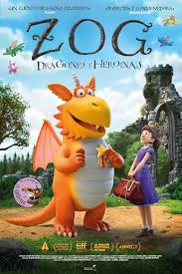 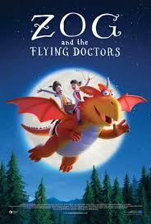
KS1 film: Inside Out(U) 

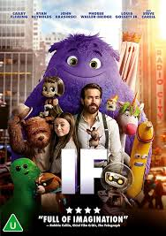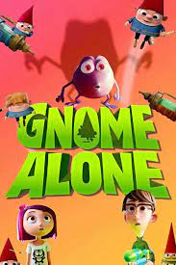

KS2 film: If (U)

.

