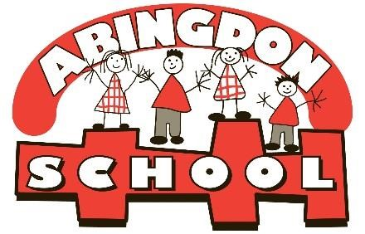
Abingdon Primary School
Abingdon Road
Reddish
Stockport
SK5 7ET
Telephone: 0161 480 4531
Acting Headteacher: Ms C Flanders
Email: admin@abingdon.stockport.sch.uk

Newsletter Friday 9th September 2022

Dates for your diary:

Wednesday 21st September – Meet your teacher drop in 3.30pm – 5pm (more details to follow)
Friday 23rd September – INSET day School Closed
Thursday 20th October harvest assembly (more details to follow)
Friday 21st October -Thumbs up Friday 8.45 until 9.10
- Abingdon Café 9- 10am
-Finish for Half term

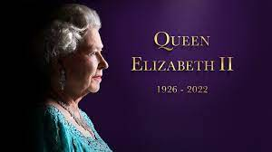

As a school, we are saddened to hear about the passing of the Queen. She was an inspiration to us all; such a hardworking, committed and dedicated woman. She will be missed. We have talked about her today with the children in our classes and in our Celebration assembly. Our thoughts and prayers are with King Charles III and the Royal Family.

Welcome back! I hope you all had a lovely summer and had chance to read the welcome back letter I sent last Friday. It is on class dojo, but I will send out another copy with this newsletter today.

We have had an amazing first week back. All the children have settled into their new classes so well. A huge welcome to our new Reception families, you should all be so proud of your children this week! They have been amazing and we are so glad to have you all in our Abingdon Family.

I would also like to welcome our new staff. They have had a whirlwind of a week, but have been absolutely fabulous and we are so glad to have them in the team. We did have some last-minute staff changes so below is an updated staff name list for your information.

 | Teacher | Support staff
Reception Badgers | Miss Hall (EYFS Lead) | Mrs McFaddon  Mrs Darley
Rec/Year 1 hedgehogs | Miss Cleary | Miss Spinoza
Year 1 Squirrels | Miss Taylor | Miss Whitehead
Year 2 Rabbits | Mr Mail | Miss Bell
Year 2 Foxes | Miss Gray (Ks1 lead) | Miss Bourke  Miss Dulson
Year 3 Falcons | Miss Hammond | Miss Baguley  Mrs Bertrand (pm)
Year 4 Owls | Mrs Whitehead/ Miss Chong | Miss Murphy
Year 4 Kites | Mr Amesbury (LKS2 Lead) | Mrs Hilditch  Mrs Caldwell
Year 5 Merlins | Miss Walton | Mrs Wood  Mr Phillips
Year 5 Kestrels | Mr Cleary | Mrs Hanif  Mrs Caldwell
Year 6 Hawks | Mr Taylor | Mrs Butler
Year 6 Ospreys | Ms Fallon (UKS2 lead) | Mrs Kerrigan



Letter from the Queen
It seems bittersweet with the recent sad news, but in the Summer holidays we were delighted to receive a beautiful card from the Queen to thank the children of Abingdon for their kind words during the Jubilee celebrations - The children wrote to letters to congratulate her. See the photos on twitter and class dojo. We are definitely having it framed and are so proud of the children.

Head teacher appointment
Please see the attached letter from Tom Saunders our Chair of Governors.

Parent Governor Vacancy
For your information, there is currently a Parent Governor vacancy. On Monday, families will receive information and a nominee form via email. It you would like to be considered for the position please complete and return it to school.

Free School Meals
A reminder that families can apply for Free School Meals via this link: https://www.stockport.gov.uk/free-school-meals/apply-school-grants-free-school-meals - all you need is your NATIONAL INSURANCE NUMBER. If your child has just gone into year 3 they will no longer be on Universal Free School Meals, so if you think you might qualify please apply as soon as possible.
Even if your child is in Reception, Year 1 or Year 2, it is beneficial to apply for Free School Meals as your child can also access a range of other benefits and school help supplement some additional provision for you and your child(ren).
If you would prefer to apply using a school computer/internet, that is no problem and we can arrange a private area with a computer for you to apply. Just ask at the office, call 0161 480 4531 or email admin@abingdon.stockport.sch.uk.

School Uniform
The children look so smart this week. Thank you all for your support with this, looking smart and being ready with all the right things make such a difference to learning.

Please make sure names are in all items of clothes – especially cardigans/jumpers and coats! It is impossible to find lost items without this.

White polo shirt
Red cardigan/jumper – with or without logo (NO other jumpers)
Black/dark grey trousers/shorts/skirts/pinafores
Black shoes or all black trainers (no colour variations accepted)

PE Kits for PE days
White t-shirt and black shorts/joggers with school jumper. (NO other jumpers/PE kits!)

Summer Reading Challenge
If you did the Summer Reading Challenge you have until 1pm tomorrow (Saturday 10th) to take back the forms to the library. I look forward to hearing who took part!

School Lottery

For those families new to school, we have a school lottery that is run by the website below. Every ticket sold provides much needed funding for our school.

If you would like to take part please do sign up using the link below. Thank you.
https://www.yourschoollottery.co.uk/
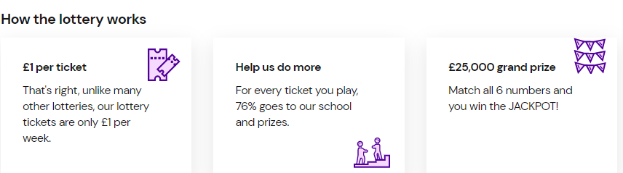



Attendance:
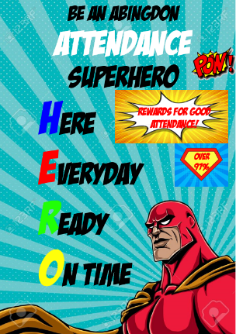
The class with the highest overall attendance each week will have the opportunity to ‘spin the wheel’! The wheel has lots of different choices on – some of these have been updated this year by the children.
Each class who achieves 97% or higher each week, or who show great improvement, will have an extra playtime the following week.
ALL children who have over 95% attendance for the year, or who show good improvement of attendance, will receive and end of term certificate and treat.
Attendance monitoring includes broken weeks and lateness. You MUST contact school if your child is late or absent.
The class with the highest attendance this week is: Y2 Foxes with 100%. Well done!
They have won ‘another extra play!!!!’ as a special treat from the wheel, as well their extra playtime next week – Foxes are going to have a great time next week!
Hedgehogs, Kites, Kestrels, Hawks and Squirrels all had over 95% - What an amazing start! – They all have an extra play too!

Hot chocolate
Each week we invite a child from each class (who is chosen for being a role model for behaviour) to come and have hot chocolate and marshmallows with the headteacher. It is definitely my favourite time of the week! It was lovely to hear today why the children were chosen. (Reception will join in after half term)
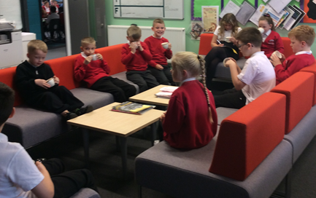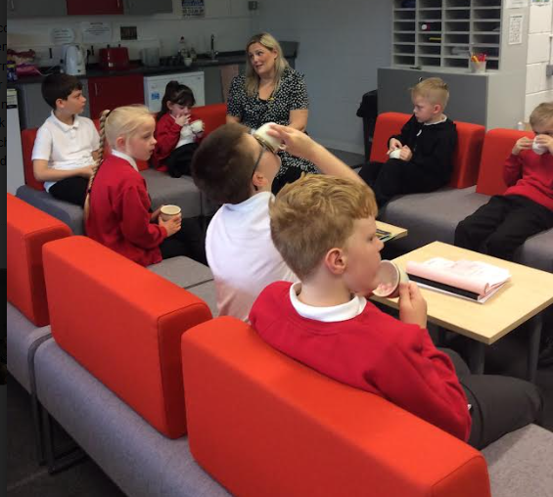

Gold Table
Children are chosen by their midday supervisors for their lunchtime behaviour. Each Friday we have a ‘Gold table’ in the hall and the children sit with me and have their lunch, they also receive a prize from the ‘Gold Box’. This will start next Friday and I can’t wait!

Class Stars of the Week
Each week children are chosen for showing our core values. We award certificates in Celebration Time each Friday. Well done to all our stars:

Year 1 /Rec Hedgehogs: Ollie Year 5 Kestrels: Ben
Year 1 squirrels : Jennifer Year 5 Merlins: Sophie S
Year 2 Foxes: Hareem Year 6 Ospreys: Lily
Year 2 Rabbits: Anna Year 6 Hawks: Melissa
Year 3 Falcons: Kyra-Rose
Year 4 Owls: Aleena
Year 4 Kites: Danica

Golden Broom
Year 1 Squirrels won the Golden Broom this week for having the tidiest classroom. Well done for setting a fantastic example to others.
The Golden Broom is awarded by Mr Bosson (Site supervisor) .

Finally, I would like to wish you a lovely weekend, and thank you for all your support.
Ms Flanders
Acting Headteacher

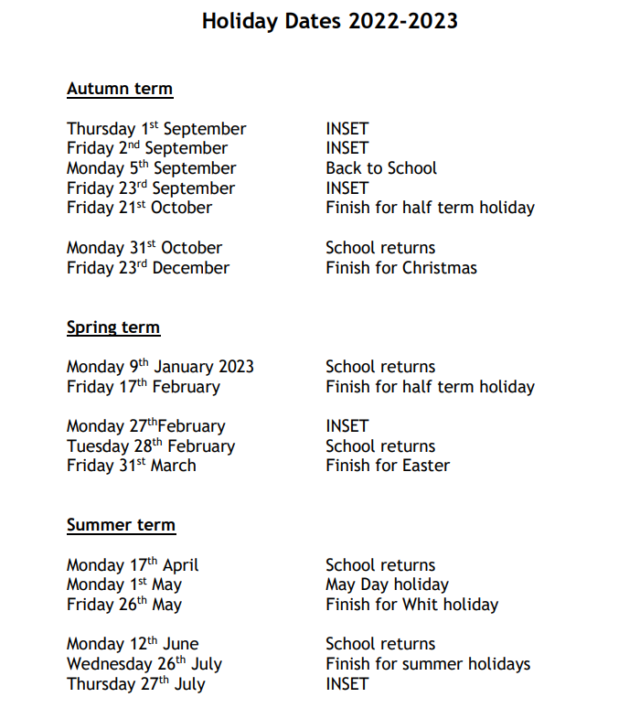

Covid-19 advice
- Children with mild symptoms of a respiratory infection include covid-19 but are otherwise well should continue to attend school. They should stay home if they have a high temperature and are unwell, and can return to school when they no longer have a high temperature/feel well enough.
- It is not recommended that children should have a covid-19 test unless directed to by a health professional, but if a child under 18 does test positive, they should stay off school for 3 days after the day they took the test. They can return to school after the 3 days if they are well enough.

The isolation period for COVID-19 is 6 days with a negative LFD test (24 hours apart on day 5 and day 6). See the link below for more information
https://www.nhs.uk/conditions/coronavirus-covid-19/self-isolation-and-treatment/when-to-self-isolate-and-what-to-do/

School advice is still:
If your child is displaying any of these COVID related symptoms
-a high temperature
-a new, continuous cough
-a loss of, or change to, your sense of smell or taste
or
if your child receives a positive lateral flow test, they should remain at home until they are feeling well again.
Please inform school if anyone in your child’s household tests positive for Covid-19.

